REGULAR MEETING
JULY 15, 2021

The Regular Meeting of the Town Board of the Town of Hampton, County of Washington and the State of New York was held at the Town Hall, 2629 State Route 22A, Hampton, New York, also via Zoom and live streaming on the You Tube Channel for “Town of Hampton New York” on the 15th day of July 2021.

Due to the Corona Virus, occupancy inside the Town Hall is limited at this time. Supervisor O’Brien did provide a link to join the meeting via Zoom.

PRESENT: David K. O’Brien----------- Supervisor
Donald Sady-----------------Councilman
Tamme Taran----------------Councilwoman
Andrea Sweeney------------Councilwoman - absent
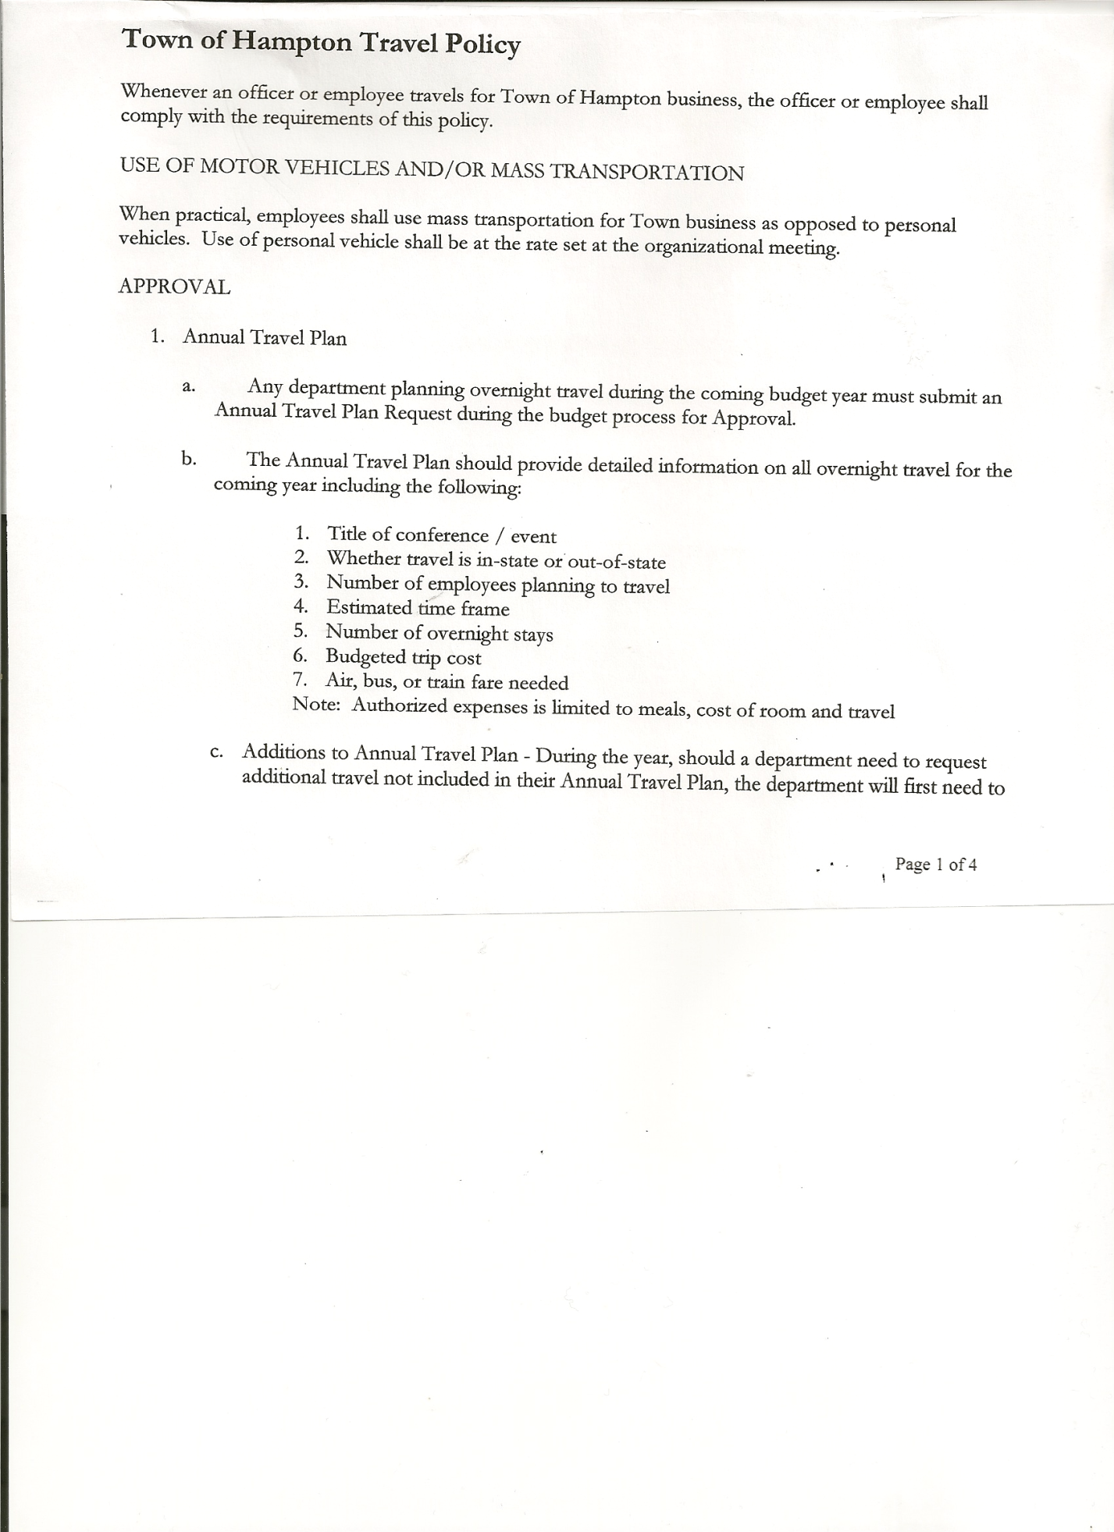
Michael Pietryka------------Councilman
Rebecca Jones---------------Town Clerk- absent
Camilla Shaw----------------Tax Collector/Deputy Town Clerk
Herbert Sady, Jr.-------------Highway Superintendent

Planning Board Member(s): Bonnie Hawley, Chair; Matthew Pratt
Others present at the Town Hall: See attached list

The Regular Meeting was called to order by Supervisor O’Brien at 7:30pm, followed by the Pledge of Allegiance. Location of Fire Exits were given. Quorum of board members present.

RESOLUTION NO. 59-2021
APPROVAL OF THE MINUTES
On a motion of Councilwoman Taran seconded by Councilman Sady, the following resolution was ADOPTED: AYES 4 O’Brien, Sady, Taran, Pietryka
NAYS 0
ABSENT 1 Sweeney
RESOLVED, that the Regular Town Board Minutes for June 17th, 2021, are approved.

Larry Carman, Dog Control Officer submitted his report, which was read by Supervisor O’Brien, copy of report is attached.

Camilla Shaw, Tax Collector, received a payment for taxes, was returned advised to contact Washington County Treasurer for amount due and to pay to them. No other activity. Submitted Bank Statement to the Board for review and signatures.

Bonnie Hawley, Chair gave Planning Board Report……Mobile Home laws is going to need to be updated as there were changes to the New York State Law in 2020 that she never received notice of. She spoke to John Graham 2 times about this. There are now three definitions of manufactured homes. Manufactured home, mobile home and manufactured prior to 6/15/1976.
She will talk to other towns and the town attorney, Matt Fuller.
Ray Terminal contacted her about adding a small parking lot and will submit paperwork. Next meeting is Wed, August 11, 2021.

Herb Sady, Jr., Highway Superintendent submitted his report, copy of which, is attached. He heard from Jimmy who stopped by the Town Garage. He is not in good shape. Not sure when he will be able to return.

TOWN BOARD MEETING
JULY 15, 2021 PAGE 2

Tyler gave some updates on Highway also. Todd Mason will be back this winter. He spoke to Ken Lufkin about paving maybe late September. Being short a CDL driver had put them back getting the shoulder work done to prepare for paving. Supervisor O’Brien reminded that doing paving that late may cause financial problems as reimbursement might not be until next year. PAVE NY money needs to be used first. The is about $117,000 total available including the $23,000 from town funds. Some funds might be able to be carried over for work next year. Tyler will try to get it done earlier. The plan is to pave Manchester Road from Vladyka Woods Rd toward Carver Falls Rd.

SUPERVISOR’S REPORT/ COUNTY UPDATES/ COMMUNICATIONS

RESOLUTION NO. 60-2021
APPROVAL OF SUPERVISOR’S MONTHLY REPORT
On a motion of Councilman Sady, seconded by Councilwoman Taran, the following resolution was ADOPTED: AYES 4 O’Brien, Sady, Taran, Pietryka
NAYS 0
ABSENT 1 Sweeney
RESOLVED that, the Supervisor’s Monthly report be accepted as submitted for JUNE
5/31/21 6/30/21
ACCOUNT BALANCE RECEIPTS DISBURSEMENTS BALANCE
General Fund $ 51,699.11 $ 9,694.76 $ 12,528.59 $ 48,865.28
Highway Fund $208,958.95 $ 5.03 $ 22,007.30 $ 186,956.68
Equipment Reserve $ 79,909.39 $ 1.97 $ 0.00 $ 79,911.36
Fire #1 $ 43,297.00 $ 0.00 $ 21,648.50 $ 21,648.50
Fire #2 $ 10,200.00 $ 0.00 $ 5,100.00 $ 5,100.00
Cemetery $ 1,749.69 $ 1.36 $ 0.00 $ 1,751.05
Totals $395,814.14 $ 9,703.12 $ 61,284.39 $344,232.87
All Board Members present signed Supervisor’s Report.

Supervisor O’Brien handed out a comparison of tax rates using the new assessed value of properties for 2021. The rate at current taxes needed to be raised would decrease by $.70 per thousand. This would also decrease the rate for County taxes and Hampton would be one of the lowest rates for the County. Copy is attached.

OLD BUSINESS

Noise Ordinance…. The town attorney was checking on it. It could be put in place for a certain time period each day. Sheriff would have control over issuing citation or not. There have been some put in other towns but may not solve the problem.

Stimulus Funds…The town should receive $46,374.65 by the end of July as part of the $92,749 total amount. The other half will be paid in the Summer of 2022. A proposed usage of funds is attached. Money cannot be used for paving, equipment, or transportation. We can prepare the town hall for better air handling for the future. Will be looking into air conditioning by hooking into the forced air furnace system. Also, there is a need for water filtration for the garage.

TOWN BOARD MEETING
JULY 15, 2021 PAGE 3

Cannabis Opt Out/In …. More discussion and views from board members on whether to permit the establishment of a Cannabis Retail Dispensary Licenses and/or On-Site Consumption Licenses within our Town. Since not all members were present a decision was not made. The issue will be tabled until the September meeting as Councilwoman Taran will be unable to attend the August meeting. Matt Fuller, Town Attorney will be contacted to see if one or the other can be approved or if it must be both. There will have to be time for a Local Law which requires a Public Hearing to opt in or out before the December deadline.

NEW BUSINESS

Constable/Sheriff… Supervisor O’Brien explained the process is different than in Vermont. They would be required to attend the police academy for 40+ weeks., do arms training and we would have to pay a salary. Whitehall has gone through the process and had them work one year and the person went to work for the Sheriff’s department. This has happened to other towns also. Hampton does not have the funds to do this.

Neighborhood Watch … Supervisor O’Brien researched and the four top ways to deter crime are as follows: 1. Have a dog, 2. Have a dog in the neighborhood, 3. Police presence 4. Neighborhood Watch (even signs help)
There is a group on Facebook trying to form Neighborhood watches in Hampton.

Supervisor O’Brien received a message about the speed limit on CR 21. The person’s GPS and road signs had different speed limits. Speed limits on the road will be looked at.

PUBLIC COMMENTS/COUNCIL COMMENTS
None

RESOLUTION NO. 61 -2021
AUDIT OF CLAIMS
On a motion of Councilman Sady, seconded by Councilman Pietryka the following resolution was ADOPTED: AYES 4 O’Brien, Sady, Taran, Pietryka
NAYS 0
ABSENT 1 Sweeney
RESOLVED that the bills have been reviewed by the Town Board and are authorized for payment in the following amounts.
General Fund No. 95 through No. 103 $ 8,350.04
Highway Fund No. 72 through No. 86 $ 51,742.61
Total both funds $ 60,092.65

The Town Clerk’s report for June 2021 was submitted to the Board. The Town Clerk had Board Members review and sign bank reconciliation statements for the Town Clerk Account and Special Clerk Account dated June 30, 2021.

RESOLUTION NO. 62 -2021
EXECUTIVE SESSION
On a motion of Councilman Pietryka, seconded by Councilman Sady the following resolution was ADOPTED: AYES 4 O’Brien, Sady, Taran, Pietryka
NAYS 0
ABSENT 1 Sweeney
RESOLVED that, the Town Board enter into Executive Session at 8:37pm to discuss employment of an individual.

TOWN BOARD MEETING
JULY 15, 2021 PAGE 4

RESOLUTION NO. 63 -2021
RETURN TO REGULAR SESSION
On a motion of Councilwoman Taran, seconded by Councilman Sady the following resolution was ADOPTED: AYES 4 O’Brien, Sady, Taran, Pietryka
NAYS 0
ABSENT 1 Sweeney

RESOLVED that, the Town Board return to regular session at 8:50p.m.

RESOLUTION NO. 64-2021
MEETING ADJOURNED
On a motion of Councilman Sady, seconded by Councilwoman Taran, the following resolution was ADOPTED: AYES 4 O’Brien, Sady, Taran, Pietryka
NAYS 0
ABSENT 1 Sweeney
RESOLVED that the meeting adjourned at 8:51pm.

Respectfully submitted,

Camilla M. Shaw
Deputy Town Clerk

