FIF 2022-2023 Schedule

Fall Semester
Registration: July 9-10
Catechist Retreat? July 31? Aug 6?
August
August 7 - Breakfast/Book bag blessing
August 14- Class
August 21 - Class
August 28 – Safe Enviroment Training

September
Septembe 4 - Breakfast
September 11 - Class
September 18 - Class
September 25 - Class

October
October 2 - Class
October 9 - No Class (Fall Break)
October16- No Class (Fall Break)
October 23 - Class
October 30 - Class

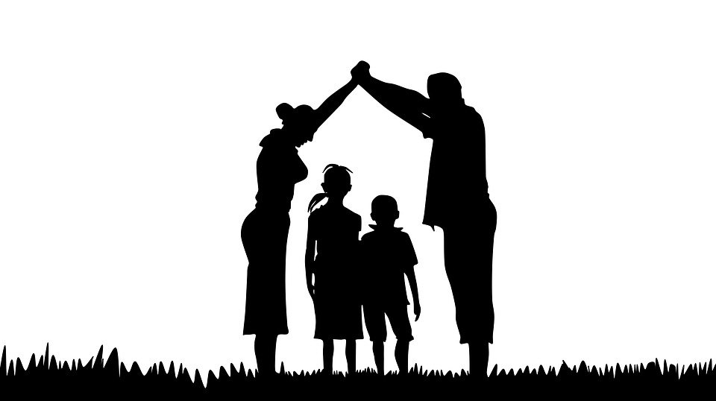
November
November 6 - Class
November 13 - Breakfast
November 20 - Class
November 27 - No Class (Thanksgiving)

December
December 4 - Class
December 11- Class
December 18 - Breakfast
December 25 - No Class (Christmas)

Spring Semester

January
January 1 - No Class (Sol. of Mary)
January 8 - Class
January 15 - Breakfast
January 22 - Class
January 29 - Class

February
February 5 - Class
February 12 - Breakfast
February 19 - Class (Sun. before Ash Wed.)
February 26 - Class

March
March 5 - Class
March 12 - Breakfast
March 19 - Class
March 26 - Class

April
April 2 - No Class (Holy Week)
April 9 - No Class (Easter)
April 16 - Class
April 23 - Class
April 30 - Closing Day

May
May 7 - First Communion
Total Class Sessions: 25
Total Breakfasts: 7
Total No-Class Days: 10

