SOLVING THE CALIFORNIA STATE WATER AND ENERGY CRISIS AND HITTING RENEWABLE ENERGY TARGETS

SHOULD THE SHASTA DAM BE RAISED?

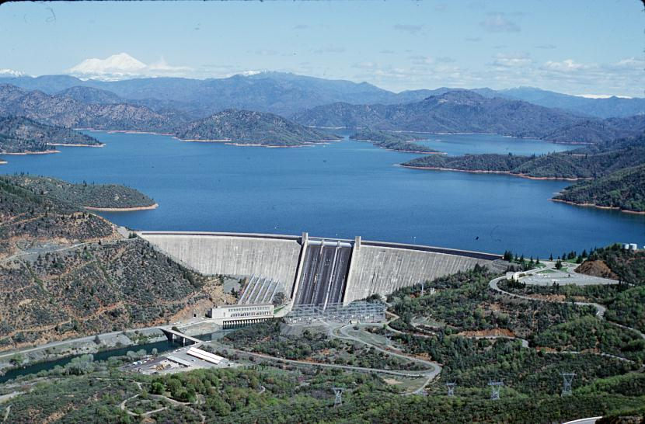
THERE ARE 4 OPTIONS : NOT RAISE OR RAISE LOW, INTERMEDIATE OR HIGH

Option | Height | Total height | Storage added | Total storage | Power added | Total power capacity
Low | 6.5 feet (2.0 m) | 608.5 feet (185.5 m) | 290,000 acre feet (360,000,000 m³) | 4,840,000 acre feet (5.97×10⁹ m³) | N/A | N/A
Intermediate | 102.5 feet (31.2 m) | 704.5 feet (214.7 m) | 3,920,000 acre feet (4.84×10⁹ m³) | 8,470,000 acre feet (1.045×10¹⁰ m³) | 1,075 MW | 1,751 MW
High | 202.5 feet (61.7 m) | 804.5 feet (245.2 m) | 9,340,000 acre feet (1.152×10¹⁰ m³) | 13,890,000 acre feet (1.713×10¹⁰ m³) | 1,300 MW | 1,976 MW
Shasta Dam Raise and Reservoir Enlargement
YOU DECIDE RAISE OR NOT RAISE ?
Friends of the River ~ March 1, 2005
The U.S. Bureau of Reclamation is studying the feasibility of raising Shasta Dam and enlarging its reservoir. Completed in 1945 on the Sacramento River, the dam is already the highest in California and its 4.5 million acre-foot reservoir is the largest (by volume) in the state.

Key issues concerning the dam raise include:

Raising Shasta Dam and enlarging its reservoir could significantly affect the human and
natural environment, including Native American tribal lands and resources, as well as
recreational sites and businesses surrounding the existing reservoir.

The dam raise and reservoir expansion would impact scenic and recreational values, river
segments upstream and downstream of the reservoir and dam, as well as rare, threatened
and endangered species and their habitat.

The dam raise would cost the public hundreds of millions of dollars and yield a relatively
small amount of very expensive water. To date, no water interests have offered to purchase
the project’s expensive water or share construction costs.

How Much Water Will The Dam Raise Produce?
Because dams don’t create water (they merely capture rain and snowmelt), the firm yield that can be reliably produced on an annual basis depends on annual rainfall. The hypothetical firm yield of water produced from the 6.5 foot raise ranges from 20,000 to 72,000 acre feet. The hypothetical firm yield of the 18.5 foot raise is 71,000-146,000 acre feet. In comparison, if farmers producing low-value alfalfa were to conserve a mere five percent of the water they consume, it would save nearly one million acre feet of water.

How Much Will The Dam Raise And The Water Cost?
The Bureau currently projects that construction costs for the 6.5-foot raise would range from
$282-356 million, with annual operation/maintenance costs of $19-20 million. Construction
costs for the 18.5 foot raise range from $408-483 million, with annual costs of $28-34 million.
(Initial dam construction cost estimates are notorious for failing to capture the final actual costs of projects.) Therefore, the cost of the water produced by the options range from $220-270 per acre-foot. This is not competitive with the $50 to $150 per acre-foot currently paid by farmers who consume most of the developed water in the Central Valley. Urban water users who have the potential to finance a dam project in California, are simply not interested in financing a Shasta raise and are pursuing cheaper and more reliable water supply and quality options.

How Much Additional Electricity Would be Generated by a Raised Dam?
Raising Shasta Dam would increase the dam’s total hydropower generation. However, it would require a significant amount of energy to pump the water by the dam to potential users in the San Joaquin Valley or Southern California. An analysis by the Natural Resources Defence Council revealed that, if the water generated by a dam raise were to be pumped to Southern California, it would require more energy than would be generated by the raise, thus making it a net energy consumer.

Impacts on the Human and Natural Environment

Native American Tribal Lands/Cultural Values – The existing Shasta Reservoir drowned more than 90% of the Winnemem Wintu Tribe’s homeland. Even the smallest proposed raise will drown the Tribe’s remaining sacred cultural sites, some of which are still in use today, and would violate state law protecting sacred sites.

Recreation Sites, Infrastructure, & Local Businesses – More than 600 structures will have to be relocated, modified, or protected from the raise. Marinas, campgrounds, roads, bridges, and other structures surrounding the existing reservoir will be adversely affected.

Scenic Values – The dam raise would significantly increase the unsightly “bathtub” ring around Shasta Reservoir. Because the dam does not create water, the height of the reservoir depends on annual precipitation. Increasing the total volume of the reservoir simply means that the reservoir will fill less often. The existing reservoir has only filled 18 times out of the last 50 years. The expanded reservoir would have filled only three out of the previous 20 years.

McCloud River – The dam raise and reservoir expansion would violate state law by drowning nearly two miles of the McCloud River. State law prohibits any new dam or reservoir that adversely affect the river’s free flowing condition and wild trout fishery. The reservoir expansion would also drown portions of the upper Sacramento River, Pit River, and Squaw Creek.

Sacramento River – The dam raise would further modify flows downstream in the Sacramento River by capturing additional flood flows and spring run off. These high flows are needed in the lower Sacramento River to drive the erosion/deposition processes (river “meander’) that recreates vital riparian and fish spawning habitat.

Rare, Threatened, & Endangered Species – In order to increase water deliveries, the Bureau
weakened two key salmon protection measures that constrained the operation of Shasta Dam. These changes will result in more than a 9 percent increase in mortality for the endangered winter run chinook salmon and more than 3.5 percent increase in threatened spring run salmon mortality in critically dry years. It is unclear whether these impacts can or will be fully mitigated by the dam raise. In any case, operating the dam to benefit salmon is largely up to the Bureau and the agency has already demonstrated its disregard for protecting the rivers dwindling fisheries.

