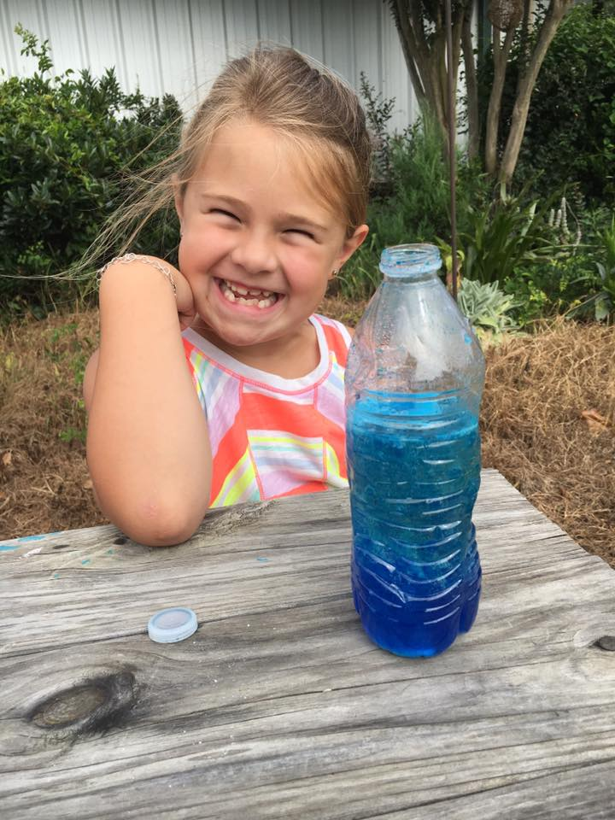
PEYTON GAMBRELL
​AGE: 7 YEARS
SCHOOL: RIVERWOOD ELEMENTRY
HORSE: "I LOVE ALL THE PONIES"
​DICIPLINE: HUNTER/ EQUITATION/ DRESSAGE
AGE YOU STARTED RIDING: 6 YEARS
​"I ride about three times a week! Although my favorite thing to do is dressage, I am currently working on trotting over cross-rails. Sometimes its difficult when the ponies wont listen, but it makes me work harder and I'm always up for a challenge. My advice to other riders is "Falling off will make you tough and determined to be a better rider."
​Peyton was selected as March's Student of the Month because she always perseveres! She likes a challenge and will often pick the pony who gave her a hard time last ride to see if she can have a better ride! Peyton will always pick up after herself and often comes early to her lessons just so she can spend time getting her pony ready. Peyton has learned to ride almost all of the lesson horses/ ponies at JRF because she is committed to her riding. Peyton's positive attitude and discipline has earned her March's "Student of the Month" honors! Congratulations!

