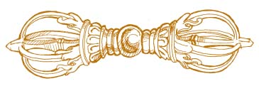

**The *Dorge* or Diamond Sceptre**

The *Dorge* (pronounced door-jay) is a Tibetan implement of great beauty and utility… “*dorge*” (Sanskrit term “*vajra*”) are generally translated as the “thunderbolt” of Indra, the Hindu Jupiter The *dorge* represents the highest spiritual power, that which is irresistible, invincible, indestructible and inexhaustible -- free from conflicting emotions.

In Tibetan “*do*” means “stone” and “*rge*” means “master”, and the “master stone” is considered to be the diamond: for its nobility, purity, clarity and ultimate hardness. The Master Stone is of course the Philosopher’s Stone or *prima materia* of the Alchemists, and this symbolism is apropos for the dorge. The secret of the Philosopher’s Stone is that anyone who attains it can no longer use it for base purposes such as riches and immorality as it will leave them spiritually dead.

The *dorge* is a sceptre, the emblem of supreme, sovereign power, hence the “Diamond Sceptre”. There are three stages of the *dorge--*the seed, the lotuses, and the mandalas-- or spirit, mind, and body.

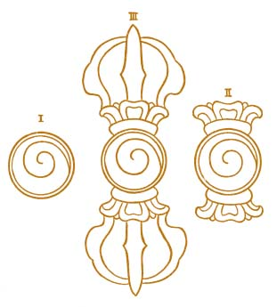The central sphere is the seed or “bindu” of the universe, corresponding to *Kether* at the apex of the Kabbalistic Tree of Life… an outward moving spiral of energy.

From the unity of the central seed spring two opposing lotus blossoms, representing the dual nature of manifest reality. Each has eight leaves, and can be understood as the eight trigrams of the *I Ching*, the fundamental binary code of our interactions with the universe.

From each lotus blossom emerges five ‘rays of power’ which converge at a higher point. Each ray depicts Form, Feeling, Perception, Intention and Consciousness, together comprising an individual’s total life experience. This is the three dimensional world we inhabit as incarnate humans. The dynamic polarities represented by the two sides of the *dorge* depicts the polarities of male and female, night and day, hot and cold, Matter and Spirit. Through the thunderbolt of awareness, we find enlightenment, and the perception that all is One. This, the supreme path of Buddhism, is termed the *Vajrajana*, or the Diamond Wisdom.

In ritual use, the *dorge* is held in the left hand while a small “*phurba*” or demon-slaying dagger is held in the right. Meditation upon the *dorge* guides the body, mind, and spirit to its unified awakened state of Oneness. It is both the Path and its Symbol. The *dorge* reveals an active inner spiritual “map of the universe” upon which one may travel to the highest levels of awareness whilst keeping grounded in their daily lives.   
  
 The Buddha nature lies within! We have only to realize and actualize it.

**Om Mani Padme Hum…..*Hail the Jewel in the Lotus!***

Reference -- http://dorge.org/dorge.html