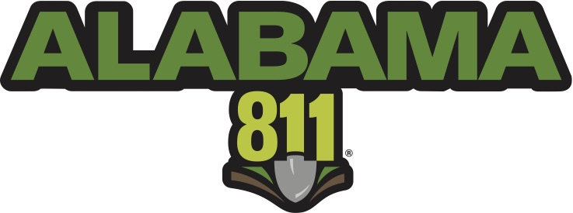
Media Contact:
Michele Dory
205.731.3206
mdory@al811.com

Alabama 811 Celebrates 10th annual NATIONAL SAFE DIGGING MONTH

Alabama 811 encourages Alabama residents to contact 811 two working days before digging.

Fultondale, Alabama, (April 2, 2018) – This April marks the tenth annual National Safe Digging Month, reminding Alabama residents to always contact 811 at least two working days before any digging project. National Safe Digging Month is formally recognized by the U.S. House of Representatives and Senate and has traditionally earned the support from nearly every state governor across the country. Alabama’s Governor Kay Ivey has signed the proclamation noting April as Safe Digging Month in Alabama.

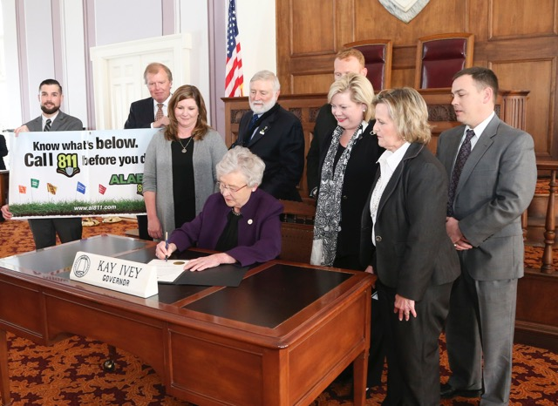
Every nine minutes an underground utility line is damaged because someone decided to dig without first calling 811. Striking a single line can cause injury, repair costs, fines and inconvenient outages. Every digging project, no matter how large or small, warrants contacting Alabama 811. Installing a mailbox, building a deck and planting a tree or garden are all examples of digging projects that should only begin a minimum of two working days after contacting 811.

When calling 811, or placing online requests through the Web Portal or Mobile Application at www.al811.com, homeowners and contractors are connected to Alabama 811, a free service to the excavating community, which notifies member utility companies of their intent to dig. Professional locators are then sent to the requested digging site to mark the approximate locations of member underground lines with flags, paint or both. If there are utility owners in the area of excavation who do not participate as a member of Alabama 811, the excavator is responsible for contacting them on an individual basis.

“As April marks the traditional start of digging season, we are using this month to strongly encourage individuals and companies to contact 811 before they begin and digging project,” said Annette Reburn, Executive Director, Alabama 811. “By contacting 811 to have the underground utility lines in their area marked, homeowners and professionals are making an important decision that can help keep them and their communities safe and connected.”

The depth of utility lines can vary for a number of reasons, such as erosion, previous digging projects and uneven surfaces. Utility lines need to be properly marked because even when digging only a few inches, the risk of striking an underground utility line still exists.

Alabama 811 encourages area residents to visit www.al811.com for more information about digging safely.
# # #

