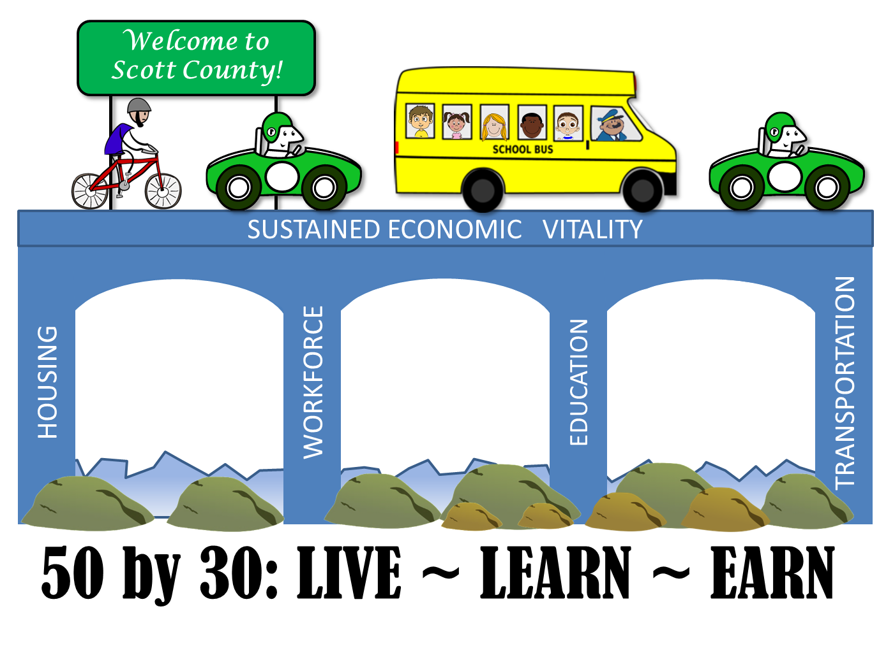
Workforce Preparedness
Meeting Agenda
May 10, 2016

- Introductions
- Background
- Meeting Logistics
- April 50X30 Meeting recap from the Steering Committee
- Roles and Responsibilities for the group
- Setting our agenda:
  - Visioning
  - Road Blocks
  - Action
- Aligning work from April’s meeting with next steps
- Plan of action

