The Ted Leszkiewicz
AMVETS
Against Drug and Alcohol Abuse
(AADAA) Program Contests
Co-sponsored by the membership of AMVETS & AMVETS Ladies Auxiliary
Poster
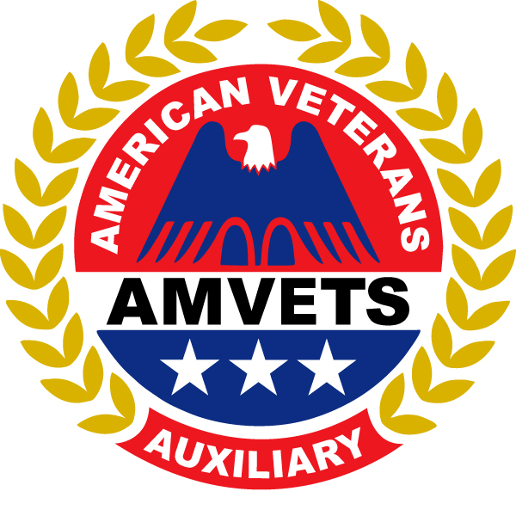
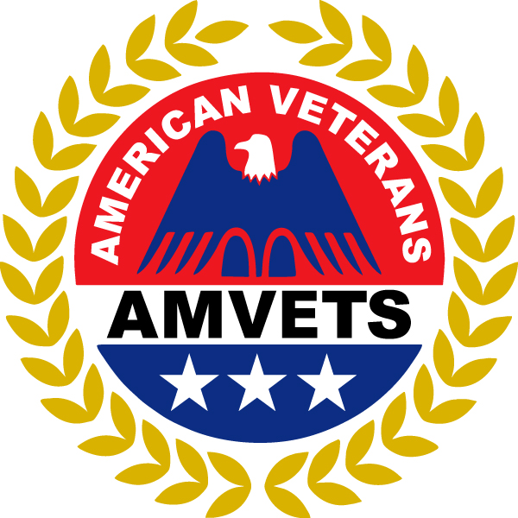
(Grade Category I: K - 2)
(Grade Category II: 3 - 5)
Essay or Poem
(Grade Category III: 6 - 8)
(Grade Category III: 9 - 12)
For more information contact your local
AMVETS or AMVETS Ladies Auxiliary Post at:
_________________________________________
(Post Contact Information)
or
AMVETS National Programs Department
at
301-683-4031 or email programs@amvets.org
A.A.D.A.A. Goals & Purposes

- Become aware of the substance abuse problem in our society and how it affects our families, communities, and ourselves.

- Become informed as to the facts – and be ready to dispel the myths – about alcohol and other drug use so that the subject can be freely discussed within the family unit and in and community settings.

- Recognize that the role of community members and parents requires responsible behavior and clear positions regarding alcohol and other drug use in our own family and within the community.

- Help youth become, capable adults by providing opportunities that promote self-image and critical life skills.

- Encourage and sponsor creative social activities that are drug-free settings.

- Encourage parents to host well-supervised parties for youth that limit the number of guests to a controllable number and work to develop family standards that prohibit the use of alcohol and drugs by adolescents in the home at any time.

- Provide opportunities that allow families to communicate with legal, medical agencies, social service agencies, and with other families so that a consistent message concerning youth behavior is established within the community.

- Support school and law enforcement policies regarding the use of alcohol and other drugs by persons within the community and encourage appropriate and consistent consequences.

- Request and endorse comprehensive prevention programs for grades Kindergarten through 12th that deal with alcohol and other drugs in the local school system.

The Ted Leszkiewicz
AMVETS
Against Drug and Alcohol Abuse (AADAA) Program
Co-Sponsored by AMVETS and AMVETS Ladies Auxiliary
Please print legibly or type
Completed Entry Form, and Poster, Essay, Story or Poem must be returned to your local AMVETS Post or Department.

STUDENT SECTION
INDICATE GRADE THE CHILD IS IN: ___________
Student Name: Birth Date: ____/____/____
Student Address:
Student City, State, Zip:
Name of Parent/Guardian*:
Parent Email: Phone number *(_____) _____-_____
Name of School/Organization:
School Address:
City, State, Zip:
Teacher’s Name: Email:
Teacher’s School Phone number:

FOR DEPARTMENT USE ONLY
This section must be complete and returned to AMVETS National Programs Department by 1 July
NOTE: This section must be completed and signed by the Department AADAA Officer, Commander, or Executive Director. Incomplete entries will be disqualified. Essay entries must be submitted to the designated Department official. Only 1st place Department entries can be submitted to National Programs Department.
The attached 1st Place (Circle One) Poster, Essay, Story or Poem entry is submitted by:
AMVETS/Ladies Auxiliary -Department/Post# _______________________________
Date
Address: ________________________________________________________________________________
City, State, Zip: __________________________________________________________________________
Phone number: Email: ____________________________________________

Print Officer Name and Title Signature of AMVETS/Auxiliary Representative

Revised 11-2021 All awards will be sent to the Department.

The Ted Leszkiewicz
AMVETS Against Drug and Alcohol Abuse
(AADAA) Program
Poster Contest Guidelines
Who can participate?
All students in kindergarten, 1st, 2nd, 3rd, 4th and 5th grades who attend public, private, parochial schools, home schooled, members of any youth organization, ie. Boy Scouts, Girl Scouts, Boys and Girls Clubs, etc are eligible to participate.
Annual Themes (based on school year):
2022-2023: There is no use for Drug Abuse
2023-2024: Be Smart...Don’t Start
Contest rules:
- All students must address the theme.
- Entries must be 9” x 12” inches using construction paper or poster board.
- All entries must be free hand drawings and may be colored with any art medium.
- A straight edge may be used as an aid to draw a straight line.
- Gluing pictures or other materials to the surface of the drawing is not permitted.
- The student’s description of the poster must be written on the back of the poster in 50 words or less. Descriptions that are firmly attached to the back of the poster will also be accepted.
- All entries must be sent to the National Programs Department and postmarked no later than July 1st. (Post and Department deadlines may vary.)
- Incomplete Entry forms and non-legible address will be disqualified.

Criteria for judging Posters:
* Artistic * Neatness * Creativity * Adherence to Theme *

First Place Winners will receive a plaque and gift card
Second Place Winners will receive a certificate and gift card
Amounts of gift cards range from $ 10 to $250
(Amounts subject to change)

The Ted Leszkiewicz
AMVETS
Against Drug and Alcohol Abuse
(AADAA) Program
Essay/Poem Contest Guidelines

Who can participate?
All students in the 6th, 7th, 8th, 9th, 10th, 11th and 12th grades who attend public, private, parochial schools, home schooled, members of any youth organization, ie. Boy Scouts, Girl Scouts, Boys and Girls Clubs, etc are eligible to participate.
Annual Themes (based on school year):
2022-2023: There is no use for Drug Abuse
2023-2024: Be Smart...Don’t Start
Contest rules:
- All students must address the theme.
- Essays must be typed in 12 Font, Times New Roman, and doubled spaced
- Essays/poems submitted by 6th through 8th grade must be 250 words or less.
- Essays/poems submitted by 9th through 12th grade must be 350 words or less.
- All entries must be sent to the National Programs Department and postmarked no later than July 1st. (Post and Department deadlines may vary.)
- Incomplete Entry forms and non-legible address will be disqualified.

Criteria for judging Essays (stories or poems):
* Originality * Literary Composition * Creativity * Adherence to Theme *

First Place Winners will receive a plaque and gift card
Second Place Winners will receive a certificate and gift card
Amounts of gift cards range from $ 10 to $250
(Amounts subject to change)

