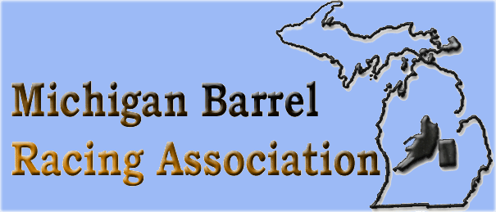 September 28, 2024 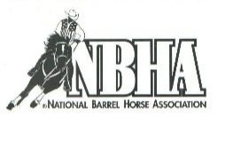
Lakeside Arena, 4635 Rathbun Rd, Birch Run
MBRA CO- APPROVED BY MI NBHA04
Expos 9AM ($5 at the gate) Show Starts 11:00AM SHARP

Classes | Entry Fee | Horse 1 | Horse 2 | ROLL
MBRA Youth Poles  16 & Under (cannot enter Open) | $10
Open 2D Poles | $15
MAVERICK BARRELS  Prizes only | $5
MBRA 3D Youth Barrels 1st go  16 & Under (cannot enter OPEN) | $10
MBRA Open Barrels 1st Go/  NBHA Sweepstakes | $15
MBRA 3D Youth Barrels 2nd Go  16 & Under (cannot enter OPEN) | $10 |  |  | Y
4D MBRA/NBHA Open Barrels 2nd Go | $20 |  |  | Y
NBHA Youth/Teen 3D Barrels  (18 & Under) | $15 |  |  | Y
NBHA Senior 3D Barrels | $15 |  |  | Y
MBRA Senior Side Pot  (Rolls from 1st Go Open) | $10 |  |  | YES
OFFICE FEE (Per horse/rider combo) | $5 | $5 | $5
NONMEMBER Fee  Must be MBRA OR NBHA | $5

Rider Name________________________________ ENTRY TOTAL ________
Horse 1 ____________________________ Horse 2 _____________________________

*** MBRA YOUTH CAN ENTER EITHER YOUTH POLES OR OPEN POLES BUT NOT BOTH
*** MBRA YOUTH BARRELS CANNOT ENTER OPEN BARRELS ( Youth age is 16 & Under as of 09/01/24)
Youth may move up to open in either event during a season but cannot move back down

