January
2018
TRUE LIES
The Stuart Rod & Reel Club Newsletter
The Stuart Rod and Reel Club is dedicated to improving local fishing through increasing angler knowledge, encouraging conservation and maximizing the fun involved in light tackle fishing in the Stuart Florida area. We hold monthly meetings on the second Thursday of each month, year-round. Please join us or contact any board member for more information on how you can become a member of the Stuart Rod and Reel Club.
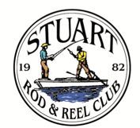
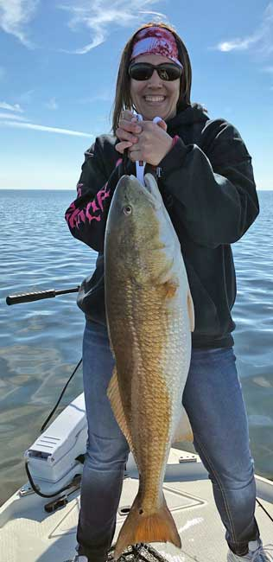
Amanda Steckley caught this magnificent Redfish while fishing with her husband Justin in the Steinhatchee area. This area is a redfish haven and they don’t get much bigger than this fish. Amanda works hard to hold this one up.

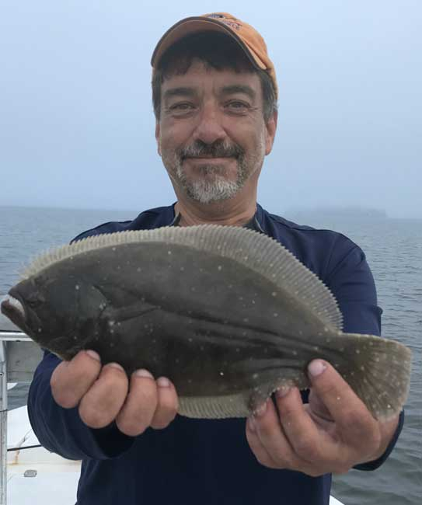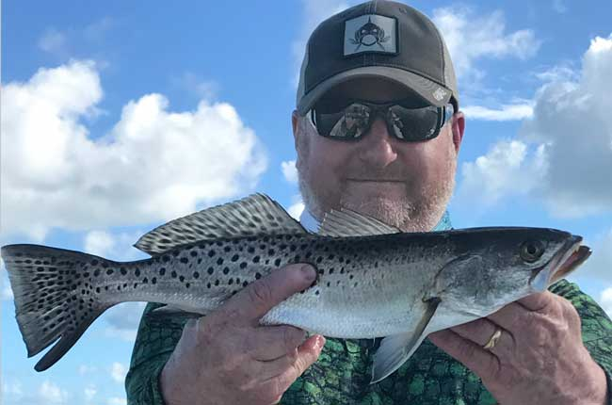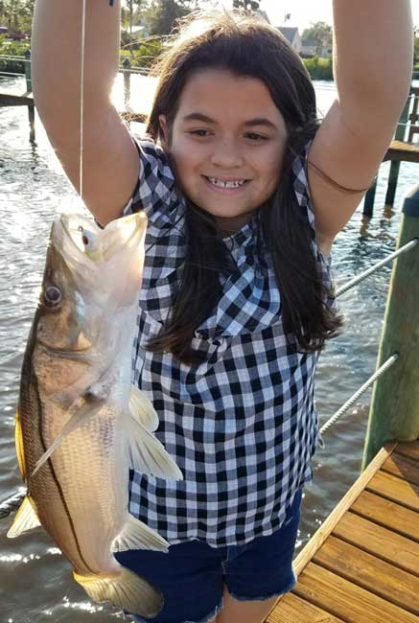
Top Left: Bob Ruggeri with a legal Southern Flounder. On a gray day, these fish can match the conditions to blend in to the bottom.
Top Right: Jeff Kittredge with a spotted sea trout
Bottom: Jim Harter’s granddaughter Annie Harter with her very first snook, caught on Christmas Day

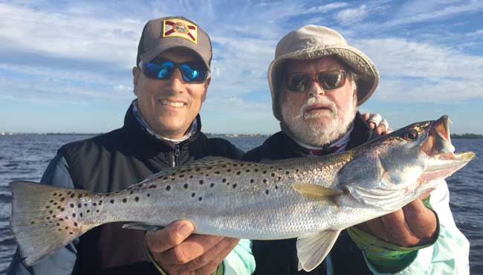
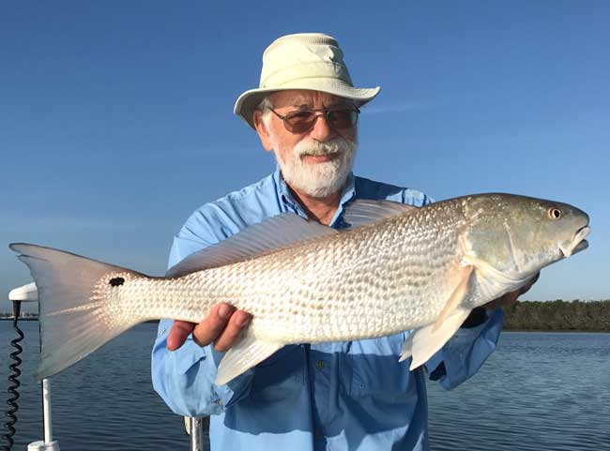
Gary Mirsky landed this very fine redfish in local waters. This fish is a silvery color and it is a large fish for our area.
Gary won the overall angler Fish of the Month contest for 2017.
Juan Giachino fishing with Jim Bohrer caught and released this beautiful trout.

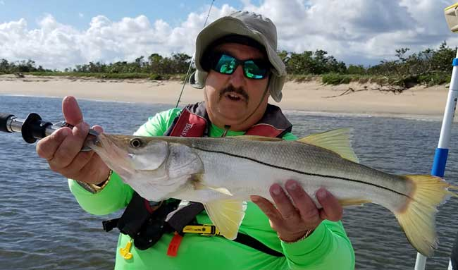
Keith Palant, your 2018 Angling Director, with a beach caught snook. Be careful when fishing this close to the beach, especially when the surf is up.

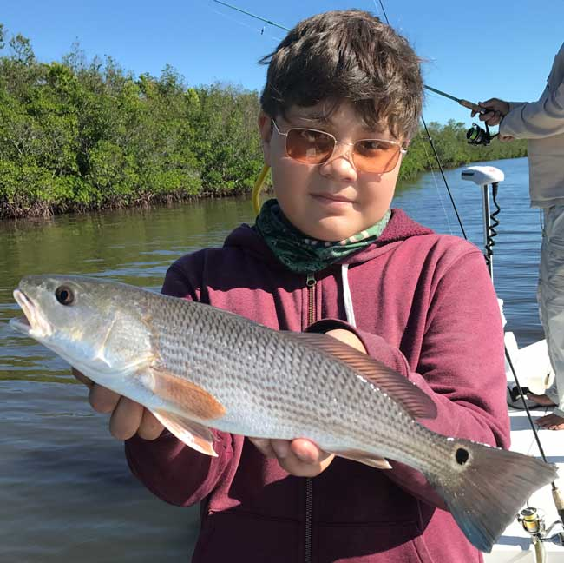
Jim Bohrer’s nephew Rooney with a mangrove edge cruising redfish.
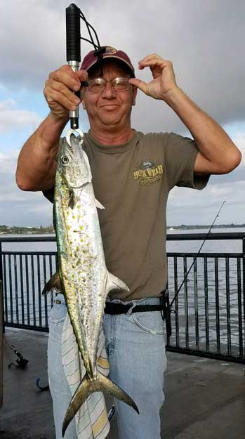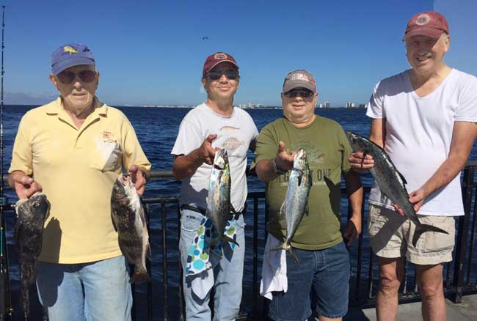

Bridge and inlet fishing can be very good this time of year, especially when the tide is moving.
Left: Eric Rosenberg with a large Spanish Mackerel, caught at the Jensen Beach Bridge.
Below (L to R), Hank Friedman, Eric Rosenberg, Joel Rosenberg and Richard Matteson had a mixed bag from the same area. They caught black drum, small goliath grouper, mackerel and bluefish.

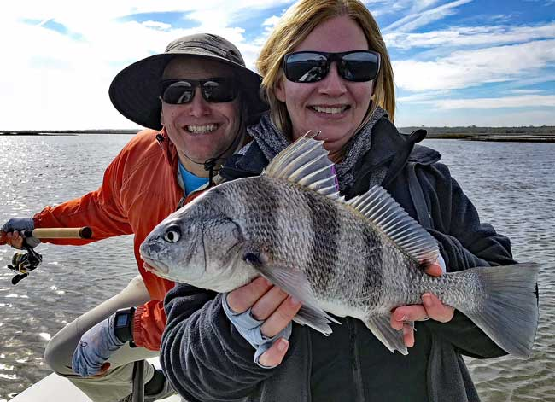
Todd and Kelly Puig took a trip to the west coast of Florida for some guided fishing. Here is a photo of Kelly and Todd with a nice black drum that Kelly caught.

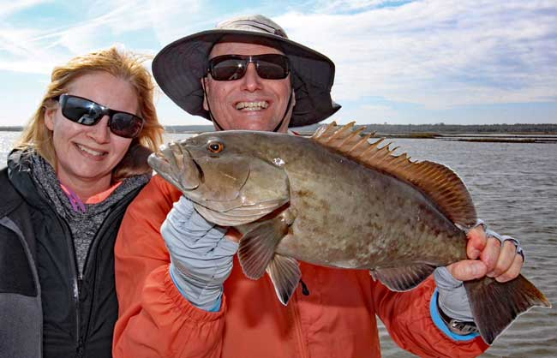
Kelly and Todd with a fine grouper caught on the west coast of Florida

Please note that 2018 Membership Dues are now payable.
Attached to this newsletter is your Membership Renewal Form. 2018 Dues remain the same as 2017. Don’t forget that your dues included luncheons almost every month, along with great speakers and informative programs. Please send in your dues promptly if you have not already done so. Thank you.

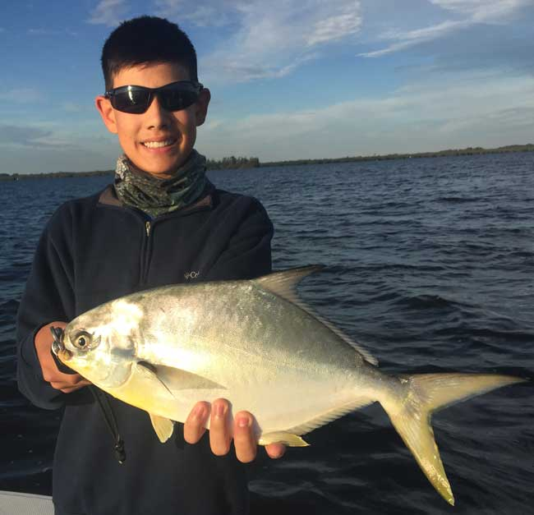
Michael Giachino with a lovely fat pompano on a day cold enough for Michael to wear fleece. Pompano should be entering our area more frequently now that cooler temperatures are here.

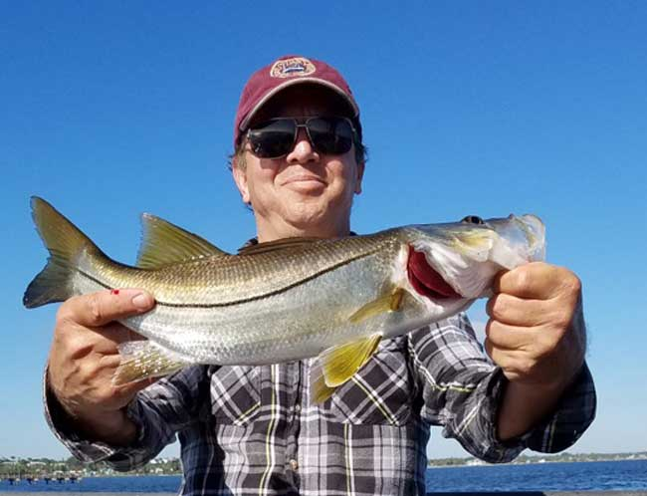
Eric Rosenberg with a nice smaller snook, ready for a safe release back to the wild.

CHRISTMAS PARTY SCENES
The Christmas Party was a big success this year. As a special bonus to the regular drawings, there were four drawings each for $250 gift certificates from White’s Tackle in Stuart. Thanks to White’s Tackle for helping support the cost of these certificates. Jim Bohrer worked with White’s in Stuart to obtain a great price for these certificates. We appreciate their support!

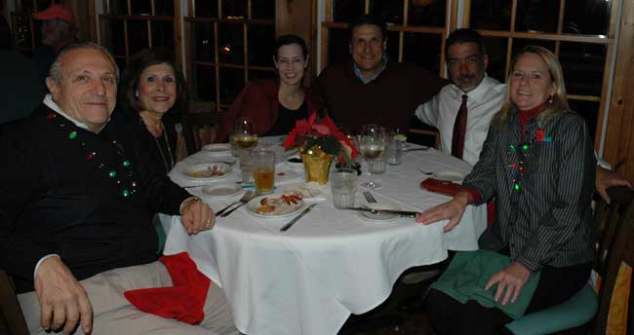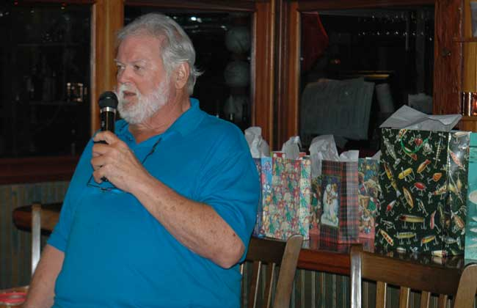

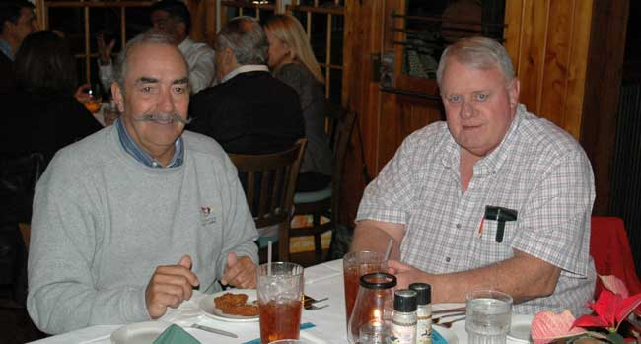

 |  |  |  | Club Officers
Vice President |  | Jim Bowdish |  | jlsb@crarybuchanan.com | 772-475-5068
Treasurer |  | Pete Noll |  | mpnoll@aol.com | 772-223-2136
Secretary and Newsletter Editor |  | Fred Bartlett |  | fredbart@aol.com | 913-909-9326
 |  |  |  | Board of Governors
Director at Large |  |  | Roy Buckley | rlbuckley007@aol.com | 772-871-7008
Angling Director |  |  | Keith Palant | aquaholiciv@gmail.com | 954-914-1988
House Committee |  |  | Jerry Hoge | jhoge@hogeengineering.com | 772-485-7267
Director at Large |  |  | Frank Miller | frmiami2@gmail.com | 305-469-4654
Membership Comm. |  |  | Eric Rosenberg | erosen1031@aol.com | 772-210-5563
Raffle Chairman and Conservation Coordinator |  |  | Jim Harter | pjharter@comcast.net | 772-223-0648
Director at Large |  |  | Frank Pryzbylski | 1pratt@comcast.net | 772-486-3531
Events Coordinator |  |  | Bob Ruggeri | bob.ruggeri@yahoo.com | 772-285-4264

All Stuart Rod and Reel Club Outings are based purely on the Honor System. You can fish anytime from first light Friday until Midnight (23:59) Sunday. Scores must be turned into the Angling Director, Aquaholiciv@gmail.com by email, phone (954-914-1988) or in-person by 2 PM local time on the day after the event.  Natural Bait (alive or dead) is allowed except for March, May and July. Bait restriction is in effect for September.  All members are invited to attend the luncheons, regardless of the day fished. Guests and spouses are invited to attend the food services. For food at sponsoring restaurants, guests and spouses will be charged for their meal and beverages costs. Alcoholic beverages are not included at any luncheon event. | Family members under the age of 18 must be accompanied by a parent or legal guardian to participate in an outing. While guests are always welcome to join members during our outings, you must be a paid member of the Stuart Rod and Reel Club to be eligible to win an outing. Outing scores shall be published in the Club’s Newsletter following the Outing. Outings cancelled due to weather shall be rescheduled for the following weekend. Outing result disputes shall be settled by the Angling Director.  OUTING SCHEDULES AND RULES MAY CHANGE DURING THE YEAR.  FISHING BOUNDARIES  Boundaries will extend from the south shore of the Jupiter Inlet to the North Vero Beach Bridge.

Date | Outing/Event | Details | Host/Food Service | Rules
January 12,13,14 | Lucky 4 | Snook, Trout, Pompano, Redfish  Total Number of all Target Species Caught - 3 fish per species max. Snook 24’’ min. | Sandsprit Park 1:00 PM  Stuart, January 13th. | Max. 3 fish each species
February  9,10,11 | Pompano & Flounder | Total Number Legal Pompano and Flounder combined Caught (Pompano 11” min fork length, max 6 fish/Flounder 12” min overall, max 12) | Sandsprit Park 1:00 PM  Stuart, February 10th. | Total Legal Number Caught
March  10th only | Round Island | DOA LURE EVENT High Point Wins  Trout=1pt. Snook =2pts. Redfish=3pts.  Max. 3 per species Snook must be 24'' min. | Manatee Island Bar & Grill, Fort Pierce.  1:00 PM, March 10th. | Must use D.O.A. brand lures only.
April  13, 14, 15 | New Member/Old Member | Any Species: Old Member fishes with any with New Member | Sandsprit Park 1:00 PM Stuart, April 14th. | New Member/Old Member
May  11, 12, 13 | Top Water Lures Only | Most Points Total - Snook =2pts.  Trout =1pts. and Redfish 3pts.  Max. 3 per species. | Sandsprit Park 1:00 PM Stuart, May 12th. | Total Points. No bait or jigs allowed.
June 15, 16, 17 | Most Species Caught-Must be legal size fish | Any species of fish caught. | Sandsprit Park 1:00 PM  Stuart, June 16th | Largest length of any 1 fish caught
July  13,14,15 | Local Tarpon Outing | Most Tarpon: 3 Points for angler touching the leader, 1 point for a jumped fish. One point per jumped fish only. No natural bait allowed | Shrimper’s Restaurant, Port Salerno 1:00PM, July 14th. | Three points for caught fish, one point for each jumped fish.
August  10, 11, 12 | Local Trout and Redfish Outing | Largest Trout & Redfish, total inch length | Sandsprit Park 1:00 PM Stuart, August 11th. | Longest total trout and redfish combined.
September  14, 15, 16 | Longest Snook | Longest Snook –Bait Restriction: Any snook caught on bait is worth ½ a fish caught on an artificial lure. 24” snook minimum length | Sandsprit Park 1:00 PM Stuart, Sept 15th. | Longest snook, minimum 24”
October  12, 13, 14 | Pine Island | Total Length in Inches: 1 Trout, 1 Redfish, 1 Snook (24”inch minimum on snook) | Pine Island Away  No Local Luncheon | Longest total length
November  9,10,11 | Local Redfish | Longest Overall Redfish | Sandsprit Park 1:00 PM, Stuart, Nov 10th. | Longest total length
December | Christmas Party | No Outing | Dolphin Bar & Fish House Jensen Beach | No Outing.

2018 TOURNAMENT OUTING SCHEDULE
Support our Advertising Sponsors
We are very fortunate to have many local businesses that advertise on our web site and provide additional sponsorship support to the Club. These businesses provide a wide range of products and services for the entire community. Whether you are looking for lodging, restaurants, fishing supplies, boat repair and restoration, guide services, legal services, or roof repair our sponsors deserve your consideration. You can learn more about these businesses by visiting our website at www.stuartrodandreel.com. Click on the advertiser’s tab and you will find a brief description of our sponsors with contact information and links to their websites. Make our advertising sponsors your priority when shopping. Please let them know that you learned about them through the Stuart Rod and Reel Club and that you appreciate their support.

Bait & Tackle  - Crowder Rods  - D.O.A. Lures  - Fish Heads of Stuart  - Snook Nook  - Treasure Coast Rod and Reel  - White's Tackle  - T & A Jigs, Inc. | Area Lodging  - Marriott - Hutchison Island Resort
Area Dining  - Big Apple Pizza  - Crawdaddy’s  - Dixie Grill  - Manatee Island Bar & Grill  - Manero’s Restaurant  - Polka European Deli  - Rancho Chico  - Shrimper’s | Guide & Charter Services  - Cajun Fishing Adventures Louisiana  - Catch 22 Charters Florida  - The Fish Intimidator Louisiana
Marine Products & Services  - C&H Trailer  - Manatee Marina  - Marine Customs Unlimited  - Marine Parts Outlet  - Master Repair  - Metco Marine Electronics  - Outboards Only  - Sailfish Marina  - Stuart Propeller  - Treasure Coast Battery & Alternator | General Business  - Capps Roofing  - Inn of the Dog  - Plaza 95 Marathon, Dairy Queen and Highway Café  Professional  - Crary Buchanan Attorneys

MEMBER’S INFORMATION
MONTHLY MEMBERSHIP MEETINGS WITH SPEAKERS: The monthly membership meeting is the second Thursday of the month. Our home port is The Quality Inn/Flanigan’s Bar & Grill located at 950 SE Federal Hwy. (US 1) Stuart, FL. We have the privilege of listening to many fishing industry and conservation leaders in the Southeastern Florida region. These experts include tackle manufacturers, tournament winning Captains and guides, television and print journalists, and academic researchers. We have a guest speaker from this pool at each monthly meeting. Speakers will address topics of interests such as how to fish for the upcoming outing’s targeted species and our diverse estuary system. This is a great way to gain additional local knowledge of this fishery. Dinner begins at 6PM with Meeting at 7 PM.

MONTHLY OUTINGS: The Club sponsors a fishing outing each month. All outings are based on an Honor System. You don’t have to keep your catch or take a picture of it either. Outings are scheduled for the weekend following the general membership meeting. Outings are usually three day events where anglers select to fish Friday, Saturday or Sunday. Most outings are scheduled from first safe light until Midnight Sunday. The targeted fish and scoring change from month to month with interesting twists such as more points for one species than another. The intent is to have fun! The winner of each monthly outing receives a Club logo embroidered fishing shirt. As part of the outing we have several lunches at restaurants along with club and family cook-outs. Additionally, the Board is encouraging members to partake of the lunch regardless of the day fished. These are no-cost events. With two away outings and the remainder based at Sandsprit Park, there is opportunity to participate without travelling around the state. Keith Palant as the Angling Committee Chairman will also consider your ideas about other outings in other parts of the state. This year’s outing schedule was developed to increase participation, emphasizing the fun of fishing. You are able to view the schedule in every edition of True Lies.

NEWSLETTER: We publish a newsletter, True Lies, each month. It is circulated by e-mail. We are constantly looking for your fishing reports, pictures, recipes, and any other Club related information for inclusion. Submitting information is easy.

WEB SITE: The Club’s web site (www.stuartrodandreel.com) is a wealth of information. You can find the latest weather and tides, fishing tips and information on our advertisers/sponsors.

RAFFLE: An activity at our membership meetings that generates a great amount of interest is the “Raffle”. Tickets are $1 each or 6 for $5. Raffle prizes vary monthly but usually include a fishing rod, reel or combination. Other prizes have been tackle bags, boxes, pliers, lures and boating accessories. Your purchase of raffle tickets gives you a good chance of winning and helps support the activities of your club.

MEMBER DISCOUNTS: Your Club membership can help you to save some money. White’s Tackle offers a 10% store discount on all purchases. Be sure to mention that you are a current member of the Stuart Rod and Reel Club and that you appreciate the support that they give the club.

to
2018 Annual Dues
Fully paid memberships begin the first day of January, and end on the thirty first day of December of each calendar year. An individual membership is one adult 18 years of age or older. Family memberships consist of the member, their spouse or significant other and their children under the age of 18.

Individual membership for a Full Year is $80.00

Family membership for a Full Year is $95.00

Send your checks payable to:
Stuart Rod and Reel Club, Inc.
c/o Pete Noll, Treasurer
1888 S. W. Mooring Dr.
Palm City, FL 34990
Membership entitles a single person (or family as applicable) to participate in all outings and to enjoy a meal at every local outing. Members also receive an included meal (with soft drinks) at Shrimper’s and Manatee Island Grill on the appropriate dates. We hold monthly meetings with interesting speakers and share information on where and when to fish in our area.

2018 SRRC Fish
of the Month Contests
The Fish of the Month Contest will run from the day after the monthly membership meeting and end at 12 Noon the day of the following meeting. All fish need to be legal size, unless specifically noted, except snook must be 24-inch minimum, overall length. Natural bait (live or dead), artificial lures and flies are allowed. The member catching the most fish (unless noted as the largest fish) will be the monthly winner. The monthly winner will receive a monogrammed club hat.
Date | Species
Jan 12 thru  Feb 08 | Sheepshead and Bluefish (total combined)
Feb. 09 thru Mar. 08 | Pompano
Mar. 09 thru April 12 | Largest Snook
April 13 thru May 10 | Largest Trout
May 11 thru June 14 | Snook and Bonefish (total combined)
June 15 thru July 12 | Redfish
July 13 thru Aug 09 | Trout
Aug. 10 thru Sept 13 | Most Tarpon. 3 points for landing and 1 point for each jumped fish
Sept. 14 thru Oct 11 | Largest Snapper
Oct. 12 thru Nov 8 | Largest Redfish
Nov 09 thru Dec 13 | Black Drum

The Winner of the Year Overall will be the person winning the most Fish of the Month contests. The annual winner will receive a monogrammed fishing club shirt.

