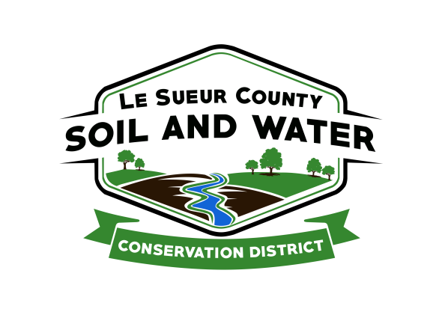

Le Sueur County Soil & Water Conservation District

Le Sueur County SWCD Tel. (507) 357-4879 Ext. 3
181 W Minnesota St Website: www.lesueurswcd.org
Le Center, MN 56057

Minutes from April 10, 2018 board meeting of the Le Sueur County SWCD Board of Supervisors. SWCD building, Le Center, MN.

Meeting was called to order by Chairman Struck at 9:00 a.m.

Members present: Chairman, Jim Struck
Vice-Chairman, Greg Entinger
Secretary, Earle Traxler
Treasurer, Cletus Gregor
PR&I, Glendon Braun

Others present: District Manager, Mike Schultz
District Conservationist, Steve Breaker
District Technician, Joe Jirik
Farm Bill Technician, Jack Bushman
Program Specialist, Sue Prchal
CRWP, Alan Kraus

The Pledge of Allegiance was recited.

Secretary’s report was sent out to the board prior to the meeting. Motion by Traxler, second by Entinger to accept the March 2018 secretary’s report.
Affirmative: All
Opposed: None
Motion carried

Treasurer’s report for March 31, 2018 was read. Motion by Entinger, second by Braun to approve as read and to pay bills.
Affirmative: All
Opposed: None
Motion carried

Motion by Traxler, second by Braun to sign the audit bid form from Peterson Company in the amount of $2475.00 for the FY17 year end audit.
Affirmative: All
Opposed: None
Motion carried

Motion by Gregor, second by Traxler to encumber $37,200 for S&H Farms German/Jefferson cost-share grant J/G-1-18. S&H Farms will be installing terraces.
Affirmative: All
Opposed: None
Motion carried

The board was updated on the status of the new storage building bid. The total bid for the new building is $134,997.00. Motion by Entinger, second by Gregor for Struck to meet with Woelfel Construction and sign the bid.
Affirmative: All
Opposed: None
Motion carried

Trees will be arriving April 26, 2018.

Alan Kraus discussed projects in the Cannon River Watershed, the Kernza study of perennial wheat grass, and a cover crop survey that was sent out. The survey indicated more acres needed in cover crops and cost-share for planting.

Steve gave the NRCS report. He discussed 2018 EQIP applications that he is waiting to see how many were funded, new 2019 cost-share, CRP, the dairy and beef workshops he attended.

Joe Jirik received job approval authority for WASCOB’s.

The board was informed that there will be Farm Bill listening sessions, with US Senator Tina Smith’s staff, Wednesday, April 18 and Thursday, April 19 if they are interested in attending.

There being no further business, meeting adjourned at 10:35 a.m. with a motion by Entinger, second by Traxler.
Affirmative: All
Opposed: None
Motion carried

_______________________ ___________________________________________
Date Secretary

