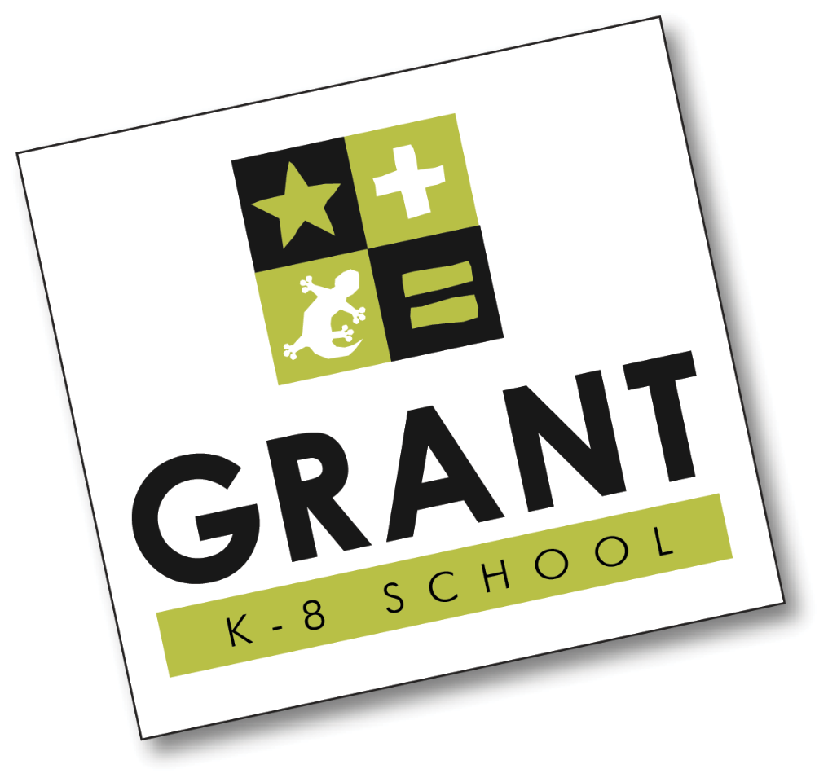
Dear Grant Parents and Friends,

The new school year has just begun and as usual this means back-to-school shopping, homework, bedtime enforcement and of course…. the kick-off to the Grant Foundation’s 2015-2016 Imagine Campaign.

While our kids’ potential to learn is limitless, unfortunately our school district’s budget is not. The San Diego Unified School District’s (SDUSD) projected budget deficit is estimated to be 35 million dollars this year. Our school budget has not been and will not be funded at the level it should be to include the fundamental programs we expect from Grant; such as science, technology, engineering, art, music, and language. Many of us chose to come to Grant because of its strong academic record, its reputation for funding special programs and above all its excellent teachers. Fortunately, students at Grant benefit from an incredibly generous and supportive school community!

We are asking every family to give what they can. An important part of Grant’s Imagine Campaign is the Annual Giving Fund drive. The Annual Giving Fund just completed its third year and raised over $57,000. This money will be used to pay for S.T.E.A.M. focused programs (Science, Technology, Engineering, Art, and Math). Specifically, the Imagine Campaign will fund the science coordinator’s position, contribute to the art program, and will sponsor the Science Olympiad, Science Fair, Science Family Night, and the Gecko Garden. This past year the science coordinator, Elena Banks, helped bring science to almost all of Grant’s students. She has also championed the Gecko Garden; extending its use as a living classroom to growing SDUSD certified produce, which means the garden produce can now be harvested for Grant’s salad bar.

We need you to be part of our success this year. Please consider giving if you are new to Grant or have not participated in our Annual Giving Fund in the past. If you have contributed in the past, please consider increasing your contribution to help maintain the high standards and academic excellence Grant has come to enjoy today. There is no better investment than money spent on your child’s education. It’s simple…..the more money we raise for Grant the more benefits and successes our kids will have.

Please make your child’s education a priority by donating today. We can maximize our ability to fund programs for the well-rounded education of our children. Your donations and involvement are greatly appreciated and are what make Grant the great school that it is. Thank you for being part of the Grant School Community!

That you give is just as important as what you give.
Gifts of every size add up big for our kids!

Your donation is 100% tax deductible. Grant Foundation, a foundation supporting students, is a California non-profit 501©3 Corporation. Tax ID: 33-0572329

** SIMPLIFY YOUR LIFE**

Write one check to participate in our “All-In” Package. Your one time contribution includes participation in each of this year’s major fundraising events and more

Visionary (All-In) Package
With an upfront donation of $1,000 to the Annual Giving Campaign, your family will receive items and credits for the major school events throughout the year. Here is what you will receive for your $1,000 donation:
• Annual Giving Donation that is tax deductible
• Two 2016 Grant Gala tickets - $150 value
• Two Tickets to the Mission Hills Wine Tasting event - $100 value
• Exclusive Grant Logo Wear - $30 value
• Grant Magnet

Or, give at the level of one of the other packages:

Coach Package
With an upfront donation of $500 to the Annual Giving Campaign, your family will receive items and credits for many school events throughout the year. Here is what you will receive for your $500 donation:
• Annual Giving Donation that is tax deductible
• Two Tickets to the Mission Hills Wine Tasting event - $100 value
• Exclusive Grant Logo Wear - $30 value
• Grant Magnet

Mentor Package
With a donation of $250 to the Annual Giving Campaign, your family will receive:
• Annual Giving Donation that is tax deductible
• Exclusive Grant Logo Wear - $30 value
• Grant Magnet

Guide Package
With a donation of $100 to the Annual Giving Campaign, your family will receive:
• Annual Giving Donation that is tax deductible
• Exclusive Grant Logo Wear - $30 value

