Liberation Petanque Club
2013 Open Doubles Tournament

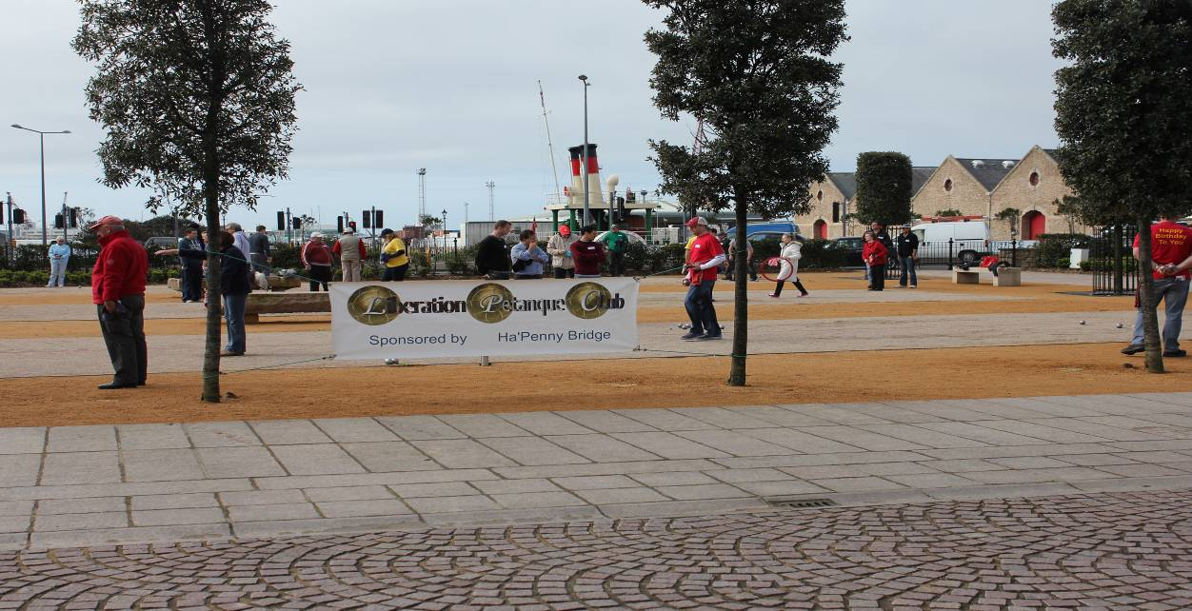

Petanques first major tournament of the year run by the Liberation Petanque Club saw 24 teams made up of many of the Islands best players, was played in the glorious winter sun and drew large crowds throughout the day.

4 of the 6 Groups of teams went down to the wire as 3 out of the 4 teams in each group all finished with 2 wins, meaning points difference decided Group Winners. Group 5 saw a shock as Cup Holders Matt Ryan and David Ibitson lost out on a quarter final place by 1 point after finishing runner up in their group following a defeat to Andrew Bellamy and Matt Pinel in their final group match.

The quarter finals were all very one sided

Keith Boleat & Chris Pinel (Carrefour) lost to Tony Morton & Brian Corbell (Carrefour) 13 - 5
Paul Le Moine & Rosie Boleat (Liberation) lost to Michel Morel & Neil Selby (Carrefour) 13 - 1
Ian Foster & Linda Taylor (Jersey) lost to Chris & Jake Romeril (Liberation) 13 - 3
Keaven Taylor & Rita Le Brocq (Jersey) lost to Andy Bellamy & Matt Pinel (Liberation) 13 - 1

The first semi final saw both Carrefour teams play each other with Tony Morton & Brian Cobell against Michel Morel & Neil Selby and an enthralling match went down to the last end with Neil Selby sealing a 13-12 win with a perfect carreaux.

The second semi final was an all Liberation affair but this very much one way traffic as Andrew Bellamy & Matt Pinel cruised into the final beating Chris & Jake Romeril 13 – 3.

The final was a very much up and down as Liberation pair Andrew & Matt raced into a 7 – 0 lead after just two ends, but very experience pair Michel & Neil turned the tables to lead 11 -7, but that was their last points as world class firing from Matt Pinel and excellent placing from Andrew saw them seal the title 13 – 11 despite never playing together before the competition clearly made a perfect partnership. Third place went to Chris & Jake Romeril.

