U.S. History with Mr. Brown Name _______________________________ Period _____
Beginnings of an American Identity
Picture Search Ch 5
Directions: Use the pictures, maps, charts, graphs, time lines, and info boxes to answer the following questions. Do not look for the answers in the paragraphs of text. (p. 116 – 135)
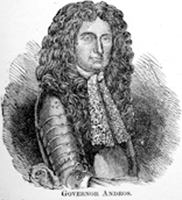
1) Who is pictured arguing against the King on p.116?
2) In what year did Massachusetts colonists over throw royal governor Andros?
3) What year did the French and Indian War begin?
4) The Journal of Madam Knight was reprinted in 1920 but what year was the story originally written?
5) Who was the highest of the high class in the colonial social structure?
6) Who was the lowest in the colonial social ranks
7) What is hanging on the back wall in the one room school house?
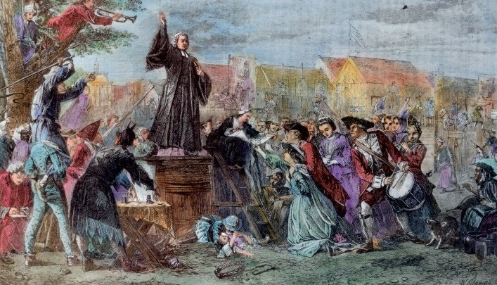
8) What book taught colonial children proper behavior?
9) Who is preaching to a crowd on p.123?
10) What year did Benjamin Franklin die?
11) What did Franklin invent the lightning rod to do?

12) “This is a detail of Increase Matter by Jan van der _______________”
13) The right to a trial by jury was established in the ___________________________.
14) What governor did the Massachusetts colonists hate?
15) Who was directly under the British Crown in the Colonial Government system?
16) Who did John Peter Zenger print and publish libel against?
17) Who painted a famous painting of Charles de Langlade attacking British forces?
18) Who is the French trader on p.131 visiting with?
19) On the French and Indian War map: Who won the battle at Fort Niagra?
20) In what year did the British when Acadia from France?
21) Which European country had the smallest North American land claims in 1754?
22) Which European country claimed Haiti as part of their territory in 1754 and 1763?
23) Which European country lost most of its territory in 1763?
24) What Native American is pictured on p. 135?
