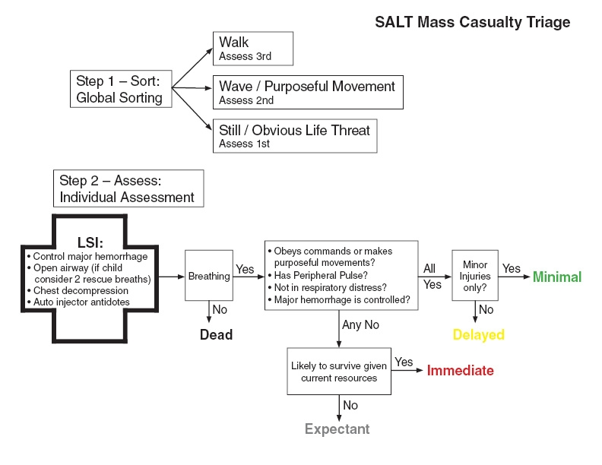

Step 1: Sort
SALT begins with a global sorting of patients, prioritizing them for individual assessment. Patients who can, should be asked walk to a designated area and should be assigned last priority for individual assessment. Those who remain should be asked to wave (i.e., follow a command) or be observed for purposeful movement. Those who do not move (i.e., are still) and those with obvious life threat should be assessed first since they are the most likely to need life saving interventions.

Step 2: Assess
The individual assessment should begin with limited rapid lifesaving interventions (LSI):
- Controlling major hemorrhage through the use of tourniquets or direct pressure provided by other patients or devices
- Opening the airway through positioning or basic airway adjuncts (no advanced airway devices should be used)
  - If the patient is a child, consider giving 2 rescue breaths
      - Chest decompression
      - Auto injector antidotes
LSI should only be performed within the responder’s scope of practice and only if the equipment is immediately available.

Patients should be prioritized for treatment and/or transport by assigning them to one of five categories: Immediate, Expectant, Delayed, Minimal, Dead. Patients who have mild injuries that are self-limited if not treated and can tolerate a delay in care without increasing their risk of mortality should be triaged as minimal and should be designated with the color green. Patients who are not breathing even after life-saving interventions are attempted should be triaged as dead and should be designated with the color black. Patients who do not obey commands, or do not have a peripheral pulse, or are in respiratory distress, or have uncontrolled major hemorrhage should be triaged as immediate and should be designated with the color red. Providers should consider if these patients have injuries that are likely to be incompatible with life given the currently available resources; if they are then the provider should triage these patients as expectant and they should be designated with the color gray. The remaining patients should be triaged as delayed and should be designated with the color yellow.

SALT Triage

STEP 1 – Global Sorting of Patients:

Walk – move pts who can walk away, lowest priority

Wave/Purposeful Movement – pts who can gesture are 2nd priority

Still/Obvious Threat – pts not moving are TOP PRIORITY

STEP 2 – Individual Pt Assessment/Triage:

Life-Saving Interventions (LSI) first:
- Control major bleeding
- Open airway (if child, give 2 rescue breaths)
- Auto-injector antidotes (if nerve gas or pesticides)
- Chest decompression (if indicated)

If NOT breathing after LSI = DEAD

- Obeys commands or making purposeful movement
- Peripheral pulse
- No respiratory distress
- Bleeding controlled

If any checkboxes missing, then IMMEDIATE (red)
If unlikely to survive given current resources, then EXPECTANT (gray)

If all boxes checked, then assess – only minor injuries?
No - DELAYED (yellow)
Yes - MINIMAL (green)

