CANDLE TALK
2015 – May 1th – Volume 2 (Posteed
CONGRATULATIONS
Way to go Charles…as a true Brand Ambassador of JIC, Charles has distinguished himself as someone who works tirelessly for his team within the Inventory Department. His efforts have proven to be instrumental in keeping the area running smoothly and efficiently. Often Charles is found helping new employees navigate their way around while maintaining inventory and supplies to others in the area. He is awarded $25, but more importantly, we want to recognize outstanding actions by our employees. Keep up the good work Charles!
Jeremy Lowe and Charles Gill

SAFETY and QUALITY
- Compliance procedures directly related to safety and quality must be followed. We are a small organization with aspirations of becoming much larger one in the near future. As we take this journey together it is important for all of us at JIC to abide by these procedures. Like it or not, you are the face of JIC as we have several reps, vendors and suppliers walking through at any time.

- No phones out in the open at work station
- Only one ear can be covered while listening to music (no phone calls)
- No undercover texting

OVERTIME
- Week of May 4 – 9, 2015 All departments plan to work overtime each day with the exception of dayshift Production

REMINDER
- We continue to see candles that are ready to be labeled but do not have the jewelry type indicated. Labeler employees will continue to verify, but we need to ensure this process is done in Production – thank you!

- 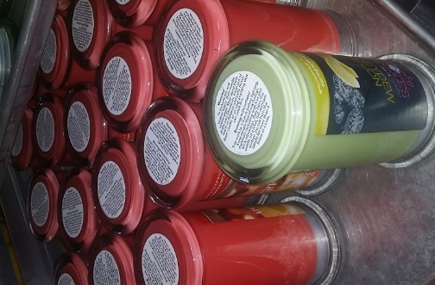

- Reminder: it is okay to have drinks at your work station but food is not allowed. While contemplating this decision I believe eating in itself wouldn’t hinder you from doing your job, however, we are here for the customer from the initial candle/tart making process to them receiving our product. At the end of the day we do not to want to jeopardize our opportunity to make a good impression on every order. That said, no one wants a nice candle or tart with Cheetos or chocolate chip cookies’ fingerprints on them. Thanks for your understanding.

JIC HAPPENINGS
- Production – a new storage container has been obtained for proper placement of old blades
- Days off request – You must put your request in one-week in advance for review, Jacob or myself will advise whether or not your request has been approved.
- Break room – is under construction! We are awaiting to get our information in MSC’s computer system in order to obtain quoting information (their rules), nonetheless, if not completed soon we will go out and find comparable chairs to secure for the break room.
- Reminder, employees are required to wear JIC T-shirts as their work attire. You may purchase additional shirts – see your supervisor, if interested.
- Negative comments in the workplace: This is a great place to work, remember, if you think you have something negative to say about the company or someone I find it to be a good practice to say the first ten words to yourself before speaking out loud. Its’ TEAM JIC – Questions see Darryl
- Error Report – Be mindful when pulling and shipping orders: ladies rings instead of men’s rings; candles instead of tarts, correct amount ordered is not what a customer receives…
- DEDICATED RESTROOMS – Women in Inventory; Men in Shipping
- BLOWOUT SALE NEXT FRIDAY MAY 8th – Priced as marked - $5 get one free (rejects only)

HAPPY DERBY 2015

