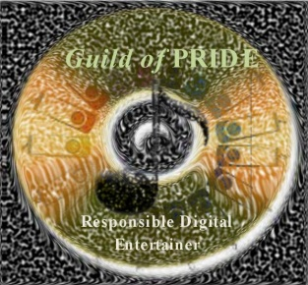
Application for Elite Membership
THE GUILD OF PRIDE
(Professional Recorded Instrumental Digital Entertainers)

Sharon Frank, Executive Director
The Guild of PRIDE
6901 Berkridge Court
Hazelwood, MO 63042
Phone: 1-314-839-0046 Fax: 1-818-705-2513
Website: www.guildofpride.org Email: sharon@guildofpride.org

Please print your name as you would like it to appear as an Elite Member. If all information is the same as in your Application for Membership, please write “Same” after your name.

Name: _____________________________________________Partner:________________________________________________

Mailing address: __________________________________________________________________________________________

City: __________________________________________ State: ____________Zip Code: _________________

Country: _________________________________________Email:___________________________________________

Telephone: (Home) ______________________ (Work) _____________________ (Cell) ________________________

Invitation to join the Guild extended by: ______________________________________________________________

Please sign the following to fulfil The Guild of PRIDE Elite Membership requirements:

By signing below, I attest that I agree with, and wholeheartedly support the mission of The Guild of Pride. This mission is to proclaim, promote, and practice the most ethical and legal methods of acquiring, maintaining, and protecting one's ownership in the use of recorded music for teaching and entertaining.

As an Elite Member, I have completed the process of thoroughly reviewing all the music I use to ensure that every piece has been obtained in a manner which properly and completely compensates the artist(s) and producer(s) responsible for its creation and distribution. I will permanently maintain my music in this standard and will not enable others to copy or use copies of my music while I retain its ownership. I can now attest that all the music I use in teaching and entertaining is “Paid in Full”.

Name: ______________________________________________________________Date: _________________________
Teaching/Entertaining Professional

Copyright owners of the music that I have
available to use when I perform have been

PAID ^{-IN-} FULL

