Lawrence M. Meadows March 29, 2017
MIA/FO/777/MDSB
AA# 332713
PO Box 4344
Park City, UT 84060

Sent via email and certified mail:

Charles Hepp, former Appeal Board (“AB”) Chairman
Allied Pilots Association
O'Connell Building - Suite 500
14600 Trinity Boulevard
Fort Worth, TX 76155

c/o CA Pam Torell, APA Secretary-Treasurer
Allied Pilots Association
O'Connell Building - Suite 500
14600 Trinity Boulevard
Fort Worth, TX 76155

Re: Motion to Strike Accused’s Exhibits in Their Entirety, and
Motion for Default Judgement

Dear Captain Hepp,

The purpose of this Motion Letter is two-fold, to serve the Appeal Board (“AB”) notice of Meadows’ Motion to Strike Accused’s Exhibits, and also his Motion for Default Judgement.

First, I respectfully Move to Strike the Accused’s Exhibits in their entirety, as she should not be allowed to submit ANY exhibits in her defense, as she never properly introduced and entered them into the record, either through testimony of herself or other witnesses. Thus, her exhibits were not properly authenticated. Thereby, depriving me of my right to perform any cross-examination of her exhibits. Under these circumstances, such submission is entirely improper and must not be allowed, not to mention in violation of the standard protocols and the rules of evidence used by administrative tribunals. Thus, it would be grossly unfair and prejudicial to allow her to use her exhibits in support on any argument she attempts to make in her brief; because she refused to appear (despite not being released from her obligation to provide sworn testimony by the AB Chairman), making herself unavailable as the necessary and prime witness to complete her testimony and presentation of her case.

Indeed, in response to her refusal to testify, the AB Chairman admonished CA Torell, stating that her attendance was mandatory and by refusing to appear she usurped the authority of the AB. Such malfeasance should not be rewarded, as she has usurped the authority of the AB, and created an adverse precedent that the future accused members do not have to appear to face their charges; rendering the Article VII machinery an ineffective toothless-tiger - to the associations detriment. Giving rise to yet another round Article VII charges. Accordingly, during the hearing, I had objected on the basis of being prejudiced by the lack of her testimony and submission of evidence as being incomplete.

Second, I also Move for Default Judgement, based on the Accused’s usurping the authority of the AB and BOD, and by refusing to appear as both the Accused and as the Accuser’s primary witness, failing to present her arguments or introduce her evidentiary evidence on the record. Thereby failing to mount any defense whatsoever, nor any dispute to Accuser’s charges; whilst depriving the Accuser of his right to a full and fair hearing (to include direct and cross-examination of Accused and her exhibits) to prosecute his meritorious charges. Additionally, the AB has already sanctioned the Accused, and ruled that Meadows’ argument and exhibits introduced into the record shall be subject to his inferences and given deference by the AB.

In particular, the Accused absolutely failed to present any argument or evidence, to support her representative’s baseless and conclusory opening argument assertions that Meadows was not a member good-standing and thus didn’t have standing to bring these Article VII charges, nor that his filing was untimely as to his 2nd charge (relating to unilaterally excluding G-12-011 from APA’s Proof of Claim. According to the C&B Art. VII. It is undisputed and a matter of record fact and law that Meadows is indeed an APA member in good standing, as supported by, the LMRDA 29 U.S.C. §402, ¶ (o). and Sec. 101(b), prior Art. VII. AB decision in Sproc v. APA, prior AAA Art. VII. arbitral precedent in Annable v. Wissing, and as admitted by former APA president Keith Wilson in his recent AAA Art. VII. sworn testimony. Moreover, the AB, couldn’t have moved this matter to a hearing unless they deemed his charges Cognizable, which means Meadows met the jurisdictional and filing criteria of APA’s C&B Art. VII. B.1, which provides that; “Charges may be brought under this Article by any member in good standing against any other member.”

Therefore, the AB by virtue of not deciding dismissing the charges as not cognizable and escalating them to a formal hearing, has in fact already decided that Meadows is indeed an APA member in good-standing, and also already ruled that it would grant him inferences and give deference to his claims, argument, and exhibits. To be certain the Accused introduced no evidence whatsoever, showing that Meadows is not a member in good standing, nor that his charge(s) are untimely, must less introduce any evidence to dispute his charges. Regardless, Meadows argument and evidence already establish that; 1) CA Torell admitted that MDD’s, like Meadows, were inactive members of APA since she took office in July 2013, 2) that she was aware of her obligations as Secretary-Treasurer under the supreme law of APA’s C&B, 3) but she made a deliberate decision not to comply with her obligations to issue MDD pilots membership cards as otherwise required under the C& Art. III. Sec. 4., 4) and the record shows that despite certified demands made by several disabled MDD pilots she willfully ignored said demands, and refused to issue them membership cards for some 3 ½ years, until the eve of the Emery LMRDA trial.

Disturbingly, CA Torell has already made a deliberate and unlawful decision to abandon these proceedings, and in so doing has waived any further rights to respond to this Letter Motion, much less be allowed to continue defend herself in these proceedings with the assistance of APA’s counsel at the membership expense. Furthermore, these proceedings are to be conducted under rules and AB Policy in place when they were filed in April 2014, just like APA BOD insisted on reusing the old AB on this instant matter. Thus, those rules do not allow for paid union leave for either the Accuser, Accused or their representatives, nor do the old or current rules (Sep. 2016 AB Policy Manual - not yet approved by BOD) allow for the substantive involvement of the Institution, to include, legal advice from either APA’s in-house or general counsel, other than for administrative support (docketing, notices, etc.) of the AB. Therefore, to allow her conflicted Representative to defend and continue to defend her with the assistance of APA’s Counsel all at the memberships expense, is indeed a Major Policy Violation and rises to the level of inter-union corruption, which is absolutely detrimental to the membership; as it violates APA’s supreme law, C&B Art. VII.A., “4. Misappropriating money or property of the Association;” and, “7. Any act contrary to the best interests of the APA as an institution or its membership as a whole.”

As CA Carey mandated in his July 1st, 2016 communique “Challenges Ahead”,

“I have asked them [APA’s Officers]to consider one question I want us to ask in everything we do: Is this good for the members we serve?"

I sayeth not, and must agree with CA Carey motto, “ENOUGH IS ENOUGH!”

In sum, THE ACCUSED IS DONE, GUILTY AS CHARGED WITH NO DEFENSE ON THE RECORD AND PRECLUDED FROM PROCEEDING, and accordingly I respectfully request that the Appeal Board must enter an Order striking her exhibits, and entering a default judgement as to all charges; and impose maximum discipline, including monetary fines for the entire cost of these proceedings as well as Meadows expenditures, and expel her from APA. To do otherwise, allows her to make a mockery of the “supreme law” of the union and its Article VII/Appeal Board machinery, rendering that process a meaningless and ineffective toothless-tiger to the detriment of each and every of our 15,000 members.

Sincerely,
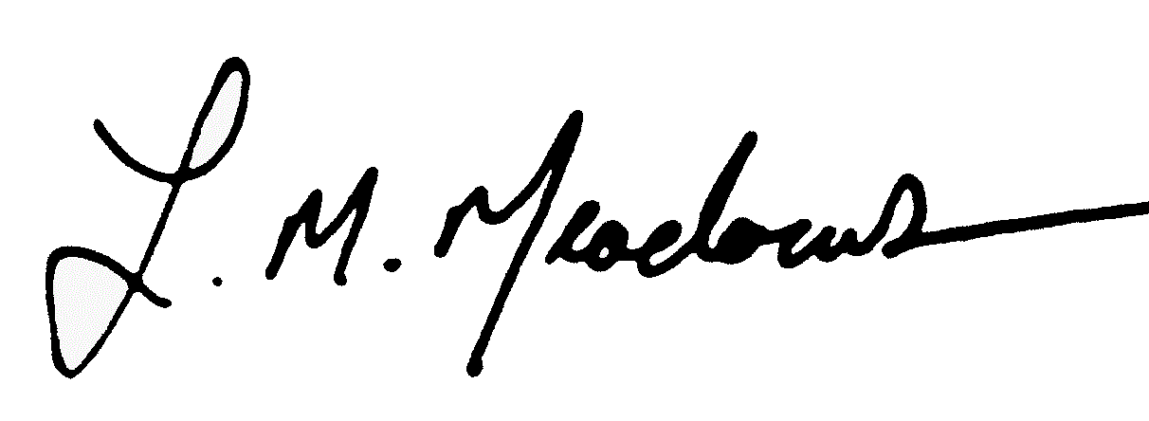
Lawrence M. Meadows
MIA/FO/777/MDSB

cc: CA Sproc, FO Fletcher, FO Heller, CA Carey, CA William Read, CA Ed Sicher

CHAIRMAN HEPP: Pam Torell is the accused in her Article VII hearing, not a volunteer. We believe this compels her to be present…Pam Torell as secretary-treasurer is usurping the authority of this appeal board and the authority given to this board by the APA board of directors… (AB Hrg. Tr., Mar. 2, 2017, pg. 311:5-18).
MR. MEADOWS: But there should have been a cross-examination. I should have had follow-up14 questions. We haven't even gotten to the point where she got crossed and I get to redirect…I know, but in other words, he could have cross-examined her after my line of questioning and I would have an opportunity to redirect. So her testimony's incomplete. (AB Hrg. Tr., Mar. 2, 2017, pg. 313:13-23).
MS. FLETCHER: Our intent is for, you know, based on the statement that Chuck read is that we are here to listen to your case, for you to introduce your exhibits, say whatever you will about them, make any inferences, any statements regarding them and regardless of what Captain Torell may or may not have said. And anything that you say in regard to your exhibits or your case will be given deference by the appeal board. (AB Hrg. Tr., Mar. 2, 2017, pg. 314:13-21)
According to Black’s Law Dictionary; Cognizable means capable of being known or considered. It means capable of being judicially tried or examined before a designated tribunal. A cognizable claim or controversy is one that meets the basic criteria of viability for being tried or adjudicated before a particular tribunal. The term means that the claim or controversy is within the power or jurisdiction of a particular court to adjudicate.
APA must be mindful of why Meadows’ Article VII proceedings are taking place to begin with. During his federal court Utah LMRDA litigation in Meadows v. APA, APA’s former general counsel Steve Hoffman argued that as an APA member, I must first fully exhaust my internal union remedies; thus, at Mr. Hoffman’s behest the Utah Court dismissed Meadows LMRDA claims without prejudice, and ordered that he must first exhaust his internal union remedies before refiling his LMRDA lawsuit. There are two important take aways. First, Mr. Hoffman by representing to a federal judge that Meadows must exhaust internal remedies, implied to a Federal Judge that Meadows absolutely had a right to exercise his internal article VII union remedies, with the implication that that Meadows MUST BE a member in good standing. Otherwise, that is yet another material misrepresentation of fact by Mr. Hoffman on behalf of APA. Second, according to the C&B and prior arbitral precedent in Annable v. Wissing that APA’s internal union Article VII remedies “do not address labor laws of the land” (i.e.; the LMRDA). Thus Mr. Hoffman, has made yet another material misrepresentation of law – there are in fact no internal union remedies for the LMRDA, only for the APA C&B. Bottom line, either Meadows is a member in good standing, OR Steve Hoffman and APA once again committed fraud upon the U.S. District Court of Utah. If certain APA officers and employees continue to in refusing to acknowledge that Meadows is indeed an APA member in good standing (as was otherwise admitted in former Pres. Wilsons’ sworn testimony), then an Independent Rule 60 motion must/will be filed in the UDC. Why does APA even want to go there??? To that end, APA must immediately and decisively resolve this confusion, and formally assert a disabled member “good standing” issue via resolution or Presidential Interpretation, as I asked of last week’s BOD.
CA Torell’s union paid Representative, CA Jeff Thurstin, has already admitted on the record that he is not only representing her, but also the interests of APA Legal, and that he will be drafting her briefing, presumably with the assistance of Mark Meyers APA Legal and/or former APA Gen Counsel Steve Hoffman, all on the memberships dime! The Institution is not and cannot be a party to these proceedings, and it is inappropriate, unethical, and in fact unlawful for them to meddle in the unions Article VII Machinery.

