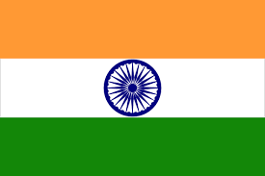
The Anglo-Indian Australasian Association of Victoria Inc. Invites you to celebrate
Anglo Indian Day
Sunday 4th August 2019

Sacred Heart Church Hall
19 Johnson Street, Oakleigh
Gates Open From: 12:00 Noon –Until Finish
12:00 noon Mass Celebrated by Father Ralph Besterwich (in the Hall)
Followed by Smorgasbord Indian Lunch catered by OZ Catering.
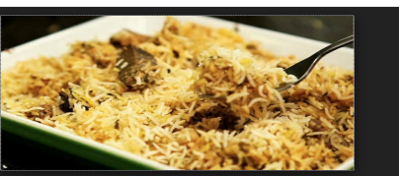
Desserts, Tea and Coffee provided---BYO Drinks
Ticket purchases and enquires: Adults: $20:00, Children: 5-10 years: $10:00, under 5 years Free
Rodney Almeida: 95696034, 0407424365, and 97988483 Audrey Osborne: 95511598
Geraldine Borgonha: 95832945, 0434528265 Eugene Girton: 95510353
Raelene Kelly: 0499539124 and Peter James: 97936041
Please call to book in Advance as there are no ticket sales at the door
Live Music By: Glaxton Saunders, Joe D’Rozario and Everest
This event is proudly sponsored by Multicultural Events and Program 2019-2020
Lucky door prize, Raffle and Bingo

