In This Issue
Pg. 1 Pastor’s Page
Pg. 2 & 3 Coming Up Next
Pg. 4 Bible Studies & Small Groups
Pg. 5, 6 & 7 Keeping You Informed
Pg. 8 Calendar for Dec 2021
Pg. 9 Church Information
CCUMC COMMUNICATES
ISSUE
Dec
2021

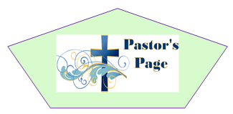
I had intended to write this month’s Pastor’s Corner about Advent and how we approach Advent and Christ in the manger, but in light of Waukesha Wisconsin and now Oxford High School in Michigan I feel it is incumbent to address these acts of evil because that is what they are acts of evil. In Waukesha Daryl Brooks had a choice he could listen to the voices of the world that speak of hate, violence, and division and right to self or he could have listened to the voice of the Son of the one true God which speaks of God’s love for all people. Daryl Brooks chose to listen to the voices of violence and hate and right to self he killed 6 people and injured at least 60 other people.
In Oxford Michigan this last Tuesday at the high school a 15-year-old sophomore took his father’s handgun and shot three fellow students killing them and wounding 7 other students and a teacher. Again, this boy had the same choice as Daryl Brooks to listen to the voices in the world that speak of hate, violence, and the right to self in the world or to listened to the voice of the Son of the one true God which speaks of God’s love for all people. Because this 15-year-old sophomore chose to listen to the voices of the world of violence and hate and right to self he killed three students. One of these students 16-year-old Tate Myre was shot while trying to stop the 15-year-old sophomore from shooting anyone else.
I do not have a simple answer for the question, “Why would God allow this to happen?” But I know how God feels about the shedding of innocent people’s blood, in Genesis 4:10 we read, The Lord said, “What have you done? Listen! Your brother’s blood cries out to me from the ground.” The people in Waukesha and Oxford Michigan were not then nor now been forgotten by God. In Tate Myre’s death I am reminded of Christ’s words in John 15:13, “Greater love has no one than this: to lay down one’s life for one’s friends.” I also know that now more than ever we as disciples of Jesus Christ and witnesses for him that now is not the time to shrink from our responsibilities to share the Hope, Peace, Love and Joy found in Jesus Christ with each other, with our children and our grandchildren and our neighbor’s. We must no longer be silent or hesitant when we are given opportunities to share the hope we have. To continue to fall into the trap of not being offensive by not sharing our faith only gives evil a bigger foot hold as Christ is silenced by the very people who claim to be his disciples. Think about it if we shared with the world John 13:34-35, “A new command I give you: Love one another. As I have loved you, so you must love one another. By this everyone will know that you are my disciples if you love one another.” Or Matthew 7:12 “So in everything, do to others what you would have them do to you, for this sums up the Law and the Prophets.” What a difference we would make in the face of evil.
My fear is that we as disciples have fulfilled Matthew 5:13, “You are the salt of the earth. But if the salt loses its saltiness, how can it be made salty again? It is no longer good for anything, except to be thrown out and trampled underfoot.” Let’s fulfill our responsibilities as disciples and not remain silent any longer, remember Matthew 5:14; “You are the light of the world. A city on a hill cannot be hidden.

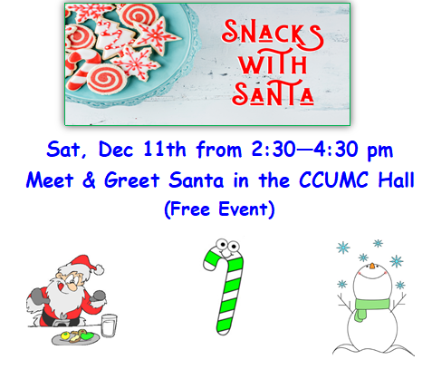
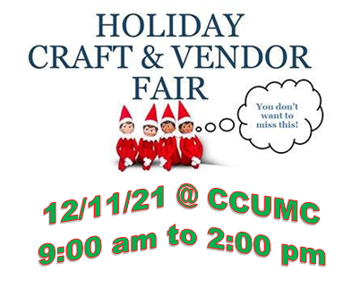
Free Admission.
Vendors include
Acrylic painting, Resin art,
Woodworking, Tupperware,
Pampered Chef, Baked goods,
Scentsy products, Rada Cutlery
cont’d
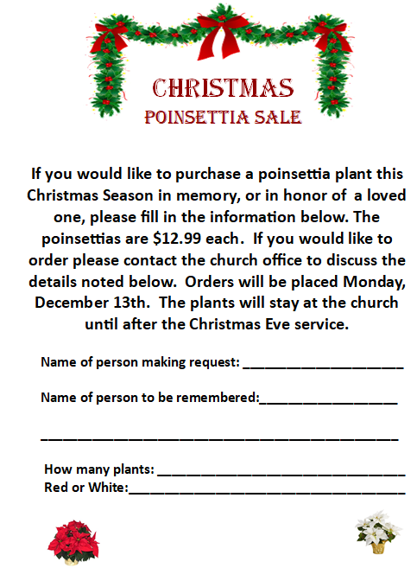
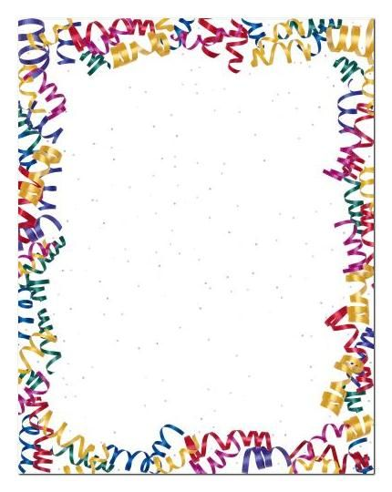
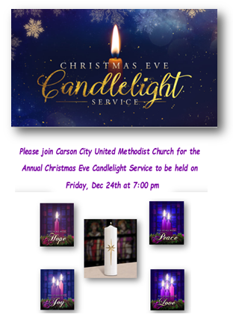
New Year’s Eve Bash
Where: CCUMC
Time: 7 pm to 12 am
Ring in the New Year with a night full of food, games, friends, and laughter.
We will be having 2 separate countdowns. One at 10pm for those with younger kids and the midnight countdown. There will be all kind of fun games for all ages, including a Murder Mystery game. A movie playing in one of the rooms AND a no talent-talent show!!!
Bring a dish to pass (your families favorite New Year’s Eve treat perhaps). A fun act for the no talent-talent show, and you smile!
Can’t wait to see you there!
Lauren Monroe 989-619-1351

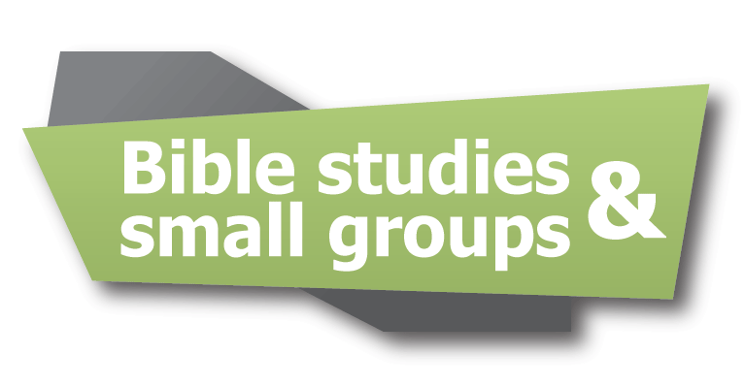
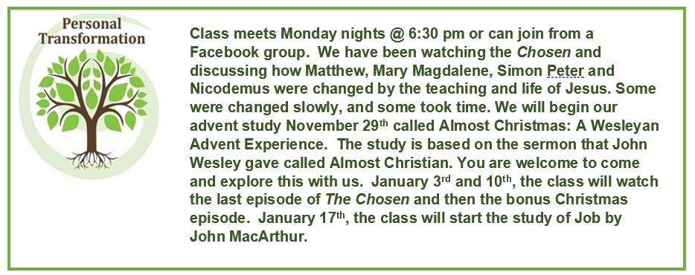
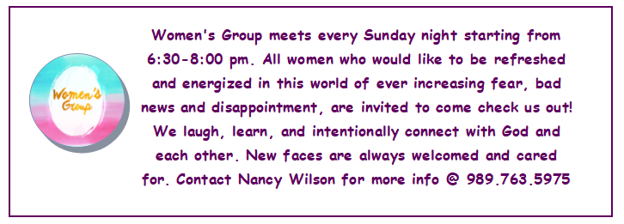

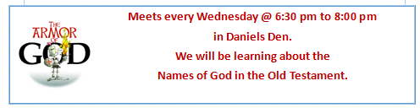

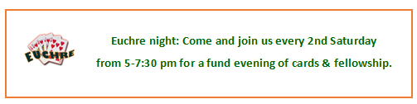

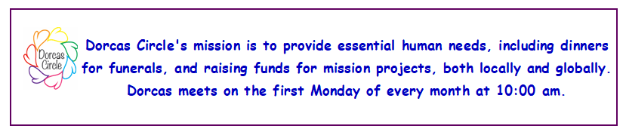

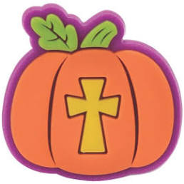
TRUNK N TREAT 2021

First of all, we would like to thank the congregation for their generous
Donation of candy to this year’s Trunk N Treat. We are always asked
Afterwards how things went. This year we saw over 500 children. As
Usual, we all had a blast. We highly encourage you to join us next year.

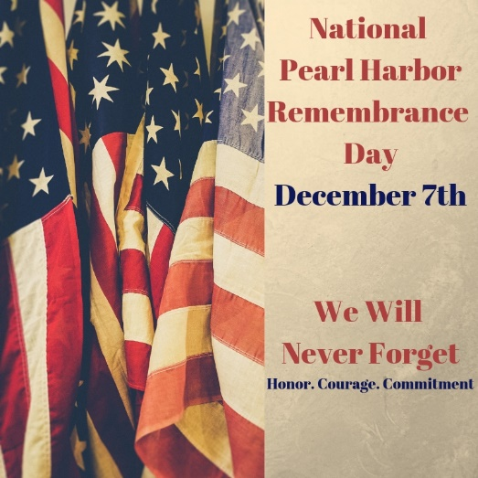

Commission On Aging Meals returns
every Tue & Thu starting with Dec 7th

New Adult Sunday School Class starting
January 2, 2022, I would like to restart the adult class in the Ambassador’s Room at 9:15 am Sunday mornings. The book is called- Living the Five by Jim and Jen Cowart. It is based around 2 key scriptures that are given to us directly from Jesus. We know these core texts as the Great Commandment and the Great Commission. Come explore these teachings. For more information- see Walthagaye

Glasgow COP 26
The meeting of 26 countries about the global warming didn’t accomplish what it had hoped but it was a start. This is the first global roadmap to limit global warming. Real action plans were made.
Substantial commitments were made in the fight against climate change:
*ending deforestation
*no more financing international fossil fuel projects
*ending support for overseas coal projects
*18 countries agreed to phase out coal by 2031
*reducing methane emissions
100 countries agreed to cut methane emissions 30% by 2030
*implementation of the Action for Climate Empowerment which is respecting, promoting and considering their respective obligations on human rights, as well as gender equality and empowerment of women

UMW CORNER

On November 1st, the UMW met at the church to have our World
Thank Offering meeting.
A total of 129.11 was collected and will be sent to fulfill our 5 channels
of giving commitment.
We also collected around 20 bags of material to be given to the Lutheran
Church for their Quilt Ministry project.
New officers were elected for 21-22.
President: Walthagaye Leavitt
Vice President: Paula Wiles
Secretary: Jan Howell
Treasurer: Diane Hoard
We are anxiously awaiting or new stove to be delivered soon.
UMW’s December meeting will be held at the home of Jan Howell
on December 6th at 1100 for a Christmas Potluck.
Dorcas Circle will be at the Holiday/Craft Show on December 11th
from 9-2pm selling Rada Cutlery.
We are again sponsoring Snacks with Santa from 2:30-4:30pm on
December 11th in the CCUMC Hall. Please help spread the word.

11 Facts about Native Peoples in Society and the Church
November is Native American Heritage Month
1.There are over 570 federally recognized tribes, nations, villages, clans and more across the United States with 61 states-recognized tribes. Each nation has its own language, culture, values and history: there is no single culture or language among Indigenous peoples.
2. Indigenous peoples are not “honored” when our cultural image, symbols and faces are stereotyped and used as sports mascots or any other mascots by non-Native people in fact, such mascots are degrading and false representations of who Native peoples are.
3. There is no specific term that is suitable for all. Many tribal peoples prefer to be called by the tribe or tribes they represent. The United Methodist Church has used the term “Native Americans” for many years. Other acceptable terms include American Indians, First Nations, Indigenous, or First Americans.
4. Not all Native/Indigenous persons live on reservations. Across the US, there are 326 reservations; yet less than 30% of all American Indians and Alaska natives live on them.
5. The regalia and dances have sacred and spiritual meaning. The wearing of costumes for Halloween or Thanksgiving is offensive to Native Americans.
6. Native Americans and Alaska Natives serve in the US Armed Forces at 5 times the national average.
7. Native Americans as United Methodist leaders date back to early 19th century.
8. Indigenous persons have made significant contributions to the world’s culture. The constitution of Haudenosaunee Confederacy was used as a model for the Articles of Confederation, later incorporated into the US Constitution. Corn was cultivated by Indigenous peoples over 10,000 years ago who in turn, taught the first European immigrants how to grow the crop. The earliest Indigenous doctors identified plants that provided anesthetics and ointments for the healing of the skin.
9. Indigenous peoples play a vital and important role in the life of the UMC. They represent the smallest racial-ethnic group by denomination at 0.47%.
10. Tipis are not the typical housing for modern US Indigenous peoples. Traditional housing for US Natives has ranged from longhouses in the Northeast and hogans in the Southwest to igloos in Alaska. Today, Tipis are mostly used in ceremonies and cultural gatherings.
11. Indigenous persons are the only racial-ethnic group that must constantly “prove” who they are. To gain US federal government recognition and protection, Native Americans must document their racial identity. Tribal peoples must register with their tribes to show their lineage. Each tribe issues tribal cards and the government issues a Certificate Degree of Indian Blood card to the individuals. The cards are often used by tribal Natives to prove eligibility for government services.

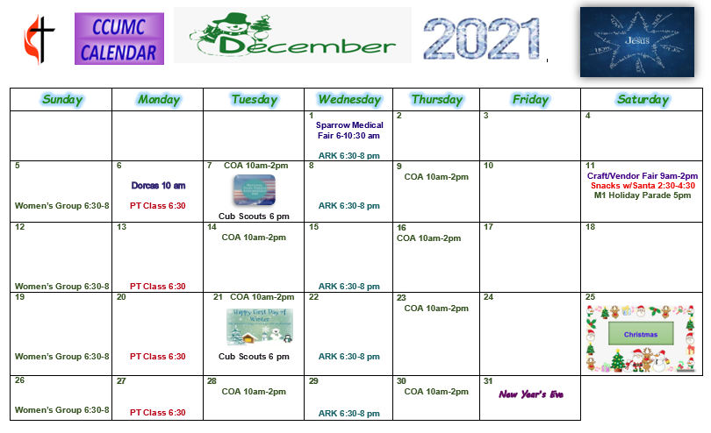

Stay connected! Follow us on:

Join Us Each Sunday

Worship Services 10:30 am

(masks are optional)

Carson City United Methodist Church
Phone: 989-584-3797
Email: carsoncityumc@gmail.com
Website: carsoncityumc.com
Office Hours: Monday to Thursday, 9:00 am-Noon
After hours by appointment
Pastor: Ian McDonald (906) 322-5318
Secretary: Bonnie Seaman (989) 763-1674

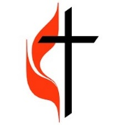
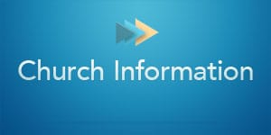

Carson City United Methodist Church
Phone: 989-584-3797
Email: carsoncityumc@gmail.com
Website: carsoncityumc.com
Office Hours: Monday to Thursday, 9:00 am-Noon
After hours by appointment
Pastor: Ian McDonald (906) 322-5318
Secretary: Bonnie Seaman (989) 763-1674

Online giving available: Website: http://www.carsoncityumc.com/donate.html

Weekly Sunday Bulletin now available on our website
at www.carsoncityumc.com

