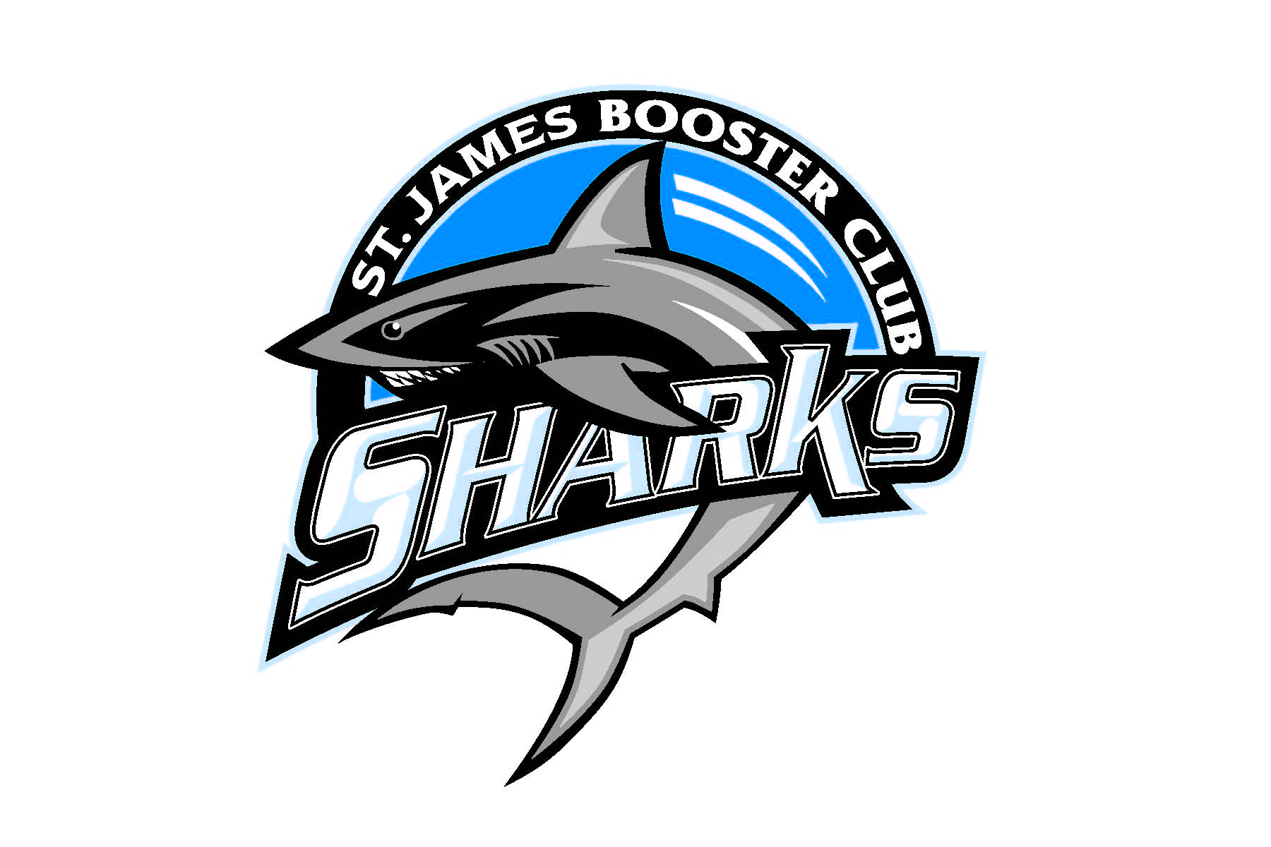
4th Annual Sharks 5k Run
Saturday, December 1, 2018
St. James High School
10800 Hwy 707, Murrells Inlet
Registration Begins 7:30 a.m. - Start time 9:00 a.m.
Name: _____________________________Age_____________Male / Female
Address: _____________________________________________________________
Phone: _______________________________________________________________
Emergency Contact name and phone: ____________________________________
Please make checks payable to: St. James Shark Club: Cost - $25.00 Students $15.00
T-shirt size - circle: S M L XL
Race Day Event: 9:00 am start on St. James High School grounds
Awards for top 3 finishers. Water available at start and finish
Release of Liability: I understand that running/walking in a road race is a potentially hazardous activity. I represent that I am medically able and properly trained to participate in this event. I assume all risks associated with this event including, but not limited to, heat exhaustion, falls, physical contact with other participants, effects of weather, dangerous traffic conditions, etc, all such risks being known and recognized by me. I hereby agree, for myself and my heirs, assigns, personal representative, executors and administrators, to waive, release, and forever discharge the St. James Shark Club and its respective directors, officers and employees, volunteer, and any and all sponsors, suppliers and any other personnel assisting or connected with this event, any rights, claims, or demands therefore which I may have or which I may hereafter accrue to me arising out of injury to my person or my property incurred in connection with participation in the Sharks 5K Run held on December 1, 2018
Signed:___________________________________________ Date:___________________________
*if under 18 please have parent or guardian sign.

