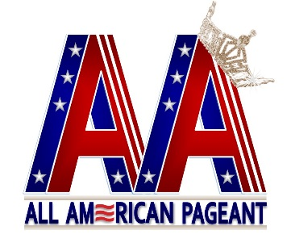
All American Pageant/Mrs. All American Pageant

Stage Sheet
This is for the MC to have something to talk about while you are on stage.

Contestant Name: ___________________________________________________
State Representing: __________________________________________________

One little known fact about you: ________________________________________ __________________________________________________________________

If you win the title, what would you like to do with it? ______________________ ____________________________________________________________________________________________________________________________________

What is your most prized possession? ____________________________________ ____________________________________________________________________________________________________________________________________

Who do you admire most and why? _____________________________________ ____________________________________________________________________________________________________________________________________

Describe yourself in three words:
____________________ ____________________ ____________________

If you could meet someone famous, who would it be? _______________________ ____________________________________________________________________________________________________________________________________

Where do you see yourself in the next five years? __________________________ ____________________________________________________________________________________________________________________________________

What has been your most memorable experience as an All American state titleholder? ________________________________________________________ __________________________________________________________________

