MAGIC Newsletter – Nov 19
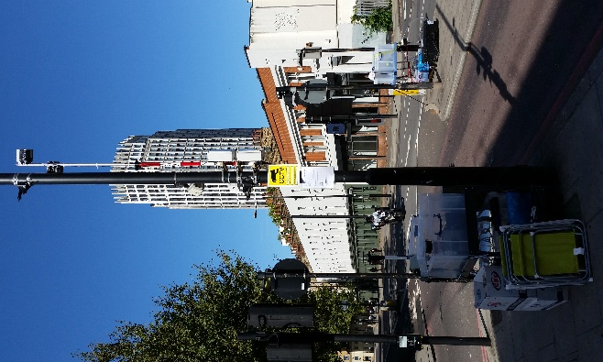
In September this year we ran a 2-week intensive field study at London Road next to London South Bank University (LSBU). Our aim for this study was to collect data for calibration and validation of the different MAGIC models.
Originally, the idea was to replicate the 2017 study which involved various low-cost sensors developed by the MAGIC project. In 2017 these sensors were based along a stretch of London Road just South of St Georges Circus and also inside a room in the LSBU Clarence Centre. This time we decided to also add a camera to obtain traffic information with the hope to be able to determine the effect of traffic on pollution levels.
As the planning of the study progressed, we were lucky to have TfL join us. TfL agreed to change the signal timings at the Garden Row/London Road junction to see whether doubling the cycle time would lead to a decrease in emissions. Furthermore, we were fortunate that Cambustion agreed to participate in the study as well. Cambustion offered to drive through the study area with their EURO 5 test vehicle measuring tailpipe emissions but also the speed and acceleration of the vehicle. This would allow us not only to get a better understanding of the effect of tailpipe emission on our on-road sensors and the ambient environment, but also help to validate the computer vision script extracting vehicle speed and acceleration from video footage.
With these two major additions it became clear very quickly that we would also need high precision and high time resolution sensors to really be able to understand the effects of both Cambustion’s tailpipe emissions and the changes in signal timings. As these high cost sensors are quite power intensive and supposed to be run indoors on mains power, we had to design various bespoke battery systems to power these instruments and find boxes to protect the sensors against rain.
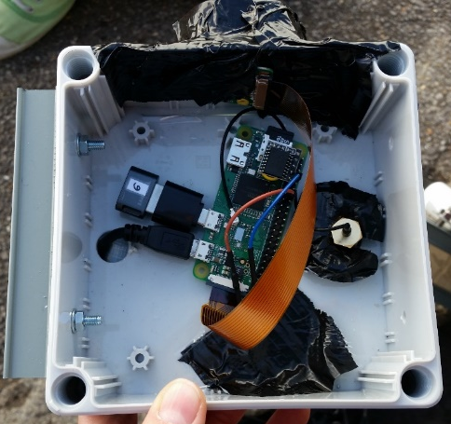
Additionally, we realized that one camera just would not give us sufficient traffic information and we ended up having three cameras on tripods to capture number plates which will allow us to get vehicle information. Furthermore, we had seven cameras attached to lampposts. As normal cameras just do not have the memory space or battery capacity to be run over several days, Raspberry Pi mini-computers with attached camera modules and powered by external power banks were used.
In the end we ended up with 17 low-cost sensors outside, 5 low-cost sensors inside, 3 high-resolution NO/NO2/NOx sensors, one high resolution CO2 sensor, 2 aethalometers to measure black Raspberry Pi Camera
carbon and one partector to measure ultrafine particles. We also
had 3 anemometers to understand wind speed and direction and one weather station on a nearby building (thanks to Reading University). This multitude of sensors really allowed us to get a got understanding of the traffic and pollution conditions along London Road and at the Garden Row / London Road junction.
While we could leave the low-cost sensors and the cameras attached to the lampposts outside overnight, the tripods and high-resolution sensors needed to be stored inside for safe-keeping. We were fortunate that LSBU offered us the use of one of their student labs which was an ideal location to store our equipment.
After two weeks of hard work on the roadside we completed the study successfully and are now hoping to obtain a lot of interesting information from the data.

