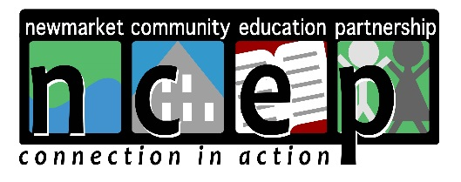

NCEP GRANT APPLICATION
Updated December 14, 2022

NCEP’s Board looks forward to considering your grant application. To ensure proper review, please carefully follow the instructions listed below. Grants that are missing requested information cannot be considered. Please visit www.ncepconnects.org for grant-writing assistance. Thank you in advance for your understanding.

NCEP is currently offering a rolling grant deadline until June 2023. Grants will be considered and voted on by the board of directors as they are received, with prompt funding if approved.

Maximum grant amount: $750

Steps for successful submission:
- Complete grant application. See important note below.
- Email application to ncepconnects@gmail.com
IMPORTANT NOTE ABOUT NEWMARKET SCHOOL DISTRICT GRANTS:
School district grants require preapproval from the building administration. Please speak to your building principal for approval before completing the grant application. If your grant request includes technology or anything that will affect district grounds or facilities, please have your request preapproved by the IT or facilities department before completing the application.

Responsibilities of Grantee and Grantor:
Organizations that receive grant money from NCEP must use the grant funds only for the purposes for which the grant was made. All grantees must provide a final written report at the end of their project; evaluating the project and accounting for how grant funds were used (available on website). NCEP has the authority to withhold and/or recover grant funds in the case funds are, or appear to be, misused. Any unused grant funds shall be returned to NCEP after a two-year period has lapsed.

Questions: Please visit our website www.ncepconnects.org, or email: ncepconnects@gmail.com

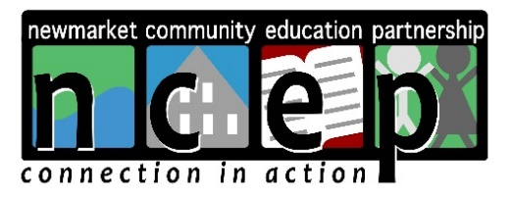
NCEP GRANT APPLICATION
Updated December 14, 2022

NCEP is dedicated to enhancing social, recreational, and educational opportunities
for children and youth in Newmarket, New Hampshire.
Grant Name
Date Submitted

Submitted By

Project Description
Funding Requested
Note: NCEP grant maximum through June 2023 is $750.

Grant Statement

In a few short sentences, tell us about your goals and objectives for this grant.
What Activities Will This Grant Fund?

Who Will Benefit From This Grant?
Include number, ages, and grades as appropriate.

Who Will Oversee The Project (and how funds are spent)?

Please include names and titles.

Project Timeline

NCEP Mission
Detail how this project supports NCEP’s mission (can be found above).
Evaluation
Describe how will this project’s success be measured.

Additional Comments
Please add any additional comments you feel would be helpful to NCEP’s board regarding this grant request.
Budget Details
Detail How Grant Funds Will Be Spent
Include itemized statement/list indicating exactly how the money will be spent. Screenshots from online stores to provide additional information are helpful.
Other Funding
Are you also seeking funding from other sources? If yes, please explain.

Prior Funding

Have you received prior funding from NCEP for a similar project? If yes, please describe amount and include timeframe.
Organization Information
Organization Name

Tax ID

Address | Newmarket, NH 03857
Grant Contact Name(s)

Contact Phone Number

Contact Email

Pre-Authorization  School district grants require preapproval. We will be unable to review/approve grant without proper approval(s). | Please obtain signature and date as required.  Principal:  ___________________________________________  Date: ________________________  IT/Facilities department (if necessary):  ___________________________________________  Date: _________________________

