SPECIAL MEETING
JULY 12, 2021

A Special Meeting of the Town Board of the Town of Hampton, County of Washington and the State of New York was held at the Town Hall, 2629 State Route 22A, Hampton, New York, also via Zoom and live streaming on the You Tube Channel for “Town of Hampton New York” on the 12th day of July 2021.

Due to the Corona Virus, occupancy inside the Town Hall is limited at this time. Supervisor O’Brien did provide a link to join the meeting via Zoom.

PRESENT: David K. O’Brien----------- Supervisor
Donald Sady-----------------Councilman
Tamme Taran----------------Councilwoman
Andrea Sweeney------------Councilwoman
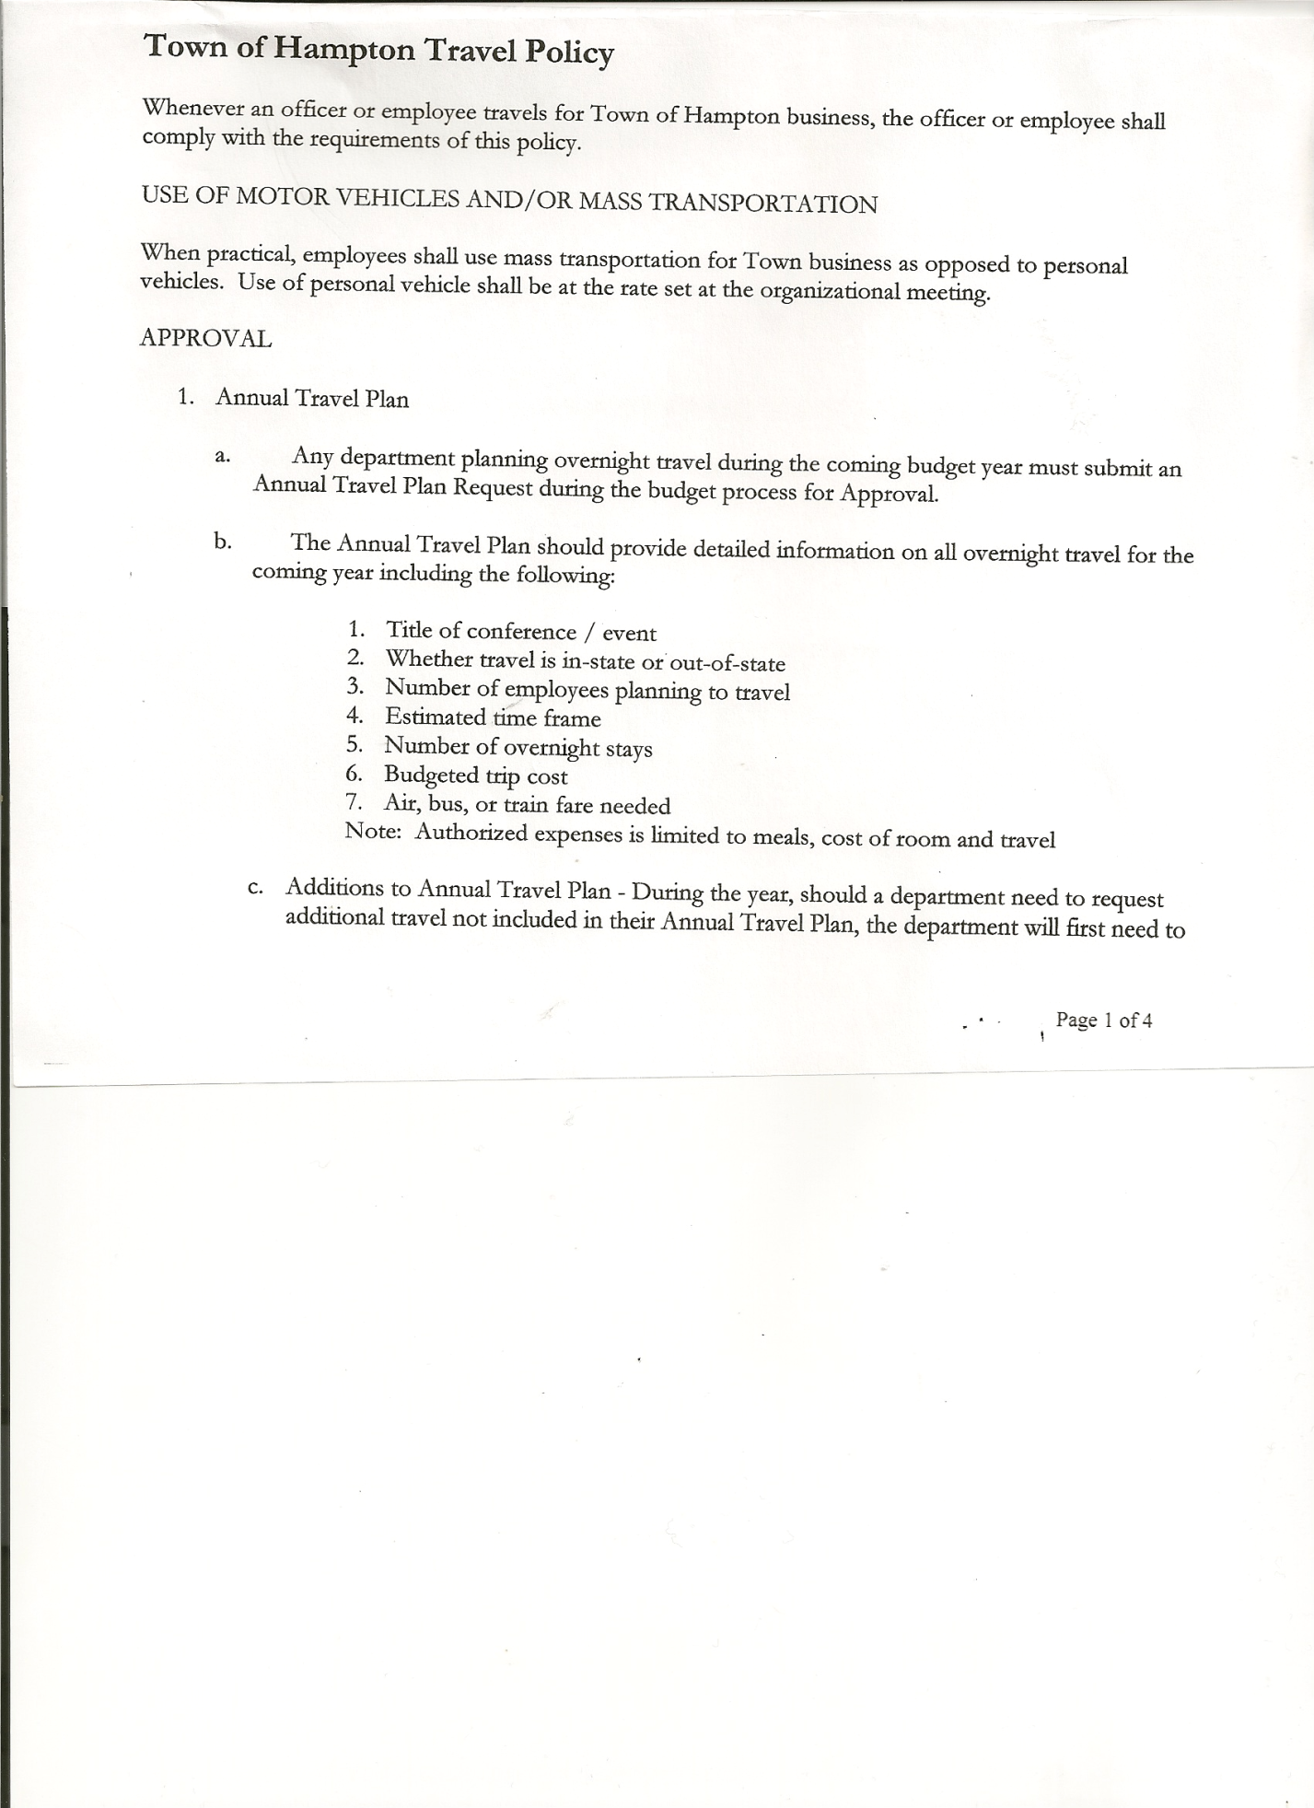
Michael Pietryka------------Councilman
Rebecca Jones---------------Town Clerk-absent
Camilla Shaw----------------Tax Collector/Deputy Town Clerk-absent
Herbert Sady, Jr.------------Highway Superintendent
Tyler McClure-------------- Deputy Highway Superintendent

Planning Board Member(s): .…Bonnie Hawley,Chair. She is also acting as Temporary Secretary
for this meeting
and Matthew Pratt
Others present at the Town Hall: Travis Dean

The Special Meeting was called to order by Supervisor O’Brien at 6:42pm, followed by the Pledge of Allegiance. Location of Fire Exits were given. Quorum of board members present.

HIGHWAY DEPARTMENT

Supervisor O’Brien opened the meeting explaining that the meeting is a discussion of the structure of the Highway Department beginning January 2022 with a new Appointed Highway Superintendent vs an Elected Highway Superintendent. The meeting is about the structure of new personnel in the Highway Department. The roads are deteriorating. This is an issue of safety of the citizens of Hampton. Some people are very concerned about their roads. The Highway Superintendent will be an appointed position in charge of the roads with the Town Board responsible for overseeing the budget. The objective is to provide safe roads for the citizens.

Question by Councilman Pietryka: When do we need to have a new Highway Superintendent hired:
Answer: Supervisor O’Brien – in place by August.

Second Question: How is the Town Board going to communicate with the Highway Superintendent? With one voice? Do we choose one person?
Answer was that this needs to be worked out.

Supervisor O’Brien asked if the Highway Department had any thoughts about what is needed by the Department to structure of the Department.

Tyler then presented many of the issues the Highway Department is facing:

- Need to find a way to get the water off the roads, as this is why they are deteriorating so badly.

TOWN BOARD MEETING
July 12, 2021 PAGE 2

- There is not enough help to get everything done, and not the budget to hire more. Highway Department very shorthanded.
- Towns are trying to work together as all in the same situation.
- Goal for next year is to fix the South Road.
- No pricing on next year’s paving costs.
- As a very small town we don’t get a chance to rent equipment, as we only need it for short term and other towns will rent for months.
- The Town needs to give up mowing the cemeteries, and should contract it out to free up the highway employees to work on roads.
- Tyler will be ditching the roads. As the water is still the biggest problem, as roads erode.
- Chipper is now available after waiting 2 years to rent it. So now doing chipping instead of waiting until late in the year. Can do 300-400 feet of ditching a day. Department could use an excavator for a month.
- Need to do everything on a road completely – ditch, chip and fix road.
- Todd will be back to plow at end of year.
- Do we blacktop this year?
- All Towns are sharing services. Fort Ann can provide trucks. Hampton then might be running 2 ½ weeks to return the favor to them for helping us.
- There is not much prep work for winter. There is more time to prepare for what we need to do. To figure out the time required for each type of job.

Supervisor O’Brien asked about the 5-year plan. Figuring out the budget needed.
- Pricing on paving - $12,000 just for mobilization fee.

Councilman Sady asked “After the culverts are in on South Road, will it need to be paved?”
Right now the shoulder is eroded.
Answer was yes. On Manchester Road and Chapman Road, once they are raised, must pave them.

PLANNING

- Need to get to a point of planning (even a rough plan)
- Is it possible to lease or rent equipment?
- Or any private companies who can do some of the work? Is it possible to contract with someone with equipment such as Joe Williams?
- Maybe work to have Whitehall give us 2 days for Tyler ditching?

MANPOWER

- Always seem to be short one person every year in the Highway Department.
- Jim will not be working for quite awhile due to his motorcycle accident.
- Tyler’s father has helped out. We could haul in some winter sand when we don’t have two people every day.
- We don’t have 2 people to work every day, so it’s hard to schedule work. We’re usually short a person 2-3 months every year.

TOWN BOARD MEETING
July 12, 2021 PAGE 3

Supervisor O’Brien – Forget the budget constraints for now. We’ll plan on what we need for next year’s budgeting. Just need to solve the problems we have now. It’s now more expensive in Washington County to maintain roads. Four (4) years age $150,000 per mile for paving. Now $275,000 per mile.

Herb and Tyler continued discussion of road issues.

Roads are being damaged by more heavy trucks on the road – especially the three companies with garbage trucks weekly, along with log trucks.

Councilman Sady asked what are the responsibilities of the Town and what are the responsibilities of the Appointed Highway Superintendent? What needs to be done to maintain the roads for the safety of the citizens? The Town Board provides the tools for the Highway Department to accomplish this, so goals of well-maintained roads are achieved

Question: How many applicants for the Appointed Highway Superintendent position?
Answer: Only one so far.

RESOLUTION 56-2021
EXECUTIVE SESSION
On a motion of Councilwoman Taran, seconded by Councilman Sady the following resolution was ADOPTED: AYES 5 O’Brien, Sady, Taran, Sweeney, Pietryka
NAYS 0
RESOLVED that, the Town Board enter into Executive Session at 7:30pm to discuss the employment of an individual.

RESOLUTION 57-2021
RETURN TO REGULAR SESSION
On a motion of Councilman Sady, seconded by Councilwoman Sweeney the following resolution was ADOPTED: AYES 5 O’Brien, Sady, Taran, Sweeney, Pietryka
NAYS 0
RESOLVED that, the Town Board return to regular session at 7:50pm

RESOLUTION 58-2021
MEETING ADJOURNED
On a motion of Councilwoman Taran, seconded by Councilman Pietryka the following resolution was ADOPTED: AYES 5 O’Brien, Sady, Taran, Sweeney, Pietryka
NAYS 0
RESOLVED that, the meeting adjourned at 7:52pm

Respectfully submitted,

Bonnie Hawley,
Temporary Secretary

