Plantar Fasciitis
It can be incredibly painful. It is often felt intensely with the morning’s first steps. With any weight bearing activity (think walking) it gets worse. And it can lead to cramping that can make it impossible to walk. It is also something that with some simple activities can be alleviated and also prevented from coming back.
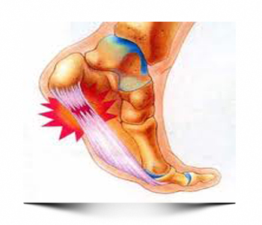
What is ‘it’? ‘It’ is plantar fasciitis.
Plantar fasciitis is a painful inflammation of the bottom of the foot. ‘Plantar’ refers to the bottom surface, while ‘fascia’ refers to connective tissue that covers muscles. When this tissue becomes inflamed it can be incredibly painful when used, and any time one takes a step, this tissue gets used. The plantar fascia travels from the heel all the way to the toes. Every time one takes a step and pushes off the balls of their foot this stretches the plantar fascia, if this is fascia is tight and inflamed this causes significant pain.
There are multiple causes of plantar fasciitis: high arches, flat arches, excessively walking on the inside of one’s foot, wearing improperly fitted shoes, standing or walking on hard surfaces for extended periods of time, and having tight calf muscles/Achilles tendons. All of these causes put extra wear and tear on the plantar fascia by either not supporting it properly or putting extra stress on it.
While one can’t really fix the arches of one foot (although in significant cases the foot can be surgically broken and a new arch formed), there are multiple ways to help with arch pain that don’t require a trip to the doctor. Wear properly fitted shoes that support the arch of the foot. Be careful to walk without rolling your foot in on your instep as this puts undue stress on the plantar fascia. Stretch the calf muscles/Achilles tendon as these attach to the heel end of the plantar fascia. Stretch the plantar surface of the foot; do this by using one hand on either side of the toes and push the toes towards your shin. If the area is really inflamed, get a cold soda can and roll it under the arch, this will reduce some of the inflammation. Once the inflammation has reduced roll a tennis ball under the arch of foot in all directions. This will break up some of the inflammation and stretch out the fascia. Do this for 1 min, 3 times a day. If you can do this without discomfort trying doing the same thing with a golf ball (NOTE: the hardness and dimples of a golf ball can make this really intense, YOU MUST BE ABLE TO DO USE A TENNIS BALL WITHOUT DISCOMFORT FIRST.)
While severe cases of plantar fasciitis can be resolved by contacting your local podiatrist, it is much easier to resolve a case of plantar fasciitis that although painful, is initially only a small problem. Remember, if you’re suffering from pain in the arch of the foot, before it gets too bad try to do some simple things first.
Feel Free To Forward This Information To A Friend!
Justin Welch, D.C.
627 College Hwy
Southwick, MA 01077
(413) 998-3482
This information is solely advisory, and should not be substituted for medical or chiropractic advice. Any and all health care concerns, decisions, and actions must be done through the advice and counsel of a health care professional who is familiar with your updated medical history.

