This is not a ladder for climbing the scaffolds.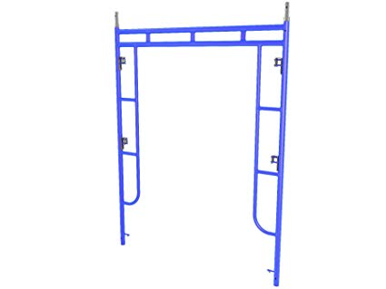

I will use the attached ladders as instructed

Signed:_______________________________________________

Date:______________________