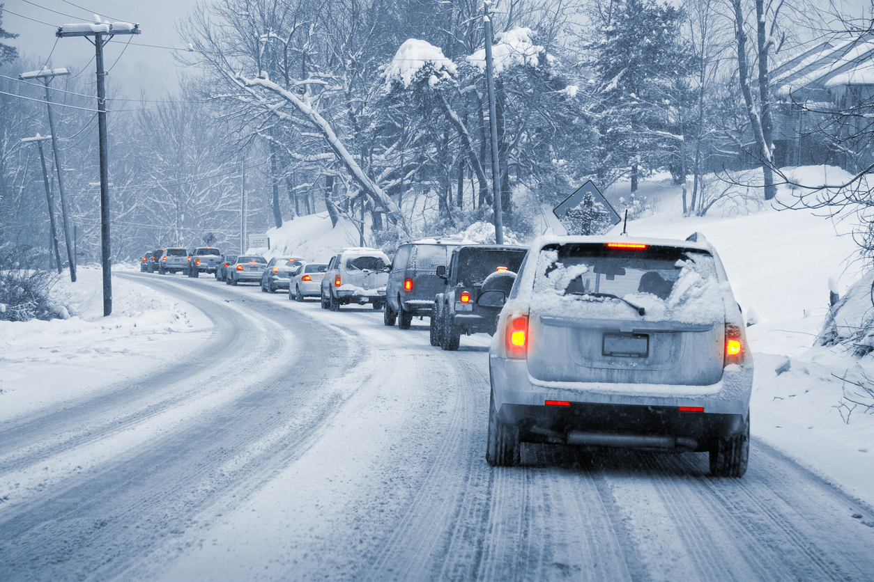
This Photo by Unknown Author is licensed under CC BY-NC-ND

Day 12: Be Patient
In Renewal, Eknath Easwaran writes about patience as a virtue:
“Patience is one of the most valuable allies in the difficult journey of self-transformation… When you are able to be patient with others, you can be patient with yourself, and that will give you all the inner support you need to persevere… But patience can’t be acquired overnight. It’s just like building up a muscle. Every day you need to work on it, to push its limits. When people tell me they don’t have patience, I always say, “That’s only because you’ve never pushed it.”
Winter gives us ample opportunities to build up our patience muscle and to push its limits. Be careful and vigilant for all the obstacles thrown into our path by bad weather, breakdowns, stressed people, and other potential patience builders. When you are out shopping, be patient with other walkers where there is a narrow path, and you must let others go before you. Be patient with traffic jams caused by accidents, icy roads, and dense snow. Be patient with breakdowns in your home, plowing services which dump snow where it wasn’t meant to go, and weather reports which are misleading and/or confusing.

