WEEK 5
BIBLE PROJECT
Genesis 3

DISINTEGRATION
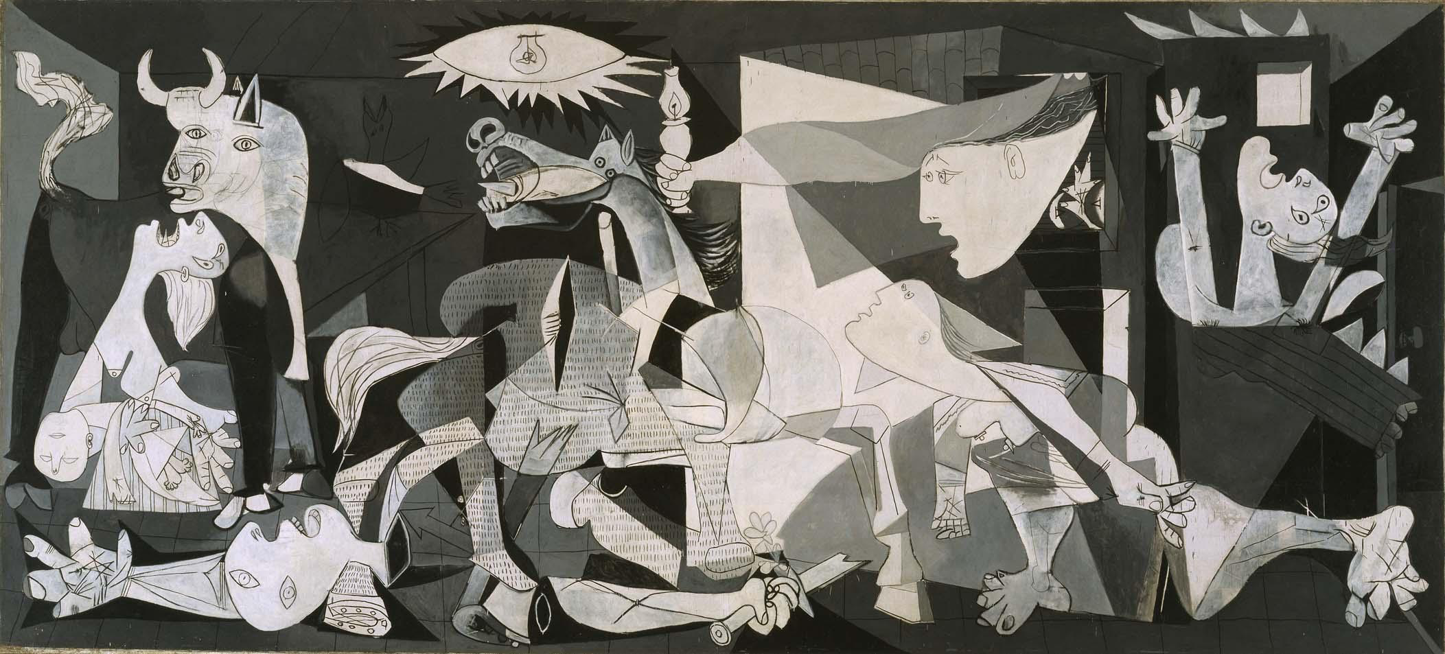
DISINTEGRATION

OVERVIEW:

REVIEW
Week 1 – “Getting It” – how to think about the Bible – what contributes to understanding/ interpretation. Thinking Hebrew, rather than Greek enable us to overcome many of the stumbling blocks that rationalist thinking put in the way of accepting its truth. To comprehend anyone or anything requires learning the frame of reference.
Week 2 – Genesis 1. The Hymn of Creation is meant to glorify the Creator and call attention to the goodness of creation and its distinction from the creator. We contrasted Genesis 1 with contemporary mythology. But we avoided making Genesis 1 into an eyewitness narrative, as in prose history or even less, scientific description. We did so on the strict observance of the composition’s internal stylistic and content cues.
Week 3 – Genesis 1 continued. We tried to compare and contrast the basic philosophical approaches to the subject of origins. Materialism and Immanentism share a similar heritage in that both see the world as an essential unity. The biblical view is that God is outside of nature – transcendent.
Week 4 – Questions arose about the differences between chapters 1 and 2. Our approach will be that the Bible is one whole, as Judaism and Christianity accept the whole, not the sources, for which there is no textual or archeological evidence. Therefore, Genesis 1 and 2 complement each other; they do not compete or correct. We discussed the concept of the image of God and introduced Chapter 2’s main themes. The discussion of literary forms was postponed.

Materialism is the view that the world is entirely and eternally material/energy, governed by the “laws” of physical nature. This is also called naturalism and evolutionary materialism.
Immanentism is the view that the world is entirely spiritual of which that which seems material is largely, if not entirely, illusion. God is the world. Self-generated. Most polytheisms have this in common in that the gods are only manifestations of nature.
Transcendentism – is the view that God / gods stand apart from the world and at a certain time create matter and spirit in a temporal sense. History has a beginning.
Dualism may be either a form of immanent philosophy or transcendent philosophy, depending on whether the world soul is from two sources or whether there are co- creators -- good and bad. Or it may try to combine both materialism and immanentism – Matter bad, spirit good.

Consideration of the literary devices used in Scripture OR more ways to “Get It”
See handout on Literature Forms

- Narrative—Luke 2: 1-7

- ____________________________________________—Genesis 12:1

The Lord had said to Abram, “Go from your country, your people and your father’s household to the land I will show you.
- ____________________________________________—Judges 9:8-15

One day the trees went out to anoint a king for themselves. They said to the olive tree, ‘Be our king.’
“But the olive tree answered, ‘Should I give up my oil, by which both gods and humans are honored, to hold sway over the trees?’
10 “Next, the trees said to the fig tree, ‘Come and be our king.’
11 “But the fig tree replied, ‘Should I give up my fruit, so good and sweet, to hold sway over the trees?’
12 “Then the trees said to the vine, ‘Come and be our king.’
13 “But the vine answered, ‘Should I give up my wine, which cheers both gods and humans, to hold sway over the trees?’
14 “Finally all the trees said to the thornbush, ‘Come and be our king.’
15 “The thornbush said to the trees, ‘If you really want to anoint me king over you, come and take refuge in my shade; but if not, then let fire come out of the thornbush and consume the cedars of Lebanon!’
- ____________________________________________—Exodus 3:8

So I have come down to rescue them from the hand of the Egyptians and to bring them up out of that land into a good and spacious land, a land flowing with milk and honey...
- ____________________________________________—2 Samuel 12:1-4

“There were two men in a certain town, one rich and the other poor. 2 The rich man had a very large number of sheep and cattle, 3 but the poor man had nothing except one little ewe lamb he had bought. He raised it, and it grew up with him and his children. It shared his food, drank from his cup and even slept in his arms. It was like a daughter to him.
“Now a traveler came to the rich man, but the rich man refrained from taking one of his own sheep or cattle to prepare a meal for the traveler who had come to him. Instead, he took the ewe lamb that belonged to the poor man and prepared it for the one who had come to him.”

- ____________________________________________—Psalm 98:8

Let the rivers clap their hands, let the mountains sing together for joy

- ____________________________________________ --Ecclesiastes 12:1-7

Remember your Creator
in the days of your youth,
before the days of trouble come
and the years approach when you will say,
“I find no pleasure in them”—
2
before the sun and the light
and the moon and the stars grow dark,
and the clouds return after the rain;
3
when the keepers of the house tremble,
and the strong men stoop,
when the grinders cease because they are few,
and those looking through the windows grow dim;
4
when the doors to the street are closed
and the sound of grinding fades;
when people rise up at the sound of birds,
but all their songs grow faint;
5
when people are afraid of heights
and of dangers in the streets;
when the almond tree blossoms
and the grasshopper drags itself along
and desire no longer is stirred.
Then people go to their eternal home
and mourners go about the streets.
6
Remember him—before the silver cord is severed,
and the golden bowl is broken;
before the pitcher is shattered at the spring,
and the wheel broken at the well,
7 and the dust returns to the ground it came from,
and the spirit returns to God who gave it.
God made everything in SYMPHONY and made THE CONCERT contingent on human obedience.

AND God made humans able to obey so that the symphony of creation would continue.

BIG IDEAS GENESIS 3: DISINTEGRATION—GOD HAS A PROBLEM

ANALYSIS OF GENESIS 2-3—“chiasm”

 | Genesis | form | content
A | 2:5-17 | Narrative | God the sole actor, man present, passive
B | 2: 18-25 | Narrative | God, main actor, man minor role, woman and animals passive
C | 3: 1-5 | Dialogue | Serpent and woman
D | 3:6-8 | Narrative | Man and woman eat
C | 3: 9-13 | Dialogue | God, man and woman
B | 3:14-21 | Narrative | God main actor, man minor role, woman and snake passive
A | 3:22-24 | Narrative | God sole actor, man passive

So what’s wrong with a talking snake?

Now the serpent … Who changed conductors?

Does the serpent give commands? Did the serpent present credentials? As in the reasons he has any authority to re-write the score?

God’s on trial: Did God really say? How could God say a thing like that? Serpent is prosecutor.
Clever distortion: ‘You must not eat from any tree in the garden’?”
What is a most common clever distortion today designed to gain credibility?

Eve defends God: “We may eat fruit from the trees in the garden, 3 but God did say, ‘You must not eat fruit from the tree that is in the middle of the garden, and you must not touch it, or you will die.’” Why does Eve exaggerate? Is Eve a match for the serpent? She’s been talking with God, now talks with a serpent? Why would she do that?

Serpent overrules God: “You will not certainly die.” Does God lie? Why would the serpent be more credible than God? On what basis does he proclaim his “truth”? How can you tell the difference between truth and a lie? A lie told with sufficient boldness, frequency and volume becomes believable. The serpent’s way.

The base appeal: “For God knows that when you eat from it your eyes will be opened, and you will be like God, knowing good and evil.” What is the attack on God’s character? What’s the attraction of the forbidden fruit? The race was already made “like” God – his very image. How can that be improved upon? What’s being offered? Omniscience? Self-determination? What does “knowing good and evil” mean? What is the desirability of knowing evil?

Rationalization: So when the woman saw that the tree was good for food, and that it was a delight to the eyes, and that the tree was to be desired to make one wise, she took of its fruit and ate, and she also gave some to her husband who was with her, and he ate.

List the “reasons” Eve and Adam give themselves for obeying the serpent. What do they omit to mention? Note: They are in this together. What does the Tree of the knowledge of good and evil stand for? Human finitude. Adam and Eve reject their limits and seek to be “like God.” We have a word for that _______________ .

“Both Adam and Jesus were tempted by the chance to play God. Whereas Adam stepped over a line and found humanity a curse, Jesus stayed behind the line and made humanity a blessing. One tried to be God, one was content to be a human being. The irony is that the one who tried to be God did not do too well as a human being, while the one who was content to be human became known as the Son of God.” Actually, LORD OF ALL.

Someone once said, “It was not the apple in the tree, but the pair on the ground that caused the FALL.”

Consequences: Then the eyes of both were opened, and they knew that they were naked. And they sewed fig leaves together and made themselves loincloths.
8 And they heard the sound of the Lord God walking in the garden in the cool of the day, and the man and his wife hid themselves from the presence of the Lord God among the trees of the garden. 9 But the Lord God called to the man and said to him, “Where are you?” 10 And he said, “I heard the sound of you in the garden, and I was afraid, because I was naked, and I hid myself.”

Eyes wide open? What did they see? That their state was now shameful: Naked and afraid.
- Guilt.
- Cover-up. Fig leaves, really.
- Hiding.
- Estrangement/hostility

GOD’S PROJECT collapses in every way:
Remember: God’s PROJECT IS To create a world where His will is done and all creatures therefore live in blessedness/paradise and in fellowship with their Creator.

Creation is mutilated, used against itself—talk to serpent? At the very least, this is a real come-down. They’ve been talking with Creator; now they are talking to a creature who slinks around. And death enters creation.

Terror breaks out. Adam and Eve fear God, rightly, and hide.

Humanity loses self-connection as community—Adam opposes Eve and the rest of creation.

Individuals are lost—no longer capable of integrity. Adam and Eve are ashamed, guilty, fig-leafed and even blame God.

WHOSE fault is a world in a state of disintegration?

WEEK 6

Assignment for week 6—TAKE A WEEK TO CATCH UP. This is the same assignment as last week. Quiz next week. Happy July!

Be prepared to raise questions on what you have heard/read so far.

Read: Genesis 12-31: AND GENESIS 32-50. SO we will finish reading Genesis.

**** Prepare for a quiz on MARKERS and BIG IDEAS: Weeks 2-5
Markers quiz: I will ask for example What chapter has the start of the Joseph saga? And you will fill in the blank: Genesis 37

What literary forms do you perceive in Genesis 1-3?

The Tree of Life and the Tree of the knowledge of good and evil—how do you understand those images?

Genesis 2 presents what kind of outlook on the human species?

What commands do you find in Genesis 2?

MARKERS:

Genesis 24: Isaac chooses Rebekah—contrast with Esau’s choice of wife
Genesis 25: Roots of rivalry with Edom
Genesis 30: Origin of “12” tribes of Israel
Genesis 34: Ugliness among Jacob’s family
Genesis 37: Start of Joseph saga
Genesis 47: Goshen a land apart from the Egyptians
Genesis 50: God’s providence wins over intended evil

