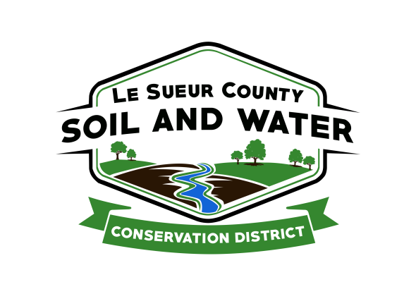

Le Sueur County Soil & Water Conservation District

Le Sueur County SWCD Tel. (507) 419-0365
181 W Minnesota St Website: www.lesueurswcd.org
Le Center, MN 56057

Minutes from May 10, 2022 regular meeting of the Le Sueur County SWCD Board of Supervisors. Le Sueur County SWCD Building, Le Center, MN.

Meeting was called to order by Chairman Struck at 9:00 am.
Members present: Chairman, Jim Struck
Secretary, Earle Traxler
Treasurer, Cletus Gregor
PR&I, Glendon Braun

Members absent: Vice-Chairman, Greg Entinger

Others present: District Manager, Mike Schultz
District Technician, Joe Jirik
Ditch Specialist, Nik Kadel
Le Sueur County Commissioner, Steve Rohlfing
District Conservationist, Steve Breaker
Program Specialist, Sue Prchal

The Pledge of Allegiance was recited.

Secretary’s report from April 12, 2022 was read and approved.

Treasurer’s report for April 2022 was read. Motion by Traxler, second by Braun to approve as read and to pay bills.
Affirmative: All
Opposed: None
Motion carried

The filing period for SWCD supervisors begins May 17, 2022 and ends May 31, 2022. Entinger and Traxler are up for election this fall.

Schultz updated the board on the Cannon 1W1P and the Lower East MN 1W1P. Cannon is trying to get projects going. Lower East last met at the Le Sueur Co. SWCD and interviewed for a consultant, there was 1 applicant, ISG accepted the position. July there will be a kick off meeting and by laws need to be approved.

MASWCD will be conducting leadership training. Schultz would like to attend the 7 sessions that will begin in August 2022.

Schultz and Prchal will be attending administrative training in Brainerd June 28-30, 2022.

Motion by Traxler, second by Braun to approve payment to Jim Struck in the amount of $4000.00 for cost-share contract #Wash-4 for sediment basins. $3000.00 Lake Washington CWF; $1000.00 Lake Washington Match
Affirmative: Traxler, Gregor, Braun
Abstained: Struck
Opposed: None
Motion carried

Motion by Gregor, second by Traxler to approve payment to Jim Struck in the amount of $3887.00 for cost-share contract #Wash-5 for sediment basins. $2915.25 Lake Washington CWF; $971.75 Lake Washington Match
Affirmative: Traxler, Gregor, Braun
Abstained: Struck
Opposed: None
Motion carried

The SWCD sold approximately 6975 trees and shrubs this year.

Kadel updated the board on the county ditches. He discussed beavers and a possible bounty, ditch spraying and buffer inspections.

The outstanding conservationist tour will be held in July this year.

Steve gave an NRCS report. He talked about EQIP and CRP contracts and construction projects.

Commissioner Rohlfing discussed courthouse remodeling projects, ordinance changes, broadband, blight issues and the Lake Washington County Park.

Vouchers were reviewed and filled out.

There being no further business, meeting adjourned at 10:05 with the local work group meeting following this meeting.

_____________________ _____________________________________________
Date District Secretary

