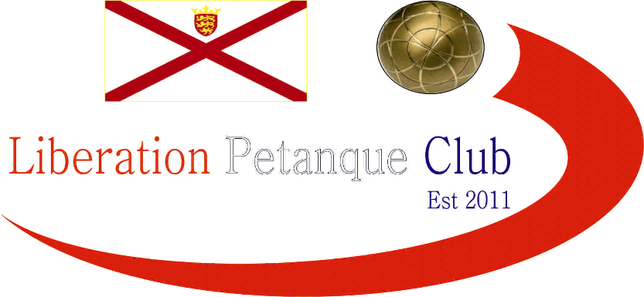

**14th May 2014**

**Liberation Cup**

24 teams played in this year’s competition with 6 groups of 4 teams each playing 3 matches, due to time constraints playing to just 11 points.

Group 1 featured one of last year’s winners, Jake Romeril who this year played with Stefan Riccio, but there was no changed as they won all 3 matches to win the group. Group 2 was the closet group with 3 teams finishing with 2 wins, but if was Matt Ryan & David Ibitson with +10 topped the group after recovering from losing their first match to Joey and Jonny +6 and Pat & Teresa -3.

Group 3 surprisingly turned out to be an easy run for Andrew & Toby as they won 11-1, 11-3 and 11-2 - +27 with Brian & David 2 wins -3.

Group 4 saw Colin & Steve win all 3 matches + 14 with Brigitte & Alice 2 wins +6 although Rod & Mary pushed they both all the way.

Group 5 was a tough group, but Callum & Andrew came back against Nathan & Matt from 2-0 nil down to win 11-2 and against Brendan & Jamie were 6-0 down to win 11-6 these are what’s known as a technical fanny. Callum & Andrew also came back from 6-0 down against Carol & William.

Group 6 saw a tie at the top with Keith & Sue and Ross & Antony both with 2 wins +9 but as Keith & Sue beat Ross & Antony they topped the group.

Ross & Antony were the best runners up but 2nd best runner up spot was a three way tie between Alice & Brigitte, Joey & Jonny and Alan & Craig all with 2 wins + 6, this mean’t a 3 way play off playing 3 ends, with Alan & Craig taking the last quarter final spot having beaten both teams.

Jake & Stefan continued their good form overcoming experienced duo Colin & Steve and yet again Callum & Andrew came from behind 10 – 5 to beat Andrew & Toby 11-10. Ross & Antony surprisingly played Keith & Sue but this time they beat them and convincingly 11-2.

Alan & Craig kept they play off form going as they beat Matt & David who must have gone cold waiting for their match.

Ross & Antony were looking to get to the final for the second year running as was Jake but this time they all missed out as Jake & Stefan lost from 10-4 up against the comeback kings Callum & Andrew 11-10 and Alan & Craig won 11-8.

Ross & Antony took 3rd place beating Jake & Stefan 13-6 under the street lights and for once in the Final Callum & Andrew could not come back to win a match, but that’s because they lead all the way winning 13-4 playing their best boules of the day as the final finished at 10.45pm (no that is not a typing error!).

**Winners**

**Callum Stewart & Andrew Bellamy**

Runners Up

Alan Oliveira & Craig Kelly

**3rd Place**

**Ross Payne & Antony Di Santo**

**Good luck to all those playing in the Island Doubles at Carrefour on Saturday**

|  |  |
| --- | --- |
| http://nebula.wsimg.com/581c5785b63ee3a672a15bb793008009?AccessKeyId=521D75783279793C7EE2&disposition=0&alloworigin=1 | http://www.inapub.co.uk/DisplayPhoto.aspx?width=290&height=290&photoid=3615 |

[www.**elementsmediajersey**.co.uk](http://www.elementsmedia.co.uk/)

Kind Regards

Toby Northern

Chairman

Liberation Petanque Club