3/26/2018 Comet Hale-Bopp and the Two Jerusalem Decrees, etc.

Our Creator Elohim said that signs have been placed in the earth and in the heavens for our benefit in the latter days. These great signs attest to the naturally supernatural abilities of our heavenly Father to structure His creation and order the affairs of nations to witness to His very existence. He's the living Elohim of Israel. He's alive, and He wants each of us to be His personal friend.

Luke 21:11 And great earthquakes shall be in divers places, and famines, and pestilences; and fearful sights and great signs shall there be from heaven.

Daniel in Ancient Babylon

The prophet Daniel was an appointed government official in ancient Babylon. He was the chief of the government's council of wise men, astrologers, and magicians.

Daniel and other inhabitants of Jerusalem had been deported to Babylon as part of YaHuWaH Elohim's judgment on the Jewish peoples for their disregarding of His instructions (Torah). After many years, Daniel became concerned about his Jewish people eventually returning to Jerusalem.

Daniel found by reading the prophet Jeremiah that a 70 years dispersal period in ancient Babylon had been alloted to the inhabitants of Jerusalem by YaHuWaH Elohim. The 70 inclusive years period began in 606 BC and would eventually end in 537 BC.

Daniel 9:1 In the first year of Darius the son of Ahasuerus, of the seed of the Medes, which was made king over the realm of the Chaldeans;
2 In the first year of his reign I Daniel understood by books the number of the years, whereof the word of YaHuWaH came to Jeremiah the prophet, that He would accomplish seventy years in the desolations of Jerusalem.

Here's a 70 years Babylonian captivity information link: http://www.johnpratt.com/items/docs/captivity.html

The Fall of Ancient Babylon

Ancient Babylon fell to the Medes and the Persians on the very night of the famous "Handwriting on the Wall" incident described in Daniel chapter 5 in 539 BC. The first year of Darius described in Daniel 9:1 above would have been in 539 or 538 BC.

Daniel chapter 9 also describes an angelic visit that Daniel experienced during which Daniel was told that 70 sevens (translated as "weeks") had been determined upon his people. Daniel 9:24+

Indications of the Fall of Modern Babylon the Great

Perseus is a constellation in the heavens that is symbolic of Messiah the Breaker, the Good Shepherd, the Door of the Sheepfold, who guards his sheep from evil and leads them out of the sheepfold when it is time.

A strange thing happened in the heavens in 1996 and 1997. Note that 1996 - 1997 would have been just about exactly 2,000 years (two 1,000 year days) from the births of John Baptist and YaHuShua Messiah in 3 or 4 BC.

A bright comet that was easily seen with the naked eye named C/1996 B2 (Hyakutake) crossed through the constellation Perseus, symbolic of Israel's Messiah, and across the forehead of the symbolic severed head of the “evil spirit” on 4/11/1996.

The comet had been discovered on 1/31/1996 by Yuji Hyakutake.

What happened a year later on 4/10-11/1997 that made astronomers take notice.

Another bright comet, this one named C/1995 O1 (Hale-Bopp), passed through the constellation Perseus exactly one year after the one in 1996, on 4/10-11/1997. Comet Hale-Bopp completed an "X" in the sky as noted in the graphic below. The X appeared on the forehead of the severed head of "Satan" or "The Ghoul", the evil spirit. Note that the word "severed" comes from the word "seven".

The second bright comet had been discovered separately on the same day by astronomers Alan Hale and Thomas Bopp, and so was named Hale-Bopp.

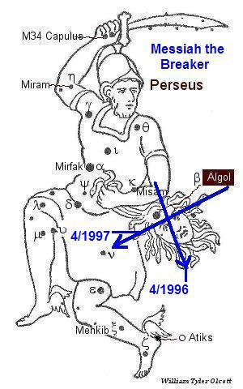

Above: Comet Hyakutake crossed the evil spirit’s forehead on 4/11/1996. Comet Hale-Bopp crossed the evil spirit’s forehead on 4/10-11/1997.

The Discovery of Comet Hale-Bopp

Comet Hale-Bopp was discovered on 7/23/1995.

The comet was found to have an orbital period of 2533 years.

That means that the last time this particular comet began to approach the sun was 2533 years before 1995, in 539 BC. That was the very year of the Handwriting on the Wall incident and the fall of ancient Babylon, the ancient world's national superpower.

The discovery of comet Hale-Bopp in 1995 in relation with 539 BC and the fall of ancient Babylon is noted in the graphic below.

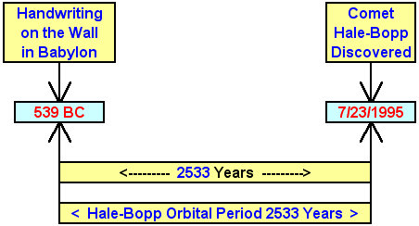

Note that YaHuWaH Elohim is a revealer of secrets, Daniel 2:47.

The Perihelion of Comet Hale-Bopp

The perihelion of a comet is the date when the comet gets closest to the sun in its orbit. The orbit of comet Hale-Bopp is very elliptical (egg shaped), with the comet spending thousands of years far away from the sun and a short period of several years relatively near the sun. One complete "year", or orbit of the sun, for the comet is 2533 of our earth years.

Comet Hale-Bopp came closest to the sun on 4/1/1997. The comet then travelled on to complete the "X" on "satan's head" in the constellation Perseus about 10 days later, around 4/11/1997.

Comet Hale-Bopp and the Decree of Cyrus

If we subtract 2533 years from 4/1/1997 when Hale-Bopp was closest to the sun, we arrive at 537 BC, the year that King Cyrus issued the decree for the Jewish people to return to Jerusalem.

Below: A graphic showing the relationship of the last time comet Hale-Bopp was closest to the sun sometime in the year 537 BC with its modern day approach on 4/1/1997.

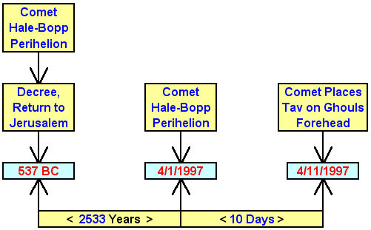

Comet Hale-Bopp and the Decree of Israel's Knesset

Below: A graphic showing the relationship of comet Hale-Bopp's closest approach to the sun (perihelion) on 4/1/1997 with the decree of modern Israel's Knesset to rebulid Jerusalem exactly 28 years (4 x 7 years) to the day earlier on 4/1/1969.

The graphic below also shows a 21 years (3 x 7 years) to the day, timely relationship with the Karaite Passover coming up later this week on 4/1/2018 which is related with Daniel 9:25.

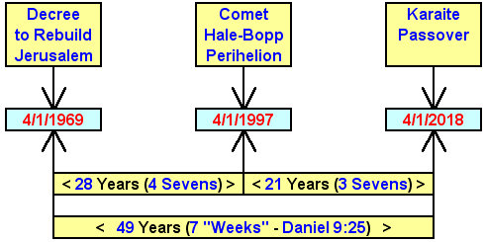

Comet Hale-Bopp and the Two Jerusalem Decrees

Below: A graphic showing the combined relationships noted above.

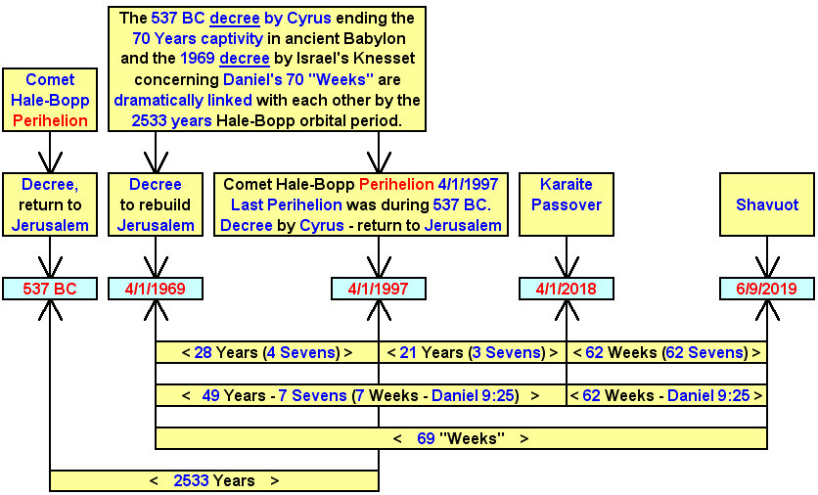

BHO and Daniel's 70th Shabua (Week)

Below: A graphic that shows a timely relationship between Barack Hussein Obama receiving the Nobel Peace Prize in Norway on December 10, 2009 and the 70th Shabua (seven, week) of Daniel 9:24.

The graphic below is an extension of the graphic directly above from 6/9/2019 forward.

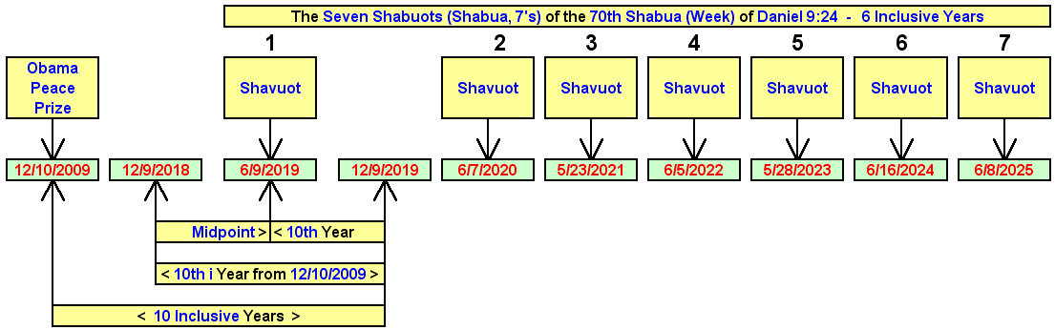

The above information is merely a presentation of history and truth, showing the timely relationships of certain events. It's not a prophecy of coming events.

