Service Provider List

Visit lasvegasnevada.gov and Las Vegas Chamber of Commerce for extensive relocation and other useful information

UTILITIES: It may take up to two business days to process your start service request
Security deposit and/or credit check may be required to start new service
- POWER – NV Energy: (702) 402-5555 nvenergy.com
- WATER & SEWER
  - Las Vegas
    - Las Vegas Valley Water District: (702) 870-4194 lvvwd.com
    - Las Vegas Sewer Services: (702) 229-1289
  - Henderson
    - Water and Sewer: (702) 267-5900 cityofhenderson.com/relocation-guide/services/local-utilities
  - North Las Vegas
    - Water and Sewer: (702) 633-1484 cityofnorthlasvegas.com/Departments/Utilities
- GAS – Southwest Gas: (877) 860-6020 swgas.com
- TRASH PICKUP
  - Republic Services: (702) 735-5151 republicservicesvegas.com
- DRIVER LICENSE/VEHICLE REGISTRATION dmvnv.com
  - Henderson: (702) 486-4368 1399 American Pacific Dr. Henderson, NV 89074
  - Las Vegas – E Sahara: (702) 486-4368 2701 E. Sahara Ave. Las Vegas, NV 89104
  - Las Vegas – W Flamingo: (702) 486-4368 8250 W. Flamingo Rd. Las Vegas, NV 89147
  - North Las Vegas – Decatur: (702) 486-4368 7170 N. Decatur Blvd. Las Vegas, NV 89131
- US POSTAL SERVICE: (800) 275-8777 usps.com
- TELEPHONE, TV, INTERNET
  - Century Link: (877) 201-6825 centurylink.com
  - Cox Communications: (866) 961-0027 cox.com
  - Directv: (800) 531-5000 directv.com
  - Dish Network: (877) 980-7359 dish.com
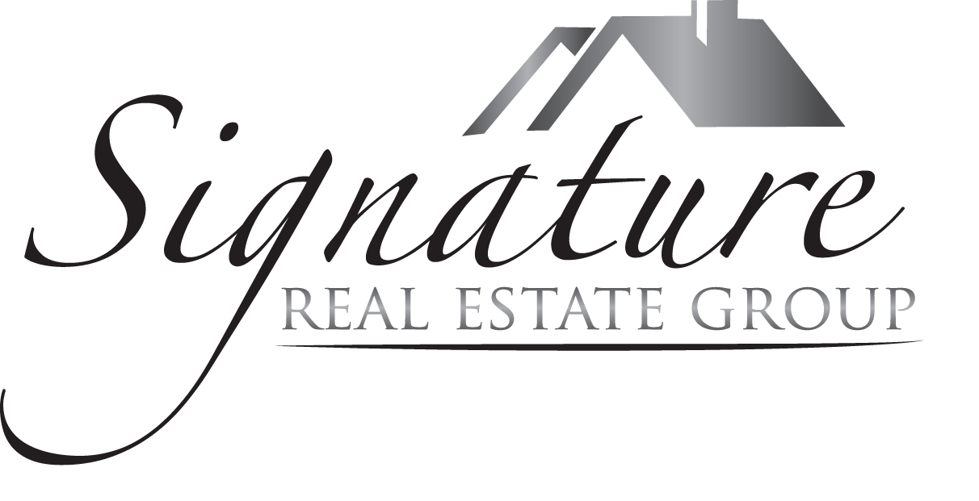
POLICE/FIRE/MEDICAL EMERGENCY: 911
POLICE NON-EMERGENCY: 311

These are only recommendations made on an informational basis only and are offered as a convenience to you. We accept no responsibility.
Courtesy of: Cristina Marinescu, Realtor®, Signature Real Estate Group (702) 983-4278 (770) 298-4949 LasVegasHomes8@gmail.com LasVegasHomesbyCristina.com

