**Heirloom Tomato Festival**

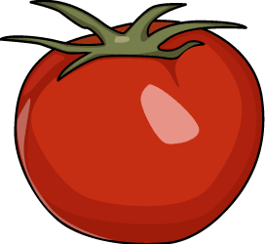  

**5th Annual**

**Agricultural Art Show**

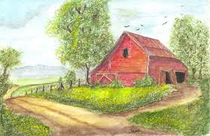

**August 2017**

Anyone can enter! All ages! All styles/mediums!

**CASH PRIZES!**

DETAILS:

* **Entry fee is only $5.00 *(no limit on entries or size of art)*.**
* **Entries must be received on Thursday, August 24th 4:00 -10:00 pm.**
* **Drop off at The Old Train Depot 115 Market Street Pierceton, IN (Brower Park)**





**Art will be on display During Heirloom Tomato Festival**

***Winners will be announced***

***during the Heirloom Tomato Festival***

***Saturday, August 26th, 10am-4pm***

**This is a judged event.**

**There is also a People’s Choice Award.**

**Questions: Call (574) 268-4860 or email** [**gogreentomato@yahoo.com**](mailto:gogreentomato@yahoo.com)

5th Annual Agricultural Theme Art Show

Name:

Address:

Email:

How did you find out about the show?

Medium:

Name of piece (s):

If for sale, how much:

Entry Fee:

Cash:

Check#:

The Heirloom Tomato personnel are not responsible for this item if damaged or stolen. By signing this form the artist is giving their permission for the piece to be on display for this festival. (Any art pieces not picked up will become the property of Pierceton Chamber of Commerce.)

Signature: Date Checked In: Out: