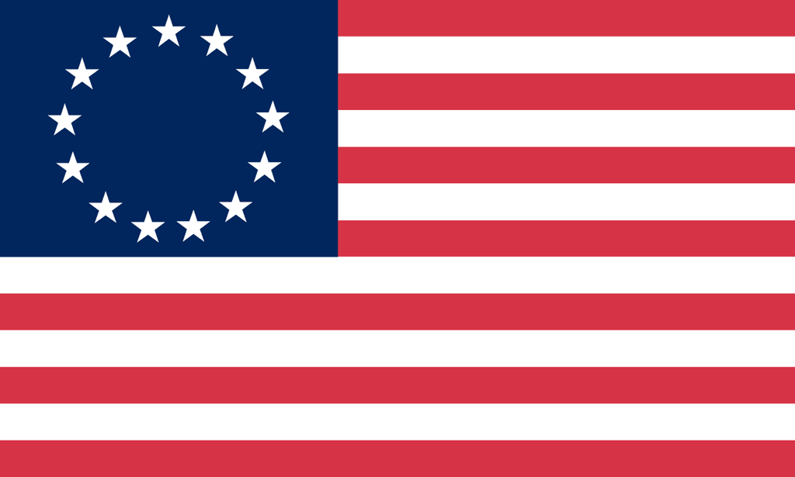U.S. History with Mr. Brown Name _______________________________ Period _____
Unit 1 Preview

- Put the following events in chronological order.

_____ Signing of the Mayflower Compact
_____ Founding of Jamestown
_____ Establishment of The Virginia House of Burgesses
_____ Writing of the Fundamental Orders of Connecticut

- What event occurred in 1607?

- Maryland was to Catholics as Pennsylvania was to—

- What were the reasons that representative government developed in the colonies?

- What colonial region had the best soil and climate for large-scale agriculture?

- Many Puritans settled in what region of the British colonies in North America?

- Why was slavery so important to the Southern colonies in the colonial era?

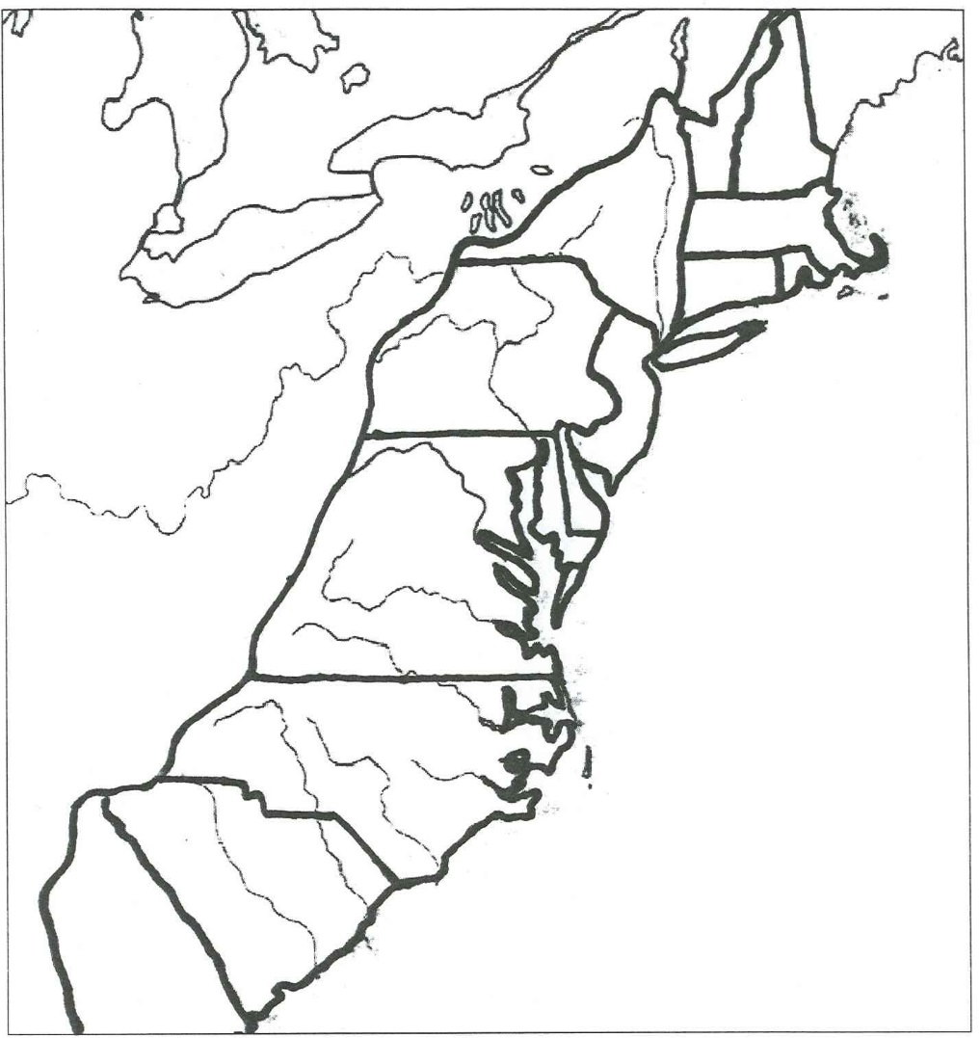
- Why is the Fundamental Orders of Connecticut important to the development of democracy in the English colonies?

- Label the following towns and geographical features:

- Atlantic Ocean
- Appalachian Mountains
- Jamestown
- Philadelphia
- Boston
- New York City

- What geographical feature acted as a barrier to Western settlement?

- What were the reasons for English colonization?

- What colonies were founded for religious reasons (God)?

- What colonies were founded for commercial reasons (Gold)?

- How did religion contribute to the growth of representative government in the English colonies in North America?

- How were both slaves and free blacks alike in the political world of Colonial America?

- What characteristic of the Virginia House of Burgesses contributed to the growth of representative government?

- Why did North Carolina, New Jersey, Virginia, New York, and Massachusetts Bay colonies develop more rapidly than the other 13 colonies?

- The higher population density colonies were located near what?

- The lower population density colonies were located near what?

- Why were the French interested in the Mississippi River and access to the Great Lakes?

- Why did the transatlantic slave trade begin?

- What was the primary cause of economic differences among the colonies in North America?

- What group settled in New York primarily for economic gains?

- William Penn believed in a government limited by the law, what action did he do to support this belief?

- Who greatly helped John Smith and the colonists survive in the difficult Virginia climate?

- What historical era will we studied this six weeks?

- What were the three main cash crops grown in the Southern colonies?

- Explain reasons for the development of the transatlantic slave trade, and the spread of slavery. Describe the economic benefits of it, as well as the intended and unintended social and political consequences of it.

- What was the chief economic cause for colonization in the Americas?
- Many British colonists came to North America seeking __________________________________.
- How did the practice of self government influence colonial life in the South prior to and after the American Revolution?
- Who had the most direct influence on the writing of the Fundamental Orders of Connecticut?
- European philosophers, __________________________ and ___________________________, were both significant individuals in the development of representative government in the colonies because their many ideas influenced colonial leaders.
- Which female British colonist was known for her contributions to the development of farming in South Carolina?
- Which female British colonist was known for challenging the authority of men in the Massachusetts Bay Colony?
- Roger Williams was motivated to establish Rhode Island because he wanted to end:
- What was a result of the First Great Awakening?
