McDowell County EMS / McDowell County 911  Internship Application | 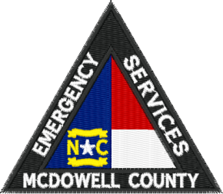

Contact Information
Name
Street Address
City ST ZIP Code
Cell Phone
E-Mail Address
Parents Name
Parents Contact Info

Availability

During which hours are you available for volunteer assignments? Please check all that apply.
Weekday afternoons | Weekend mornings
Weekday evenings | Weekend afternoons
 | Weekend evenings

Career Interests

Please check the career paths in which you are interested in.
EMS
___ 911 Communications
Fire
Nursing or other health care related field
Law Enforcement
Other please describe ______________________________________________________________

Which internship program are you applying for: __________EMS __________911 Communications

Special Skills or Qualifications

Summarize special skills and qualifications you have acquired from the MHS Public Safety Academy and or your time at a volunteer emergency service agency. (100 word minimum)

EMS Internship

Please describe for the interview panel why you wish to be selected for an internship at McDowell County EMS. What do you hope to gain from this opportunity? (200 word minimum- 500 word max)

Person to Notify in Case of Emergency
Name
Street Address
City ST ZIP Code
Home Phone
Work Phone
Cell Phone
E-Mail Address

GPA / Grades / Volunteer Work
YES ------- NO | Enrolled or successfully completed MHS Public Safety Class or Health Science Class
Please list other volunteer
work / community service that you have performed.
Days Absent Current School Year

Agreement and Signature

By submitting this application, I affirm that the facts set forth in it are true and complete. I understand that if I am accepted as an intern, any false statements, omissions, or other misrepresentations made by me on this application may result in my immediate dismissal.
Name (printed)
Signature
Date

Please return this application along with three letters of recommendation and any other supporting documentation to the following address. An official current transcript from McDowell High School must also be submitted.

All applications must be received by April 2, 2018.

Email – Director William Kehler wkehler@mcdowellems.com
US Mail:
McDowell EMS
60 East Court Street
Marion, NC 28752

