Hillsboro Homecoming & Festival
CAR SHOW
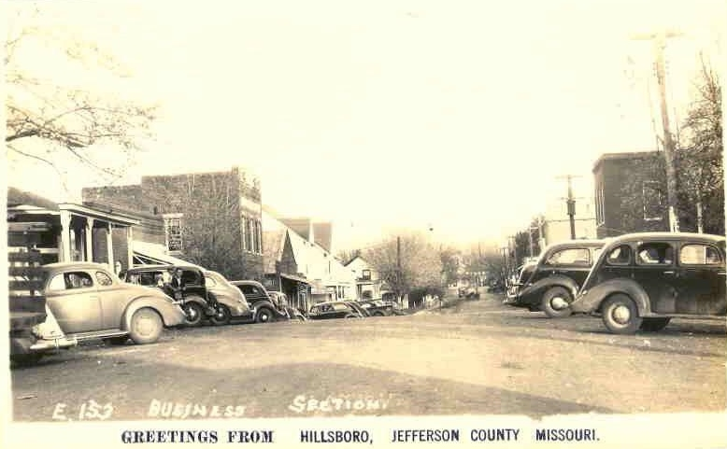
MAY 19, 2018
12:30PM – 4:00pm
Main Street & Business 21, Hillsboro, MO 63050
Registration begins at 12pm, following parade. (Rain or Shine)
If you wish to be in the parade please call the Chamber to register in parade.
ENTRY FORM
Name:
Address: City: State: ZIP:
Phone: E-Mail:
Make: Model: Year:
Color: Engine:
“1st & 2nd PLACE AWARDS FOR EACH CLASS”
CLASS
(Circle One)
Pre-War – 1942 & Older 40’s & 50’s
60’s – 70’s & Newer Stock Muscle Cars
Street Rods Modifieds
Trucks Survivors-Unrestored
Additional Awards
Best of Show Mayor’s Choice Kids Future Drivers Choice Best Vintage Costume

$15 PRE-REGISTERED OR $20 SHOW DAY
Mail or Email to
Hillsboro Chamber of Commerce
P.O. Box 225, Hillsboro, MO 63050
chamberoffice@sbcglobal.net
For more info call 636-789-4920 or visit our website @ hillsborochamberofcommerce.com
ENTRY NUMBER ___________ (JUDGES’ USE)

