

**Social Media**

* Facebook: Hannah Drake or Hannah L. Drake (Fan Page)
* Twitter and Instagram: @HannahDrake628
* Website: www.hannahldrake.com
* Blog: www.writesomeshit.com

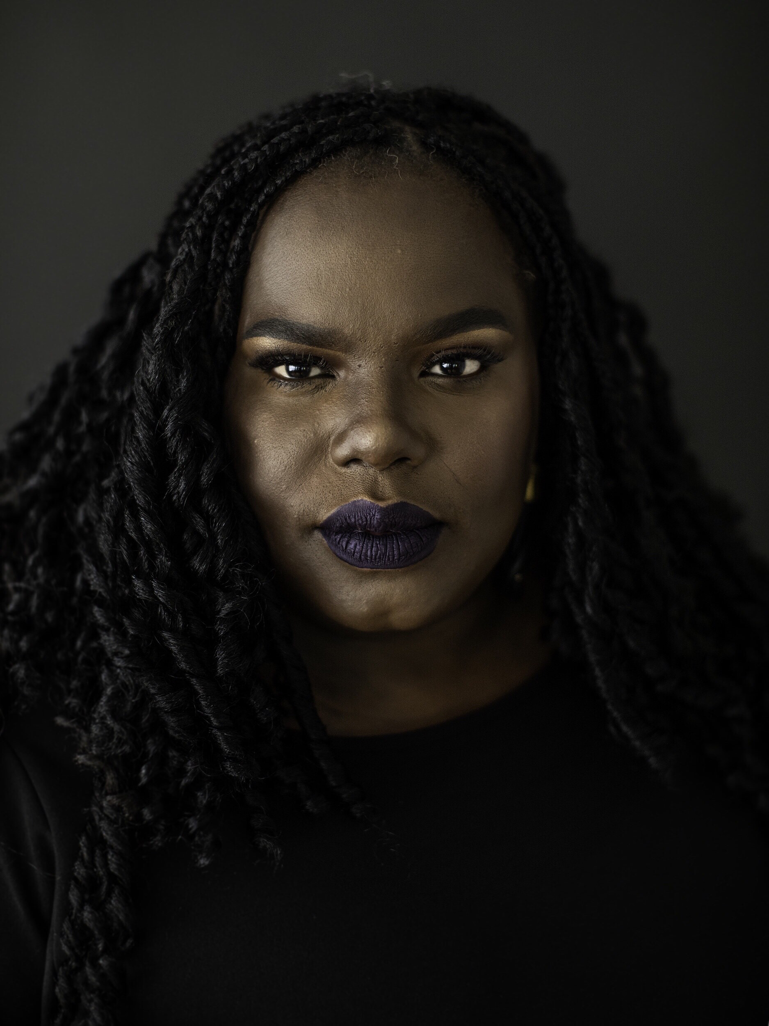**Full Bio**

**Hannah L Drake** is a blogger, activist, public speaker, poet, and author of 11 books. She writes commentary on politics, feminism, and race and her work has been featured online at Cosmopolitan, The Bitter Southerner, Harper’s Bazaar and Revolt TV. In 2019 during Super Bowl Sunday, Hannah’s poem,["All You Had To Do Was Play The Game, Boy,"](https://writesomeshit.com/2017/12/20/spoken-word-hannah-drake-all-you-had-to-do-was-play-the-game-boy/) which addresses the protest by Colin Kaepernick, was shared by film writer, producer and director Ava DuVernay, and then shared by Kaepernick. The poem has been viewed more than two million times.

Hannah’s commentary on life and challenging others to dream bigger have been recognized by First Lady Michelle Obama. Hannah Drake was featured on the Tom Joyner Morning Show with Jacque Reid to discuss her international movement, [Do Not Move Off the Sidewalk](https://writesomeshit.com/2018/07/12/do-not-move-off-the-sidewalk-challenge-holding-your-space-in-a-white-world/), which addresses the power of holding your space. Hannah was selected by the Muhammad Ali Center to be a Daughter of Greatness which features prominent women engaged in social philanthropy, activism, and pursuits of justice. Hannah was selected as one of the Best of the Best in Louisville, Kentucky for her poem Spaces and recently was honored as a Kentucky Colonel, the highest title of honor bestowed by the Kentucky Governor recognizing an individual’s noteworthy accomplishments and outstanding service to community, state, and nation.  Labeled as a change agent, Hannah’s message is thought-provoking and at times challenging, but Hannah believes that it is in the uncomfortable spaces that change can take place. “My sole purpose in writing and speaking is not that I entertain you. I am trying to shake a nation.”

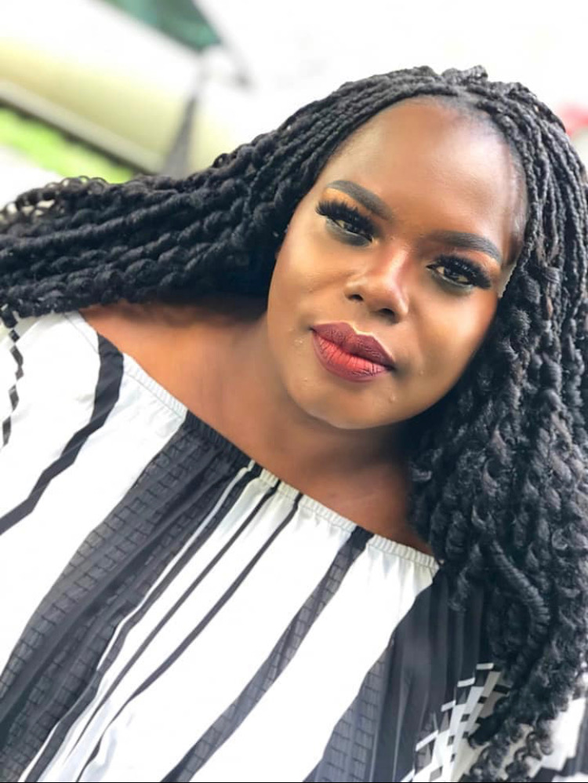

**Short Bio**

Hannah L Drake is a blogger, activist, public speaker, poet, and author of 11 books. She writes commentary on politics, feminism, and race. Hannah was selected by the Muhammad Ali Center to be a Daughter of Greatness which features prominent women engaged in social philanthropy, activism, and pursuits of justice. Hannah was selected as one of the Best of the Best in Louisville, Kentucky for her poem Spaces and recently was honored as a Kentucky Colonel, the highest title of honor bestowed by the Kentucky Governor recognizing an individual’s noteworthy accomplishments and outstanding service to community, state, and nation. Hannah’s message is thought-provoking and at times challenging, but Hannah believes that it is in the uncomfortable spaces that change can take place. “My sole purpose in writing and speaking is not that I entertain you. I am trying to shake a nation.”