“OPERATE AS ONE”

Greenwood Military Aviation Museum Commemorative/Memorial Stone Application

Museum Granite Stones (7”x 14”x 3”) will be inscribed for donors and mounted at ground level beside the walkways of the Museum Memorial Garden and Air Park. Location/relocation of these Stones will be determined by the Museum and recorded in a register at the Museum.

Individuals/groups may commemorate their service at Greenwood or in the Forces (Commemorative Stone) or donate a memorial to a deceased individual or past group (Memorial Stone). Stone donations are for inscriptions of Museum Stones only; all Stones will remain in perpetuity at Greenwood.

Payment may be made by cash, credit card, cheque, or money order to:

The Greenwood Military Aviation Museum

PO Box 786

Greenwood NS B0P 1N0 Canada

Eligibility Criteria (Please circle one letter category below.)
a) Any person who has served or does serve in any of Canada’s Air Forces.
b) Any person who has served or does serve in an Allied Air Force.
c) The spouse of anyone eligible in a) or b) above.
d) Foreign military persons who served/are serving with the CF Air Force.
e) Regular members of the Air Force Association of Canada, as approved by the Museum Operations Committee. Approval Date: ______________________
f) Members of the Canadian Air Cadet Instructors Cadre, as approved by the Museum Operations Committee.
Approval Date: ______________________
g) Any person employed now or in the past at the Greenwood Base, including DND employees; or residents of the area, as approved by the Museum Operations Committee: Approval Date: ______________________

(Enter Donor Information Here – PLEASE PRINT)

Donor’s Name ________________________________________________________________

Donor’s Mailing Address ________________________________________________________

City/Province/Country __________________________________________________________

Postal Code ___________________ Telephone ( ______) _____________________________

E-mail address ____________________________________________ Date _______________

Donor’s Signature ______________________________________________________________

Is this Stone in memory of someone? Yes ___ Print Name ______________________ No ___

Rev: 02 Dec 2002
Stones will be engraved with the information you enter below.
Four lines to a maximum of 18 characters per line, including spaces and punctuation marks. Applications will be reviewed and approved by the Museum Operations Committee. Dates must be complete e.g.: 1966 -1986

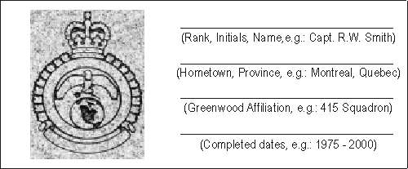

First Line | Rank, Initials, Name.  e.g.: Capt R.W. Smith

Second Line | Hometown, Province  e.g.: Montreal, Quebec

Third  Line | Military Affiliation  e.g.: 415 Squadron, MP&EU

Fourth Line | Completed dates  e.g.: 1975 - 2000

REMEMBER…MAXIMUM OF 18 CHARACTERS PER LINE

For further information, please contact the museum at:

Telephone: (902) 765-1494 extension 5955,

E-Mail: dndwingmuseum@bellaliant.com

Web Site URL: www.gmam.ca

MUSEUM APPROVAL: ____________________________ Date: _____________

Note: This form may be reproduced locally.

