REGULAR MEETING
JUNE 20, 2019

A Regular Meeting of the Town Board of the Town of Hampton, County of Washington and the State of New York was held at the Town Hall, 2629 State Route 22A, Hampton, New York on the 20th day of June 2019.

PRESENT: David K. O’Brien------------Supervisor
Tamme Taran----------------Councilwoman
Donald Sady-----------------Councilman - absent
Andrea Sweeney------------Councilwoman
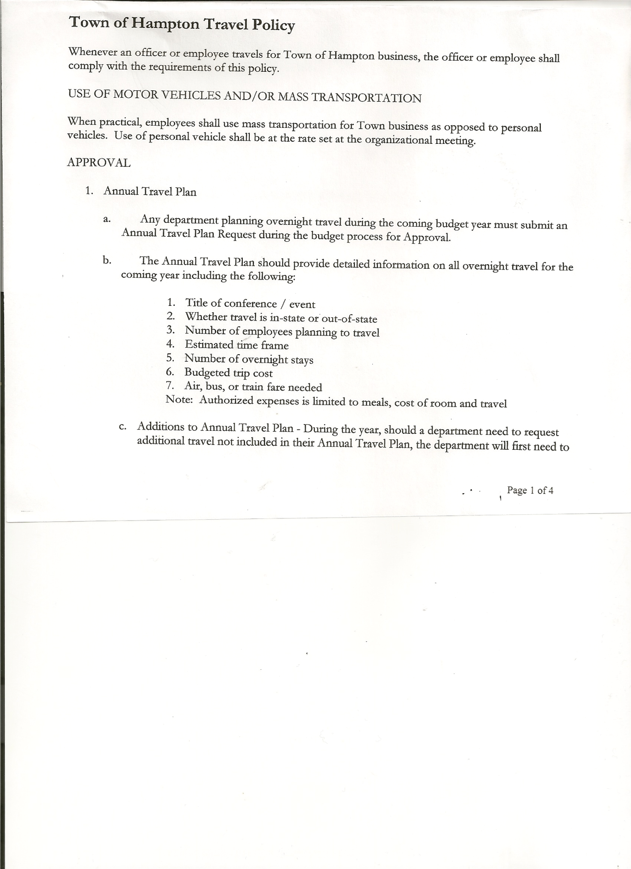
Roger Weeden---------------Councilman - absent
Rebecca Jones---------------Town Clerk
Camilla Shaw----------------Tax Collector/Deputy Town Clerk - absent
Herbert Sady, Jr.-------------Highway Superintendent
Kim Perry---------------------Bookkeeper/Budget Officer

Planning Board Member(s): Bonnie Hawley, Chair and Matthew Pratt

Also present: Artie Pratt and Leonard Reed

The Regular Meeting was called to order by Supervisor O’Brien at 7:30pm, followed by the Pledge of Allegiance. Location of Fire Exits were given. Quorum of board members present.

Supervisor O’Brien asked for a moment of silence in memory of Francis “Frank” Baker,
William “Harry” Douglas and Dr. Jay Edison (former Health Officer).
Supervisor O’Brien also asked that we keep Councilman Don Sady in our thoughts, as he recovers from his heart attack and bypass surgery.

RESOLUTION NO. 56-2019
APPROVAL OF THE MINUTES
On a motion of Councilwoman Taran, seconded by Councilwoman Sweeney, the following resolution was ADOPTED: Ayes 3 O’Brien, Taran, Sweeney
Nays 0
Absent 2 Sady, Weeden
RESOLVED, that the Regular Town Board Minutes for May 16th, 2019 are approved.

Town Clerk, Rebecca Jones submitted Tax Collector Report in Camilla’s absence- Zero balance. Submitted a Bank Statement to the Board for review and signatures.

Larry Carman, Dog Control Officer…submitted his report, which was read by Supervisor O’Brien, copy of report is attached for 5/14/19 - 6/17/19.
Received from NYS Agriculture and Markets...“Municipal Shelter Inspection Report”, dog shelter services were rated “Unsatisfactory”. Another inspection will occur in approximately 30 days.

Planning Board Report…
- Working on Farm Land Ag Protection Plan, receiving info from the County and looking at Granville as a guideline.
- Next meeting will be July 10th, 2019 @ 7:00pm at the Town Hall

Herbert Sady, Jr., Highway Superintendent submitted his report, copy of which, is attached.
Following a discussion where CHIPS money would be spent, the following Resolution was introduced.

TOWN BOARD MEETING
JUNE 20, 2019 PAGE 2

RESOLUTION NO. 57-2019
AGREEMENT TO SPEND TOWN HIGHWAY FUNDS
On a motion of Councilwoman Sweeney, seconded by Councilwoman Taran, the following resolution was ADOPTED: Ayes 3 O’Brien, Taran, Sweeney
Nays 0
Absent 2 Sady, Weeden
RESOLVED, to accept the Agreement to Spend Town Highway Funds as submitted. (Copy is attached).

Uniforms…Highway Department has decided to stay with UniFirst for the rest of 2019, considering other options for 2020.
Class 3 (reflective) jacket/vests need to be purchased for when the Highway Crew is working on the roads.
Tandem truck needs piston to be repaired.
After a discussion of selling or keeping the 2000 International Truck, the board is opting to keep the truck.

RESOLUTION NO. 58-2019
APPROVAL OF SUPERVISOR’S MONTHLY REPORT
On a motion of Councilwoman Taran, seconded by Councilwoman Sweeney, the following resolution was ADOPTED: Ayes 3 O’Brien, Taran, Sweeney
Nays 0
Absent 2 Sady, Weeden
RESOLVED that, the Supervisor’s Monthly report be accepted as submitted for MAY
4/30/19 05/31/19
ACCOUNT BALANCE RECEIPTS DISBURSEMENTS BALANCE
General Fund $ 65,664.52 $ 13,519.36 $ 9,766.07 $ 69,417.81
Highway Fund $151,725.29 $ 100,007.73 $ 20,274.51 $231,458.51
Equipment Reserve $123,672.32 $ 5.25 $ 0.00 $123,677.57
Fire #1 $ 41,616.00 $ 0.00 $ 0.00 $ 41,616.00
Fire #2 $ 7,756.00 $ 0.00 $ 0.00 $ 7,756.00
Cemetery $ 1,715.70 $ 2.17 $ 0.00 $ 1,717.87
Totals $392,149.83 $113,534.51 $ 30,040.58 $475,643.76
All Board Members present signed Supervisor’s Report.

The Town Clerk’s report for May 2019 was submitted to the Board. The Town Clerk had Board Members review and sign bank reconciliation statements for the Town Clerk Account and Special Town Clerk Account dated May 31st, 2019.

Following a discussion regarding Charter Communications and Rights-of-Way for communications and related services, the following resolution was introduced.

RESOLUTION NO. 59-2019
RIGHTS-OF-WAY USE AGREEMENT
On a motion of Councilwoman Taran, seconded by Councilwoman Sweeney, the following resolution was ADOPTED: Ayes 3 O’Brien, Taran, Sweeney
Nays 0
Absent 2 Sady, Weeden
RESOLVED, to authorize Supervisor O’Brien to sign the “Rights-of-Way Use Agreement” between the Town of Hampton and Time Warner Cable Northeast, LLC locally known as Charter Communications.

TOWN BOARD MEETING
JUNE 20, 2019 PAGE 3

RESOLUTION NO. 60-2019
RESERVE FUND
On a motion of Councilwoman Taran, seconded by Councilwoman Sweeney, the following resolution was ADOPTED:
By Roll Call Vote: Supervisor O’Brien AYE
Councilwoman Taran AYE
Councilwoman Sweeney AYE
Councilman Sady ABSENT
Councilman Weeden ABSENT
RESOLVED, to pay the Steel Tariff Surcharge of $2800.00 (cost associated with the new Highway Truck) from the Highway Reserve Fund.

COMMUNICATIONS
Received from NYS Dept. of Taxation & Finance Office of Real Property Tax Services our Certificate of the Final State Equalization Rate for 2019 Assessment Roll….
Town of Hampton Final State Equalization Rate is 94.75.

NEW BUSINESS
Discussed the cost of Gas, Diesel & Heating Oil….going to put out to bid for next year.

RESOLUTION NO. 61-2019

AUDIT OF CLAIMS
On a motion of Councilwoman Taran, seconded by Councilwoman Sweeney, the following resolution was ADOPTED: Ayes 3 O’Brien, Taran, Sweeney
Nays 0
Absent 2 Sady, Weeden
RESOLVED that the bills have been reviewed by the Town Board and are authorized for payment in the following amounts.
General Fund No. 88 through No. 105 $ 28,461.43
Highway Fund No. 53 through No. 66 $201,318.93
Total both funds $229,780.36

RESOLUTION NO. 62-2019
QUARTERLY AUDITS-TOWN CLERK AND TAX COLLECTOR
On a motion of Councilwoman Taran, seconded by Councilwoman Sweeney, the following resolution was ADOPTED: Ayes 3 O’Brien, Taran, Sweeney
Nays 0
Absent 2 Sady, Weeden
RESOLVED, to accept the quarterly audits completed for the Town Clerk and Tax Collector.

On a motion of Councilwoman Sweeney, seconded by Councilwoman Taran, the meeting adjourned at 8:48pm. All in favor Aye.

Respectfully submitted,

Rebecca S. Jones, RMC
Town Clerk

