ECO ORCA CLASS FEBRUARY 2025 SOLAR SYSTEM, OUR PLANET
SUNDAY |  |  | MONDAY | TUESDAY | WEDNESDAY | THURSDAY | FRIDAY | SATURDAY
 |  | 26 | 27 | 28 | 29 | 30 | 31 | 1

 | 2 |  | 3 | 4 | 5 | 6 | 7 | 8
 |  |  | MOUNT DOUG PARK | Beacon Hill  Feed the Ducks | Honey Crisp Park | Mount Tolmie Trails | Sooke Pothole’s Lower | 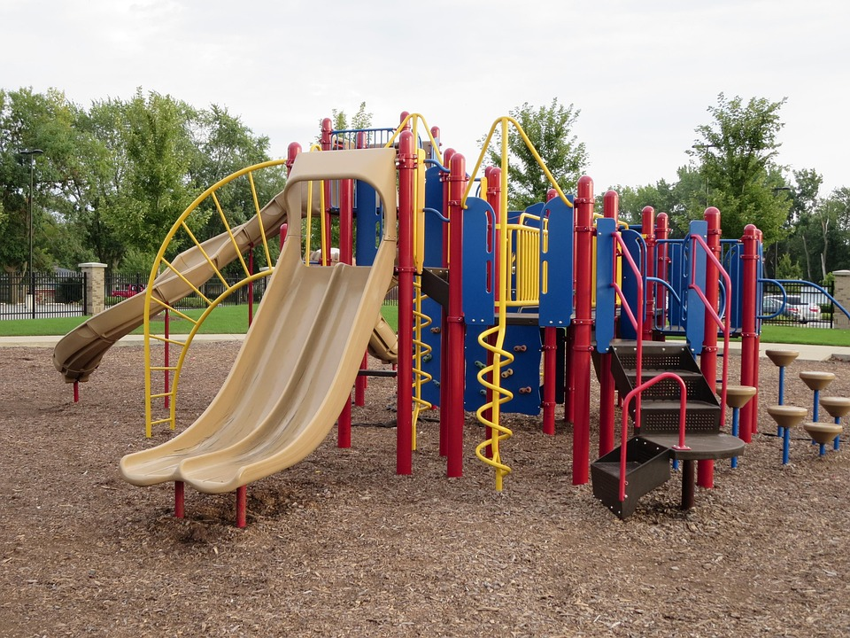
 | 9 |  | 10 | 11 | 12 | 13 | 14 | 15
 |  |  | Pink Elephant Park | Caleb Pike Park | Esquimalt Lagoon  Feed the Ducks | Ruby Creek Trails | OSC Pro Day  Valentine's Day
 | 16 |  | 17 | 18 | 19 | 20 | 21 | 22
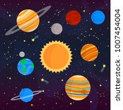 |  |  | Closed  Family Day BC | Charlie’s  Trail | Goldie  Park | Roche Cove Trails | Christmas Hill Trails
 | 23 |  | 24 | 25 | 26 | 27 | 28 | 1
 |  |  | JDF  Trails | Esquimalt Lagoon Bridge | Sooke  Park | Centre of the Universe $5 | Witty’s Lagoon | 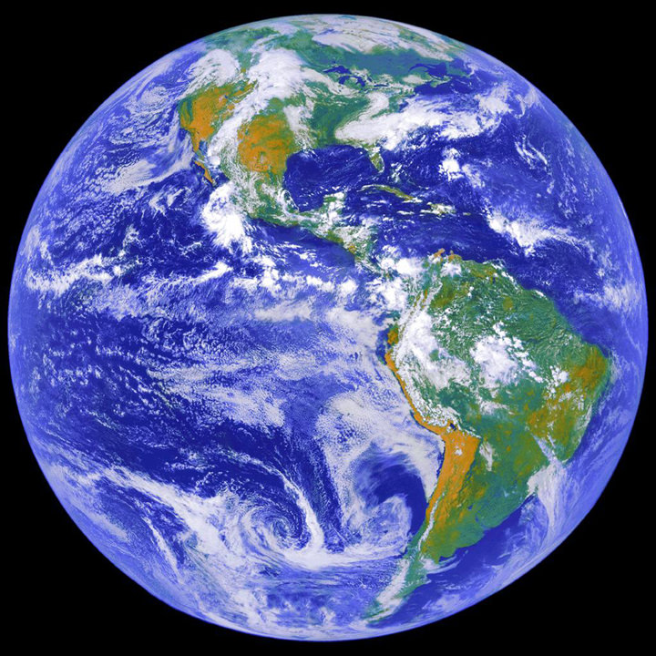  This Photo by Unknown Author is licensed under CC BY

