Enjoy a FREE movie
Mother’s Day weekend!

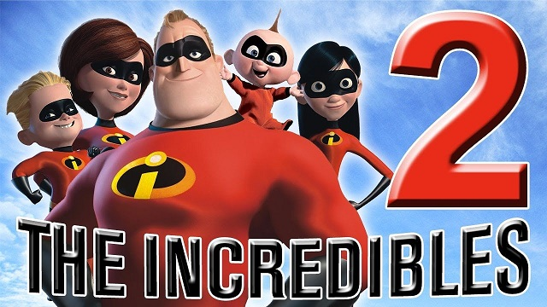

Hamburg Strand
Movie Theatre
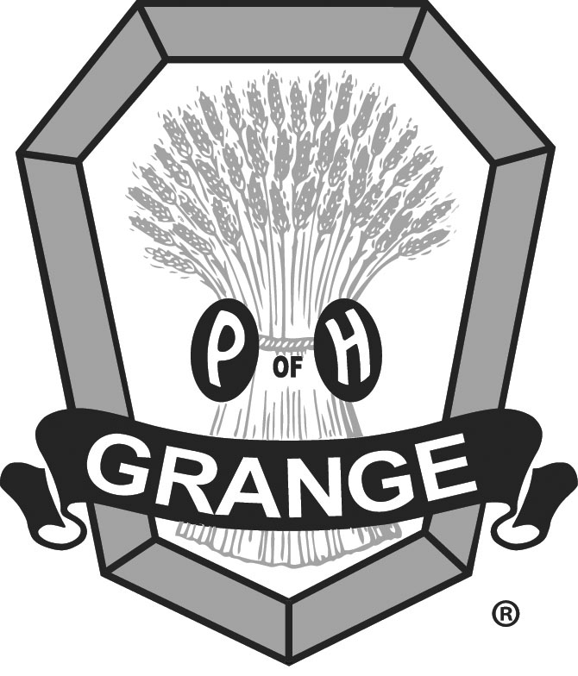
Sponsored by the
Hamburg Grange

Saturday, May 11, 2019
1 - 3 PM

Doors open 12:30PM
REFRESHMENTS AVAILABLE FOR PURCHASE

