2022
CLUB PRECISION SHOOTING CUP
9th April

18 Players took part this year after the initial twenty-six entries saw a number of people drop out.
Five separate disciplines are undertaken in the Precision Shooting with a maximum available score of 100 points, although the world record is 67 achieved by Christophe Sevilla in July 2011.
After Round 1 the scores were as follows:
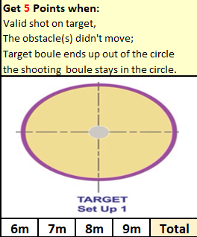
Andrew Limbrick | 0
Brian Harris | 3
David Ibitson | 2
Gavin Scott | 3
Geoffroy Buffetrille | 0
Jake Romeril | 0
James Rondel | 1
John Flaherty | 0
Keith Pinel | 6
Laurent Pellaton | 0
Luc Rochefort | 0
Matt Buesnel | 3
Matt Pinel | 6
Paul Bell | 3
Ross Payne | 3
Tim Jackson | 3
Toby Northern | 4

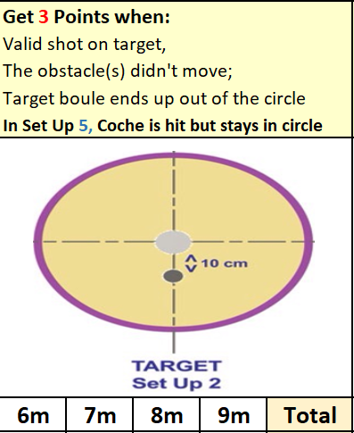
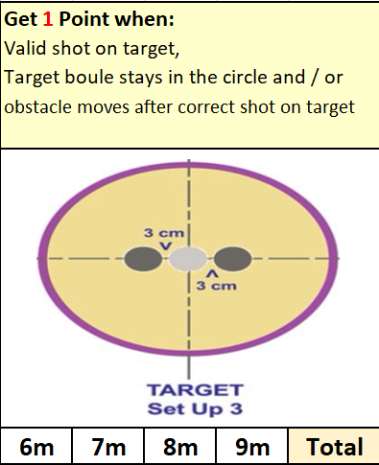
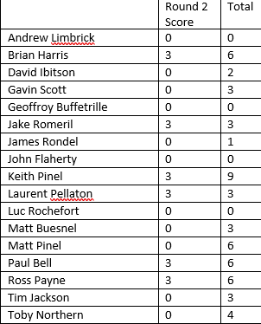
 | Part 3 | Total
Andrew Limbrick | 0 | 0
Brian Harris | 2 | 8
David Ibitson | 0 | 2
Gavin Scott | 4 | 7
Geoffroy Buffetrille | 7 | 7
Jake Romeril | 5 | 8
James Rondel | 0 | 1
John Flaherty | 0 | 0
Keith Pinel | 4 | 13
Laurent Pellaton | 3 | 6
Luc Rochefort | 0 | 0
Matt Buesnel | 1 | 4
Matt Pinel | 7 | 13
Paul Bell | 0 | 6
Ross Payne | 0 | 6
Tim Jackson | 3 | 6
Toby Northern | 4 | 8

 | Part 4 | Total
Andrew Limbrick | 3 | 3
Brian Harris | 0 | 8
David Ibitson | 3 | 5
Gavin Scott | 0 | 7
Geoffroy Buffetrille | 3 | 10
Jake Romeril | 0 | 8
James Rondel | 0 | 1
John Flaherty | 0 | 0
Keith Pinel | 3 | 16
Laurent Pellaton | 3 | 9
Luc Rochefort | 3 | 3
Matt Buesnel | 1 | 5
Matt Pinel | 1 | 14
Paul Bell | 0 | 6
Ross Payne | 3 | 9
Tim Jackson | 0 | 6
Toby Northern | 1 | 9
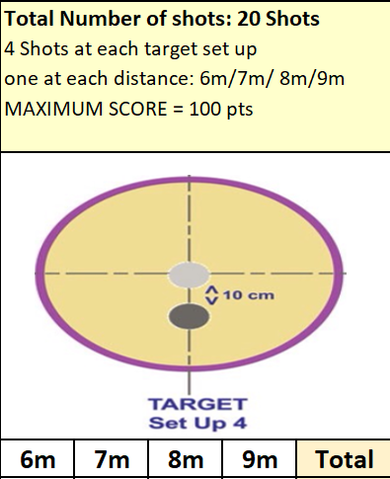
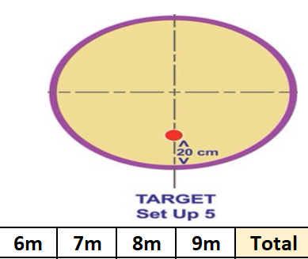
 | Part 5 | Total
Andrew Limbrick | 0 | 3
Brian Harris | 0 | 8
David Ibitson | 0 | 5
Gavin Scott | 3 | 10
Geoffroy Buffetrille | 0 | 10
Jake Romeril | 0 | 8
James Rondel | 0 | 1
John Flaherty | 0 | 0
Keith Pinel | 0 | 16
Laurent Pellaton | 0 | 9
Luc Rochefort | 0 | 3
Matt Buesnel | 0 | 5
Matt Pinel | 0 | 14
Paul Bell | 0 | 6
Ross Payne | 5 | 14
Tim Jackson | 0 | 6
Toby Northern | 0 | 9

With the qualification criteria set at 16 points to go through to the knockout stages and only Keith Pinel achieving this score, that meant he automatically won the competition after some of the top shooters posted disappointing scores. This ended Geoffroy Buffetrille three-year winning streak after he could only post a score of 10.
Two players with fourteen points were Matt Pinel and Ross Payne who then played off at 6 & 7m over the five disciplines with Matt taking the Runners up spot 12 – 6.

2022 Precision Shooting Champion – Keith Pinel
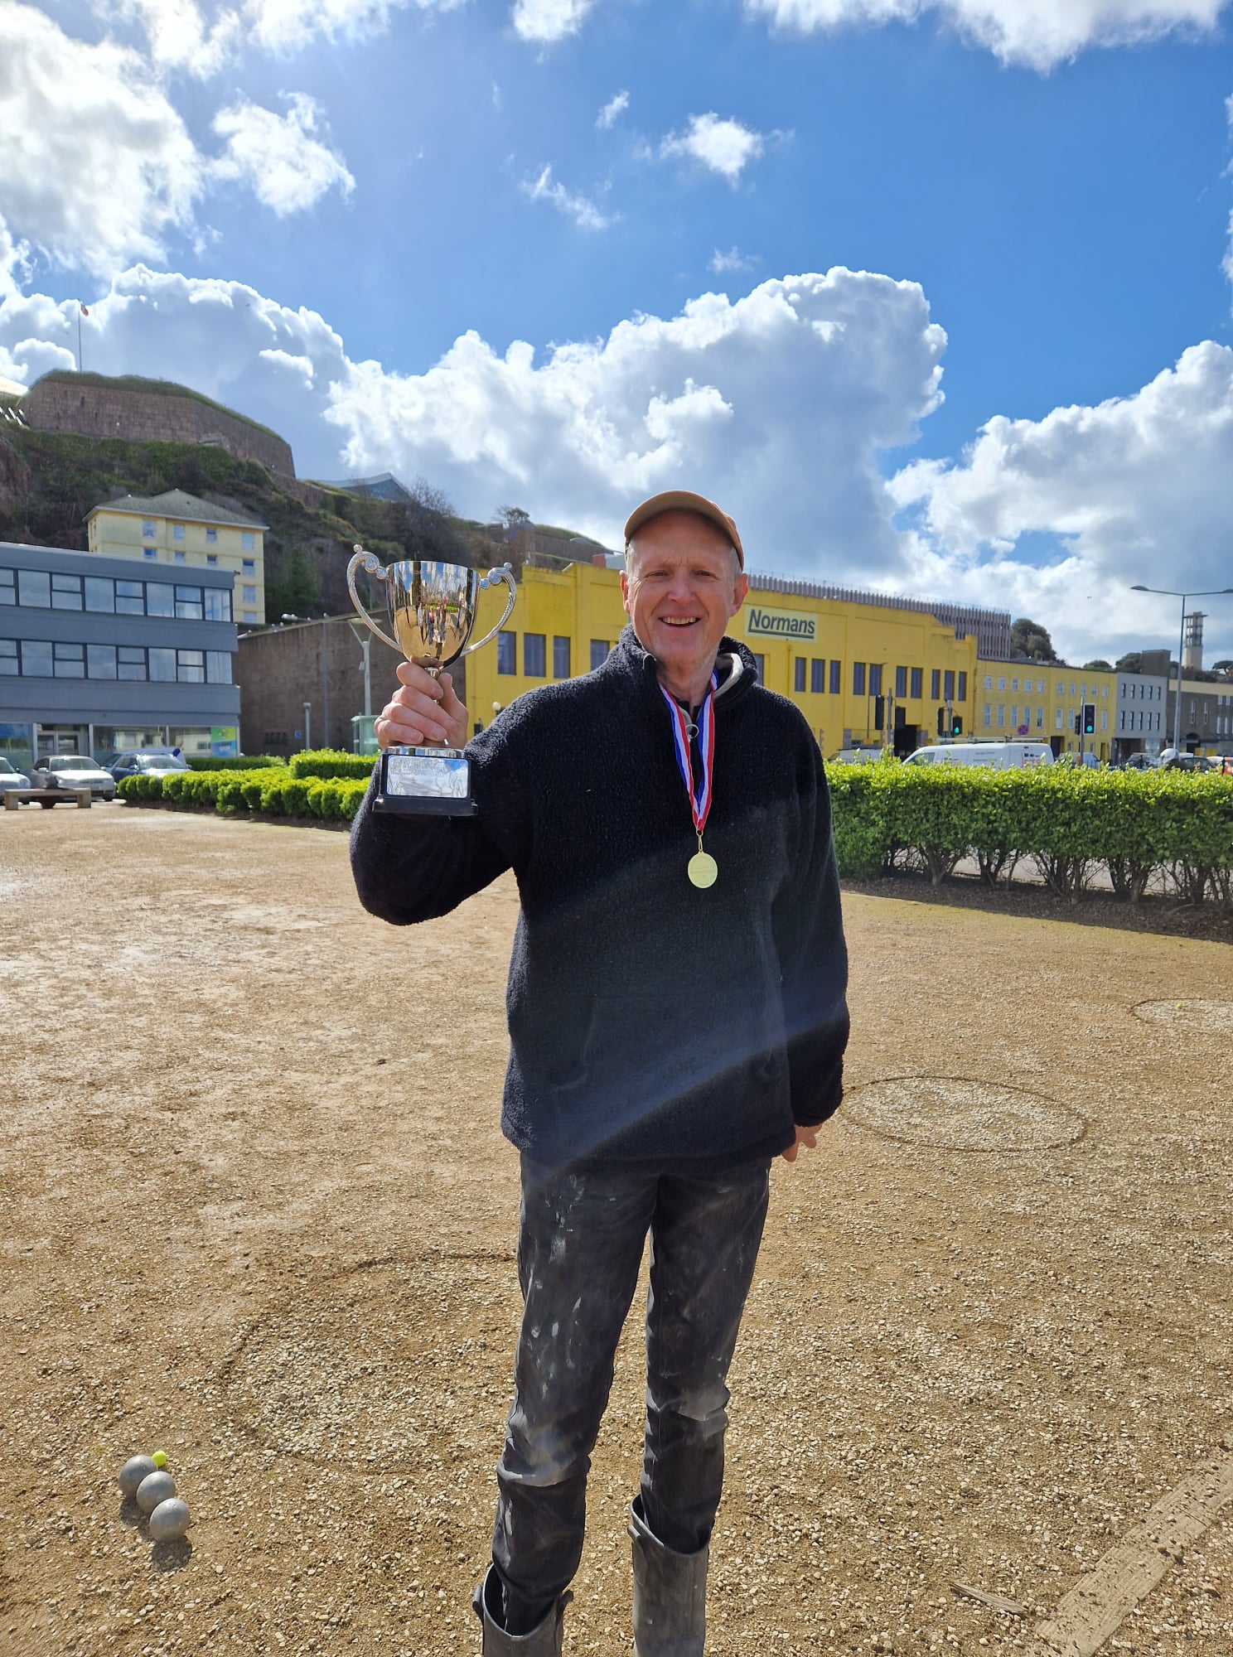

Special thanks to Matt Pinel, James Rondel, Matt Buesnel and Geoffroy Buffetrille for running the competition on the day and to all those who took part.

