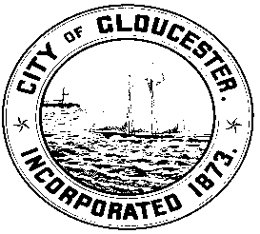
CITY OF GLOUCESTER 2016
CITY COUNCIL ORDER DRAFT

ORDER: CC#2016-00
COUNCILLOR: Melissa Cox
Ward 2 Councillor

DATE RECEIVED BY COUNCIL: 4/12/16
REFERRED TO: O&A
FOR COUNCIL VOTE:

ORDERED that the O&A shall review and recommend the matter of prohibiting the use
of polystyrene food and beverage containers or serving items from food service
establishments if the packaging takes place on the premises of food service establishments and further that waivers may be granted for no more than six months if this poses an economic hardship. This ordinance amendment shall take into account CC2015-044 concerning plastic checkout bags.

ORDERED that a new Code of Ordinances Chapter 9, “Art. II” be ADDED and titled “Prohibition on Polystyrene-Based Disposable Food Serving Items”. “Sec.9-12 (a) Effective _______2016 polystyrene food and beverage containers or serving items (such as utensils or straws ) shall not be used in the City of Gloucester to package or serve food or beverages if that packaging takes place on the premises of “food service establishments” , as defined in sec. 9-21.
In the event that compliance with this ordinance is not feasible for a food establishment
because of either unavailability of alternative non-polystyrene containers or economic
hardship, the Public Health Department may grant a waiver of not more than six months upon application of the owner or owner’s representative.”
“Sec.9-12 (b) Definitions;”
“Food Service Establishments shall mean those establishments which serve food or beverages which they have packaged on the premises.”

And by ADDING at Sec. 1-15 of the Code of Ordinances that “Violations of sec. 9-12 of the Code of Ordinances shall be subject to civil ticketing by agents of the Public Health Department” by a fine of : ___________________”

Further Ordered that the O&A shall recommend to the Council that the ordinance on Polystyrene Food and Beverage Containers be adopted.

