WORSHIP
Revised 3/23

This is the Worship Area Manual complete with pictures on setting up each Chapel.. There are a few items that you will need to provide but most of the items are in storage and will be brought to your location by logistics. It is recommended that you arrive at Camp Alamisco by 3:00 P.M. This will give you a chance to get everything unpacked and organized. This committee should consult with and coordinate all plans with the ASD’s, ALD’s and designated committees of the walk.
BRINGWITH YOU:
- 1 bottle of grape juice (1gallon should be plenty)
- 4-5 bags of pita bread (you will use 4 to 6 slices for each communion service) and a box of Gluten Free crackers (check with Spiritual Director to see if there are any other special requests) These are used for:

- Thursday morning chapel
- Friday - Dying Moments
- Friday - Community Candlelight
- Saturday - Closing

Old towels to wipe off benches at the outdoor chapel. If you use towels from Agape, these should be washed and returned to Agape before you leave on the last day of the walk.
8 taper candles – 2 each for
- Thursday morning chapel
- Friday – Dying Moments
- Friday – Community Candlelight
- Saturday Closing
Butane Lighters
Kleenex - 10 boxes

NOTES:
- Be sure Kleenex boxes are placed at the ends of each row in the chapels, especially for Dying Moments.
- To make it easier, put the tubs, easels and cross in your car to carry to the outdoor chapel and pavilion
- As much as possible, pack up as you go so that you won’t have it all to do at once.
- The chapel and the worship workroom are located close to each other. Remember that sound travels very well at the lake and keep voices low, especially when the pilgrims are in the chapel.
- While the 72-hour candles are in the chapel, it is the responsibility of the Worship committee to be sure they remain lit. The Sponsor’s Hour committee will be responsible for putting the candles in the chapel on Wednesday and taking the transporting box to Agape.
- Agape will be responsible for taking the candles to the Conference Room on Saturday.
- There are green foam seats in a tub marked “Permanent Agape for Worship.” These are used for outside worship. The green foam seats are also used any other time the seats may be wet. If you’ll ask, Logistics will put the tub at the top of the steps for the ALD’s to hand out to pilgrims so they don’t get wet with dew. The tub is usually left at the outdoor chapel between services. Remind ALDs that the seats should remain on the benches in order to dry out – not placed wet back into the tub.
- Each worship setup has been put into separate tubs i.e, the first day’s materials are in one tub, and the second day’s morning worship setup has its own, while Dying Moments has two. One tub is shared between Candlelight and Closing. Each tub is labeled for the particular service and has all the materials needed except for the tablecloths, communion cloths and the large cross. There are separate totes for tablecloths and communion cloths. These are to be put in the large Ziploc Bag to keep clean.
- Some materials are in Ziploc bags for safekeeping.
- Separate boxes for candles, black tarps and the spotlight for Dying Moments are also part of the Worship inventory.
- Chalice and element plates are in a separate tote and need to be wrapped with bubble wrap very well to keep from breaking during packing. If possible, the board rep for Worship should take these home with them to keep from getting broken in the shed.
- If something cannot be found, check the other boxes to see if it was misplaced.
- The only banners used for the chapel services are the two for Dying Moments, "I've been expecting you" and "Dying Moments". NO OTHER BANNERS ARE USED DURING ANY CHAPEL SERVICE
- Each chapel service is identified on a storage bin. There is a list of the items contained in the bin and taped to the lid along with a picture of the setup. PLEASE RETURN THE ITEMS TO THE SAME BIN FROM WHICH THEY CAME.
- The Worship Team doesn’t have the access code to the Sound Room. Turning on that equipment is the responsibility of the Spiritual Team.

If the white cloths and communion napkins are soiled, please take them home, wash them and return at the next walk. Please call the Board Representative in charge of Worship to let them know that you have the linens.

FOLLOWING EACH WORSHIP SERVICE WHERE COMMUNION IS SERVED, THE WORSHIP CHAIRPERSON IS RESPONSIBLE FOR TAKING CARE OF THE COMMUNION ELEMENTS!!!!!!!!!

The Communion elements are discarded in the following manner:
- The elements are returned to earth.
- Take the Communion bread, crumble it and throw it out on the ground for the birds and animals to eat.
- Take the Communion cups outside and pour out the juice making sure that it is done in a "Cross" configuration.
- This is to be done in a reverent and prayerful manner.

Please observe the worshipful nature of this process.

1st Chapel Service
PRODIGAL SON

1st CHAPEL SERVICE: THURSDAY MORNING 6:15 am (if using the Outdoor Chapel)
Pilgrims will usually arrive about 7:00 a.m.

Turn on the lights as you go down to the Outdoor Chapel. On the light pole located on the left side of the path to the Chapel, you will find the lights for the path. On the light pole in front of and to the left of the large speaker podium and sound system cabinet, you will find the switches for the outdoor lights. These are dimmer switches.

Wipe off the benches if there has been a heavy dew or it has rained the night before.

You will NEED:
- 2 Candles with wooden Candlesticks, 2 glass globes to shield candles, and small folding table.
- Easel
- Blue Draped Material and 2 tablecloths to cover the small table on both sides and front.
- Sandals
- Ring and Large Pin
- 5 Cloth Napkins, 1 for each Chalice, others to cover plates of Communion Bread and crackers
- Wooden Cross
- 2 Pottery Chalices and 3 plates for the bread
- GRAPE JUICE, PITA BREAD and Gluten Free crackers (or other bread as directed by the Spiritual Director)

PRODIGAL SON 7:00am Thursday
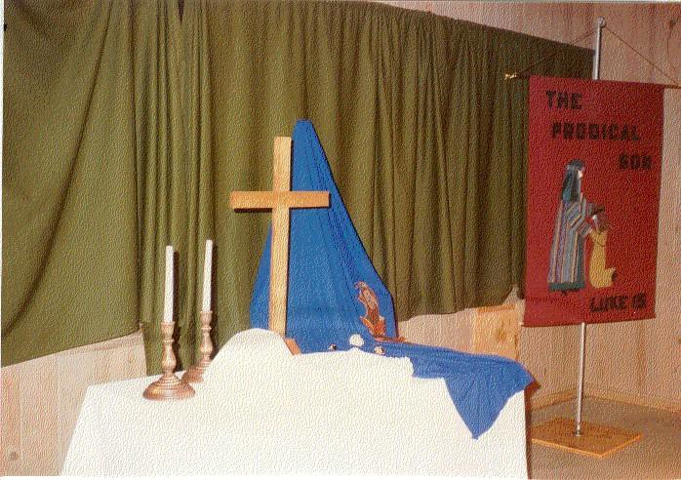
Thursday Morning:The above picture is accurate except the banner. Use hurricane globes to protect candles.

Set up worship table as follows:
- Cover table with white cloth.
- Put out hand sanitizer.
- Set up easel and drape blue cloth over the easel as shown in the picture.
- Prop up the sandals on the blue cloth as shown in the picture.
- Place the pin and ring on the blue cloth as shown.
- Cross is placed in the center of the table.
- The chalice and plate are placed just to the left of the cross and a little forward.
- Wipe down the benches as needed.
- Place a box of Kleenex at each end of each bench – 6 benches in all plus the top row for Conference team.
- Pour juice, unwrap bread and cover each with the white communion napkins.
- Light candles and place globes over them.
- Do not forget butane lighter to light candles!!! Test them to be sure they light. (Each tub used for a communion service should have its own lighter.) Do not light candles until ALD comes to find out if you are ready. You can light the candles if only 15-20 minutes before pilgrims come up the hill or ask the ALD if they would light the candles when pilgrims arrive so they don't go or blow out. Leave lighter on the table behind the cross so the ALD can light candles just before the pilgrims turn into the chapel. ASK THE ALD TO BLOW OUT CANDLES BEFORE THEY LEAVE THE CHAPEL SERVICE AREA.
- The Logistics Team needs to set up the stage for pictures Thursday morning so return to the outdoor chapel as soon as possible to pack everything up and return the tub to the Agape/Worship room. (You might want to check with Logistics to see how quickly they’ll be setting up.) The Kleenex tub and small table can be stored beside the sound room. The cushions tub can stay on the top bench.
- Turn off the lights.

2nd Chapel Service Thursday Evening 7:00 p.m. Emmaus Road
This service may be held in the Conference Room (Check with the LD or an ALD) Need:
- Tan Material (Burlap)
- Striped material
- 2 metal easels
- “Walk to Emmaus” picture
- Staff
- Cross from that morning
- Sandals
Use:
- Cross to drape material and hold staff
- Oblong card table if done in outside chapel
- Tablecloths to cover table

Can be set up before dinner (around 4:00 pm) on Thursday afternoon if held outdoors
Emmaus Road 7:00 pm Thursday

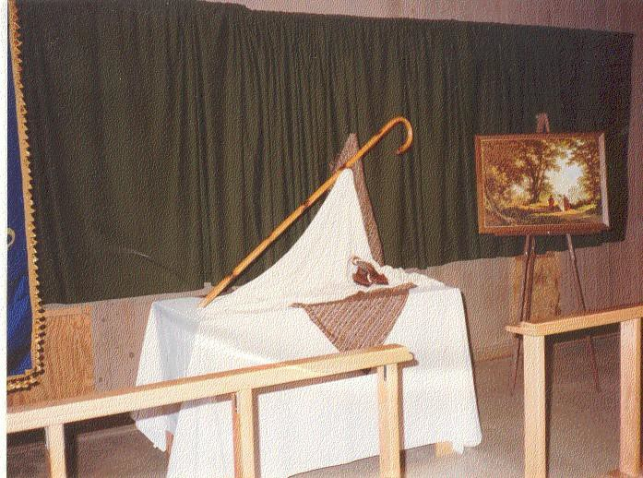

Turn on the lights to the walk and the lights on the poles.

Set up worship table as follows:
1. Set up the table in the center of the platform and cover with tablecloth. Cover the white cloth with the burlap cloth, making sure that a point is draped over the center of the table.

- Place the easel to the right and behind the table. Drape the striped cloth over the easel as shown above.

3. Place the cross just to the left of the easel on the striped cloth and cover it with a white cloth.

4. Balance Shepherd's Crook between the easel and the cross. See picture.

5. Prop up the sandals as shown in the picture.

6. Put the "Road to Emmaus" picture on the second easel to the right of the table.

7. Make sure that there is a box of Kleenex at each end of the rows of benches.

3rd Chapel Service Thursday10:00 p.m. Examination of Conscience

Thursday Evening (7:45 pm) After the pilgrims leave the 7 p.m. chapel service (about 7:45 p.m.) begin setup for the 10:00 p.m. service. The setup is the same as the 7:00 p.m. service, "Emmaus Road" – just add the following:
NEED:
- Low table & cloth (use a tub as low table.)
- Prayer box, cards & pencils (place cards & pencils outside the box)
- Stained glass window (with mechanical candle & holder behind it)
NOTE:
• Check Kleenex, Seat Pads (if outside).
• Must light candle behind stained glass at 9:30 p.m OR WHEN ALD COMES TO CHECK ON READINESS.

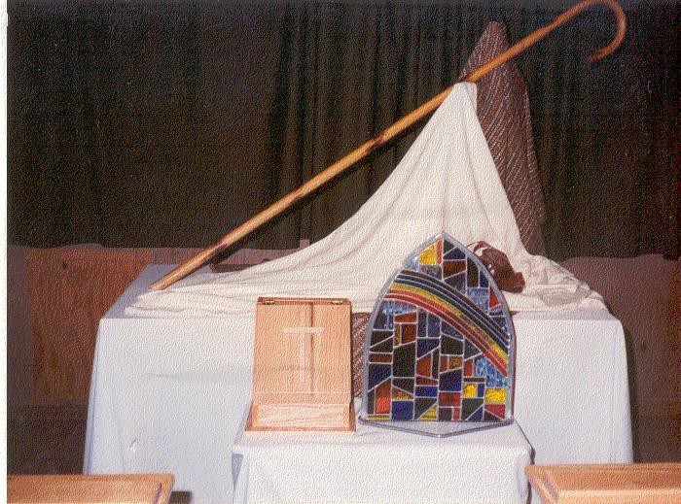
Examination of Conscience 10:00 pm Thursday

Thursday Night (10:00 pm) setup

Break down chapel after last pilgrim leaves the chapel. If held indoors, the ALDs will break it down and set tubs outside the Conference Room for you.

4th Chapel Service
Friday Morning 7:00 a.m.
Four Responses to Christ

NEED:
• Easel
• Blue ointment jar
• Rooster
• Hem of garment (small white material draped from wash bowl)
• Cross (not in box, use one from earlier services)
• Money bag (Judas)
• Pieces of silver (taped to cloth)
• Pitcher & Bowl
• Praying Hands
USE:
- Sheets to cover table
- Use small folding table if done in Outdoor Chapel)
- Kleenex on ends of each bench if outdoors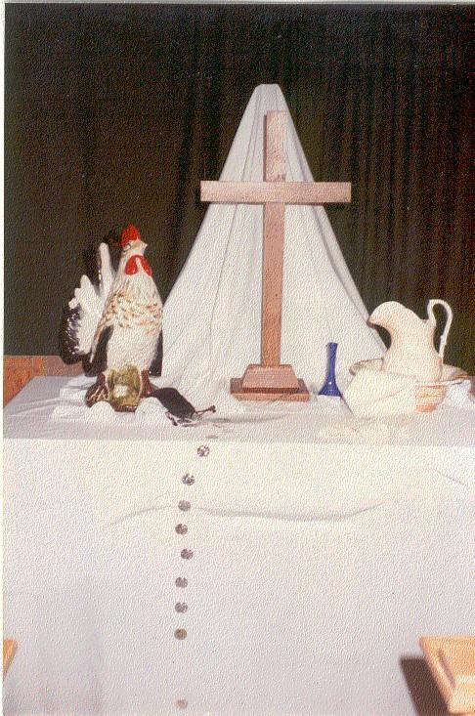

Four Responses to Christ 7:00 am Friday
- Turn on Lights
- Set up table in center of platform. Drape with white cloth. Make sure that front and sides are covered to floor.
- Place easel in center behind table and drape with a white cloth.
- Place cross in center of table.
- Place rooster to left of cross and slightly forward.
- Place bowl and pitcher to right of cross and slightly forward. Place a small napkin draped over side of bowl.
- Place blue vase between cross and pitcher in bowl.
- Place money bag between cross and rooster and slightly forward. Drape the string of silver coins from bag down over edge of table. Tape coins to cloth. (,if you don’t have tape make sure there are not too many coins over edge so as not to fall.
- Wipe off benches. Wait for ALD to check readiness or text them that you are ready
- Friday after breakfast take down the chapel and prepare for Dying Moments.

4th Chapel Service – Dying Moments
Friday 11:00 a.m.
“Dying Moments” Indoor Chapel

NEED:
- “Dying Moments” banner
- 2 candles & candle sticks
- 2 chalices/ 3 plates
- Grape Juice, bread, Gluten free crackers
- Cloths to cover elements

- Logistics will set up the chairs according to the ALDs direction, hang the tarps on the walls and Dying Moments banner plus the spotlight.
- On the long table in front of the room with the pilgrim's candles, place the cross in the center of the table. Place the candle sticks with candles on either side of the cross and a little forward.
- Place the chalice and the bread plate to the right of the cross and close to the edge of the table.
- Pour juice into the chalice. Cover both chalice and plates with the communion napkins.
.
NOTE:
- Ask Spiritual Director what container to use for the ‘discarded sins’. Many of them have their own vessels. The Glass Cross is available for the SD to use if they choose to do so. The Worship Board Rep will have access to this cross. It will not be packed up and put in the shed.
- Find out if Lay Director has their own vessels (chalice & plate) they want used for this service
- Open the Bible to Luke 24 and prop in front of the cross
- Take time to pray over each of the pilgrim’s and team’s chairs.
- Light candles shortly before pilgrims arrive. Ask ALD to let you know when they start up the hill. Go next door to the Agape room and please be quiet until all are inside with door shut. Then leave the area quietly or wait quietly in the Agape Room until they leave.

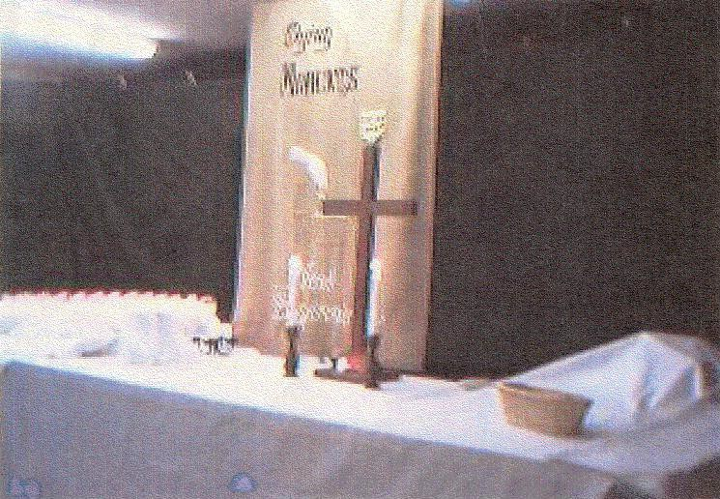

“Dying Moments” set up outside the Indoor Chapel (Foyer)

NEED:
- “I’ve been expecting you” banner
- Easel covered with cloth
- Rough Cross
- White garment with blood
- Large spikes & nails
- Crown of Thorns
- Whip
- Sandals
- Greenery – if using fresh greenery, it can be gathered on Thursday afternoon from outside the camp grounds. If using ‘store-bought’ you might want to intersperse with live greenery.
- LED candles
- Giant Jesus mural
- Black material to enclose foyer.
USE:
• Small folding table with white cloth

Dying Moments Foyer 11:00 am Friday
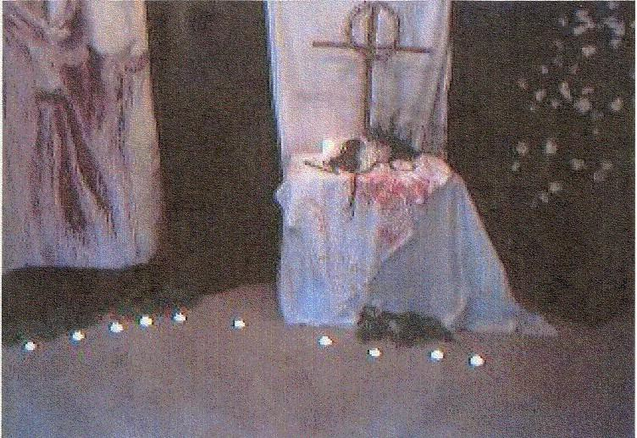

- Logistics will hang the tarps, the “I’ve been expecting you” banner and place the large "Jesus" painting in the foyer slightly to the left toward the back edge of the foyer.
- Place the small folding table to the right of the "Jesus" painting and cover with a white cloth.
- Cover the white cloth with the "Blood Stained" cloth, draping it over the edge of table.
- Set up the large rugged cross in center of table. Place the "Crown of Thorns" on the cross.
- Place the whip, nails and sandals on the table as shown in the above picture.
- Place greenery on the floor around the "Jesus" painting and in front of the table.
- Place LED candles in and around the greenery.
- Make sure Kleenex boxes are placed at each end of rows including Conference team.
- Make sure the lights for the foyer are turned off.

Friday after lunch break down the Dying Moments area and repack everything.

5th Chapel Service – Candlelight Service
7:00 p.m. Friday Night

NEED:

- Cross & 2 candles / Glass holder with glass covers and 2 tablecloths for the communion table.
- Communion elements (juice, GF crackers & pita bread - enough juice for two large chalices and two plates of bread
- 3 plates & 2 chalices
- 5 cloths to cover elements
- Collection baskets (4)
- Small folding table (Logistics will bring table if you ask).

- Place table between kneeling benches and cover, making sure that front and sides are completely covered.
- Center the cross on table toward the back.
- Place candles with globes flanking the cross and slightly forward.
- Place a plate toward the end of each side with a chalice next to each, closest to the cross. Place the extra plate slightly behind. Just before Candlelight begins (6:50 p.m.), place 2/3 pieces of bread on each of 2 plates and some GF crackers on the other. Pour grape juice when you place the bread and crackers. Cover each with a cloth.
- Place the juice container and an additional pack of bread under the table letting the Spiritual Director know there are more elements if needed. Be on hand to get them out if needed.
- Place collection baskets – 2 on each side – on the kneeling benches
- When the worship service is over and the pavilion is being prepared for the arrival of the pilgrims, clear the table, blowing out the candles, putting hurricane globes back in their boxes and everything including communion and tablecloths into the tub. There should be time to dispose of the blessed elements but if not, place them in the tub to retrieve in the morning. Place in the office along with the collection baskets.

NOTE:
- Logistics will bring the table from the outdoor chapel for you if you ask. You will be responsible for collapsing it when the worship service is over.
- Candles don’t need to be lit until 15/20 minutes before the Worship Service begins
- With the exception of the cross, these supplies can stay until Saturday because you will use all of this to set up for closing.
- Check your stock of communion elements for Closing.

6th Chapel Service
Saturday 7:00 a.m.

Come Holy Spirit

NEED:

- Blue Velvet
- White Dove
- Dogwood & white flowers in vase
- 9 Gifts of Holy Spirit
- Cross
- Grapes
- China dove

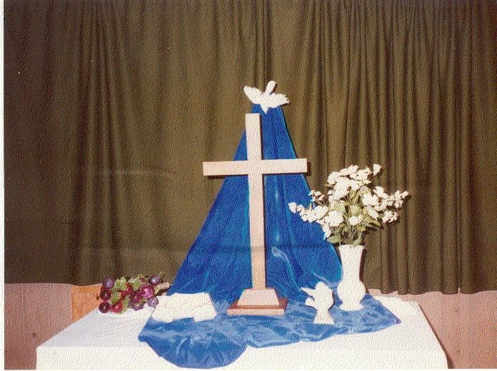

- Set table in center of platform and cover with the white cloth.
- Place easel behind the table. Drape blue velvet cloth over easel and on to the table as shown in the picture.
- Attach a white dove to the top of the blue cloth with either a straight pin or a clothes pin.
- Place the cross in the center of the table on the blue cloth.
- Place the vase with the dogwood flowers to the right of the cross.
- Place the grapes to the left of the cross and slightly behind toward the edge of the table.
- Place the praying hands slightly forward and between the vase and the cross
- Turn off lights when you clean up and before you leave the area.
- This is the last outdoor chapel service. Logistics will come pick up the tub of seat pads and any other equipment when you let them know they’re ready.

7th Chapel Service - Closing
Saturday 4:00 p.m.

The Walk Lay Director, Spiritual Director and Board Rep will decide by 2:00 pm on Saturday if it is too cold or too hot for the pilgrims to sit under the Pavilion during extreme cold or extreme hot weather for Closing. In that event, Closing will be set up in the Downstairs Dining Room. The Walk ALD’s will notify the Worship Chairperson and the Logistics Chairperson and the Community Lay Director so he/she can notify the community.
Saturday after Lunch (1:00 pm) setup Closing

NEED:
- Grape Juice
- Pita Bread and GF crackers
- 2 Chalices
- 3 plates
- 4 collection baskets
- 2 candles with 2 glass candle holders with glass covers
- 5 cloths to cover elements
- Small bottles of water for the pilgrims and conference room team during hot months
- Colored seat covers for pilgrims and conference room team’s chairs.
- Kleenex boxes at ends of each row of chairs

Logistics will set up chairs and hang banners:
“Jesus My Lord” “Communion”
“Emmaus Walk

- Use the same instructions for Communion set up as the Candlelight service. Light the candles about 15 minutes before pilgrims come up the hill.
- When Closing is over and community is clearing the floor, break down as you did previously. The plates and chalices can be rinsed in the water fountain at the back of the pavilion after disposing of the elements properly.
- Repack in the same storage bin for Worship Board Rep to pick up.
- Notify board rep of missing or broken items

Worship Chair or Co-Chair should go into the office to witness counting of the offering with the Housing Chair or Co-Chair.

(Speaker’s Prayer Chapel Chair will bring LD Cross and SD Cross to Closing)

Central Alabama Emmaus Community
Worship Sign-In Sheet
Walk #

Chairperson(s):

Co-Chairperson(s):

PLEASE PRINT YOUR NAME, Walk Number and current contact information.

Name | Walk# | Phone # | Email Address

Note to Chairperson: Please see that each person who serves in your area logs in. Give
the completed log to any member of the CAEC Board at Candlelight or Closing or mail to
Rita Carswell, 538 Winding Road, Dadeville, AL 36853 or email to ritacarswell14@yahoo.com

