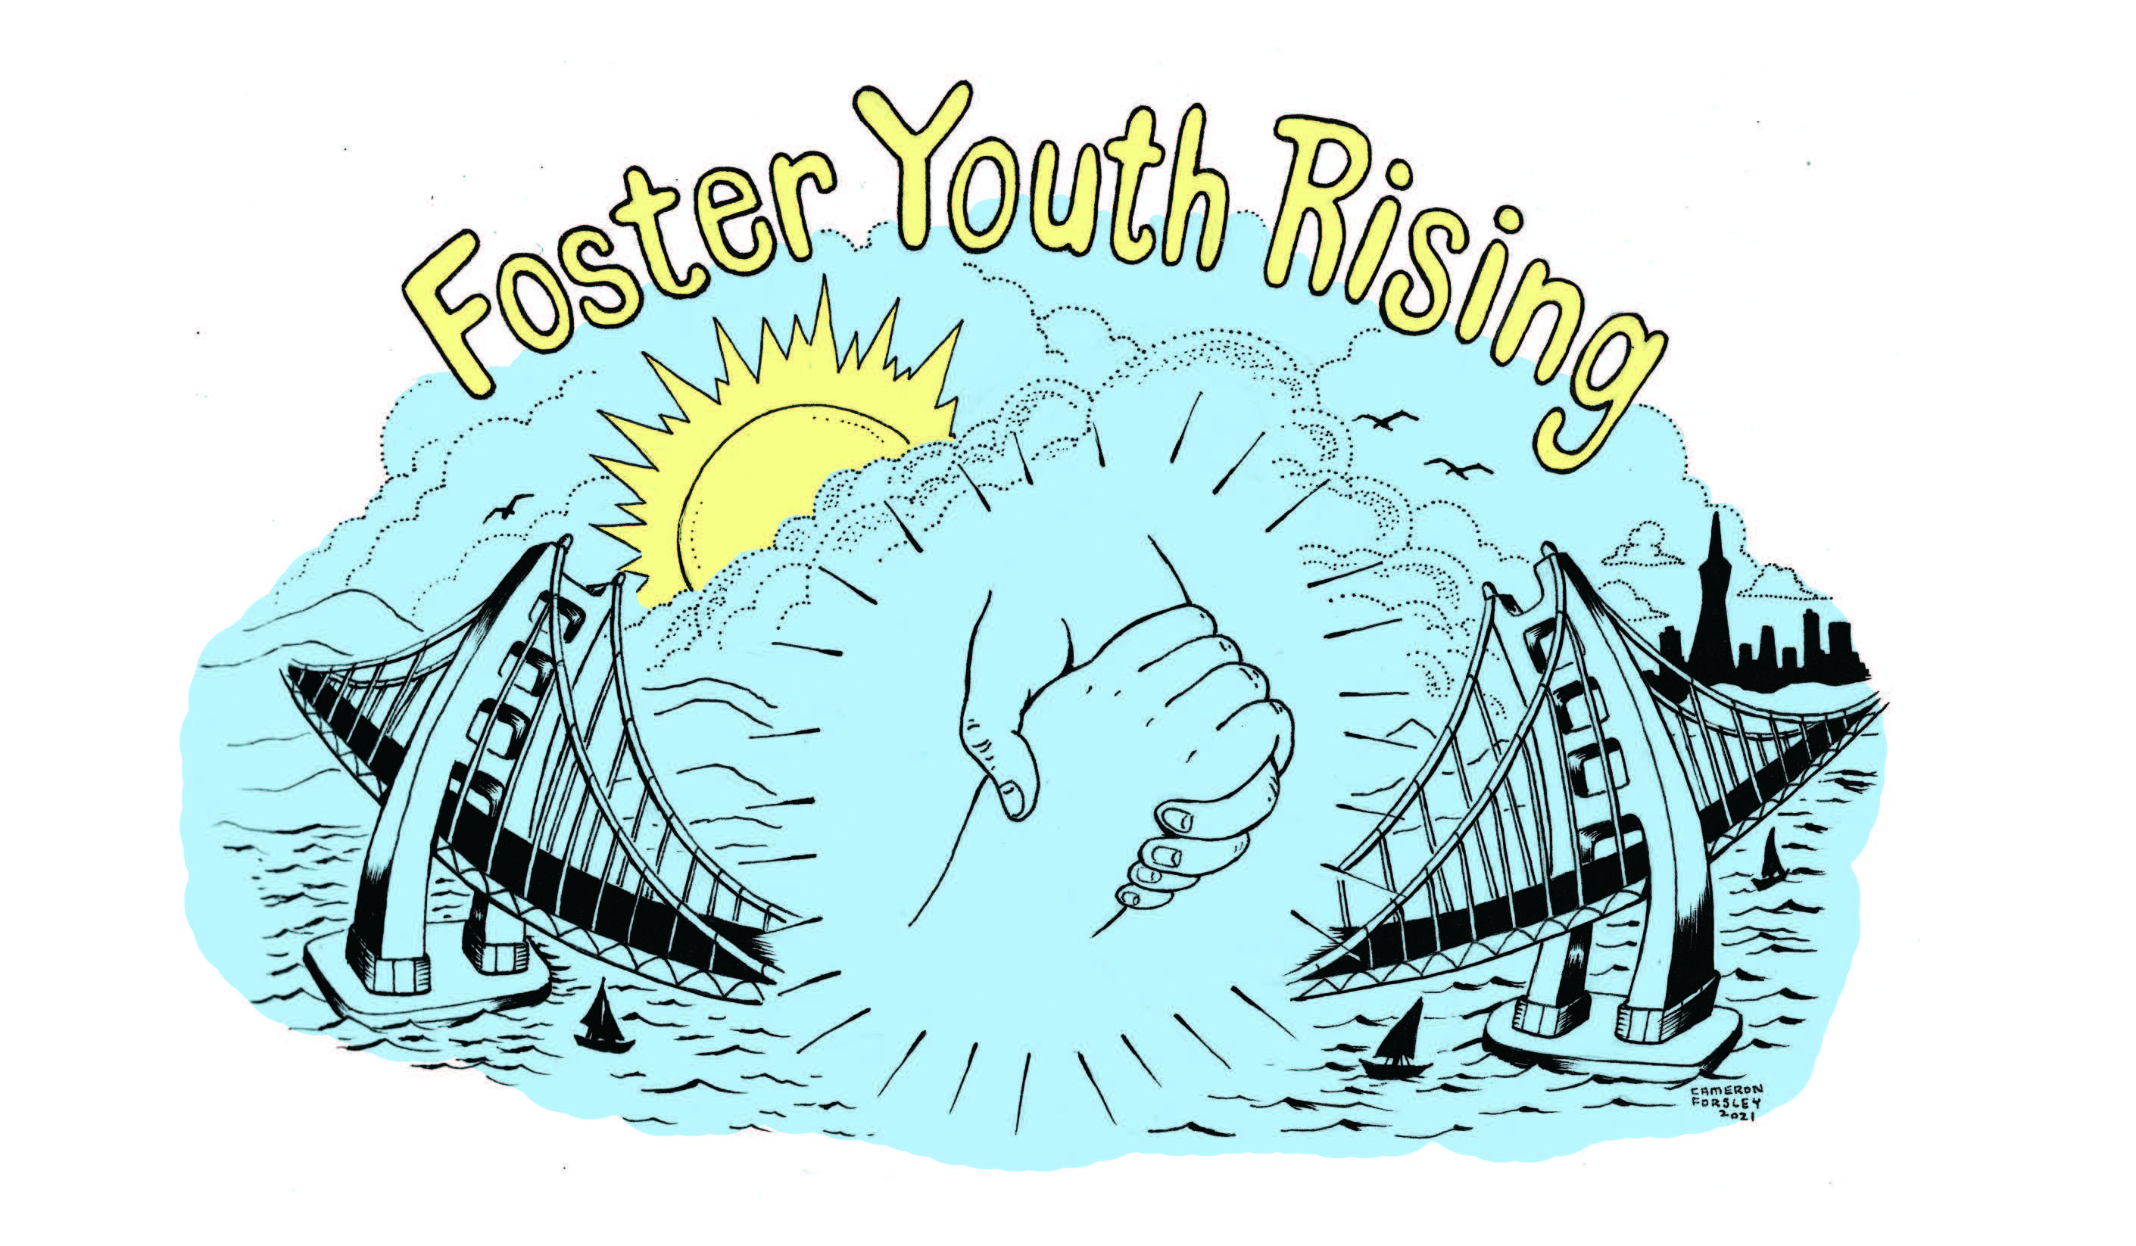

Foster Youth Rising Grant Application

Goal
The goal of the Foster Youth Rising grant is to provide financial assistance to current and former foster to help them thrive.

Who is eligible?

Be a current or former foster youth, aged 17 to 25, who was a dependent or ward of the court, living in foster care, at some point in time. Preference is given to individuals enrolled in a university, community college or vocational school program.

What can I use the money for?

Funds can be used for costs related to EDUCATION, HOUSING, JOB TRAINING and DEVELOPMENT, and BASIC LIVING EXPENSES such as tuition, books, fees, transportation, basic living needs while attending college or job training, and/or for housing related costs that help
you to become stable and able to support yourself.

How do I apply?

Complete the application that is attached. Make sure your application is complete and has all supporting documents. Please contact us at info@fosteryouthrising.org if you have questions. Send all completed applications to:

Foster Youth Rising
PO Box 32136
Santa Fe, NM 87594

Or email scanned applications and additional documents to: info@fosteryouthrising.org

What else do I need to know?
You can receive one grant per calendar year. However, if you applied earlier this year and did not receive a grant, you can apply again.

All grants will be paid directly to your school, landlord, or vendor. When this is not possible, you will receive a check in your name and will need to give us the receipts within 30 days. Grants given to you will not affect your financial aid but may be considered part of the money that you pay taxes on.

Our goal is to fill the gaps in funding available to foster youth. You should make sure that you have worked with your ILSP education/employment specialist and/or your social worker to make sure that you have taken advantage of existing support. Because we are an emergency granting organization, we ask that you exhaust all other financial possibilities. You must give us proof of getting other grants, scholarships, and any other financial support you receive. You will need to show that you have filed or are filing the Free Application for Federal Student Aid, or FAFSA.

File online at www.fafsa.ed.gov or get a form from your school. If you are eligible for the Chafee grant, you must apply separately. For more information, visit http://www.chafee.csac.ca.gov/.

We will ask for proof of your need, including bills and/or receipts. For example, you will be asked to give us a copy of an unpaid bill for your books or fees.

What if I have questions about the program? You can contact us at
info@fosteryouthrising.org.

FOSTER YOUTH RISING GRANT APPLICATION
Please type or print clearly.

Personal Information

Name |  | Date of Birth

County/State that has your foster care records:_______________________________

Address
Street Apt. # City State Zip

Best Telephone to Reach You: |  | Email:

Name and telephone of a person who can always reach you: _________________________________

No. of Children/Ages:

Income Source(s) (Check all that apply):

- Work
- TANF
- SSI
- PAES
- Disability (DIB)
- Unemployment (UIB)
- General Assistance (GA)
- Social Security
- Financial Aid
- Scholarships
- Other (please specify) _____________________

How will you use this grant? Please explain in detail exactly what you would like to use the grant for?
__________________________________________________________________________________
__________________________________________________________________________________

How much money are you requesting? __________________________________

If grant amount is approved, to whom should Foster Youth Rising make the check out to? (Foster Youth Rising send money directly to schools, landlords,

__________________________________________________________________________________

Education and Employment

Are you currently (check all that apply):
A full-time student
A part-time student
Employed full-time
Employed part-time
Unemployed
Other (please describe): ________________________________________________________

Are you currently attending or enrolled to attend one of the following?
High School 2-year College 4-year College Graduate school
Vocational school Other

What is the name of the school you attend? ___________________________________________________________________________________________

What is your major or what are you studying? ___________________________________________________________________________________________

How many credits have you received towards your Bachelor’s, Associate’s, or other degree? _________

What is your educational or career goal? ___________________________________________________________________________________________
If you are not currently in school, but are planning to get more education, please give us the name of the college/university/vocational school you plan to attend and when you will begin: __________________________________________________________________________________
If employed, where do you work? ______________________________________________________

___________________________I
Personal Essay (2 page limit)
Please tell us about your personal, educational and career goals. How would this grant help you to achieve your goals? How has your experience in foster care affected these goals? Please limit to 2 pages. Please attach as a separate sheet.

Your Needs & Expenses

Please complete the budget form for your request. Please remember that all of your income will be checked by us. Please make sure to include all of your monthly income as well as your expenses. Please contact us if you have questions. Please make sure to attach the following:
- Financial aid award letter for the current school year.
- Proof that you are enrolled in school, such as current semester class list or transcript.

Your Monthly Budget
Part I – Your Income

Your Monthly Income | What You Receive
Monthly Income from all sources (work, benefits, etc.)
Total Monthly Income
Your Financial Aid/Scholarship | What You Receive
Financial Aid & Scholarships amount received for this
entire school year
Chafee Grant Amount Received/Anticipated for this
entire school year
Total Annual Financial Aid/Scholarships

Part II – Your Expenses

Your Educational Expenses | What You Pay
Tuition for the year
Rent or Dorm fees for this year
Books for the year
Other educational costs
Total Annual Education Expenses
Your Monthly Living Expenses | What You Pay
Utility Bill – PG&E
Phone Bill
Food
Transportation Costs
Total Monthly Living Expenses

References

Please submit the name, email, and telephone number for one reference who can speak on your behalf. These can be teachers, current or former employers, case workers, your CASA worker, etc. Please, no relatives or friends.

Reference

Reference Name and Relationship to you

Telephone and Email Address

Authorization for release of information to Foster Youth Rising

I, _________________________, an applicant of the Foster Youth Rising Grant, do hereby authorize the reference listed above to furnish verification information to the Foster Youth Rising regarding my application and grant request. This information will be maintained in confidence. My signature below indicates that I have been informed and understand the information contained on this form.

Participant Signature _______________________________ Date_________________

Please sign only one of the statements below. Your decision will not affect your eligibility for a grant.

I DO GIVE PERMISSION to use my name and information in telling donors and other people about Foster Youth Rising.

Participant Signature _______________________________ Date_________________

I DO NOT GIVE PERMISSION to use my name and information in telling donors and other people about Foster Youth Rising.

Participant Signature _______________________________ Date_________________

