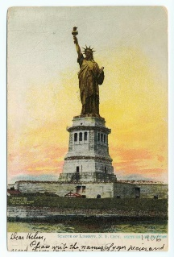  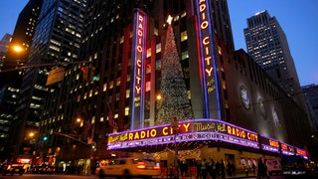

Ocean City AARP Chapter 1917 presents

**!!!NEW YORK, NEW YORK!!!** **NOVEMBER 20-21, 2024**

Join us for an overnight trip to fabulous New York City for a fun adventure.

**You’ll enjoy reserved seating to see a matinee performance of the

ROCKETTE’S CHRISTMAS SPECTACULAR and

the radio city music hall backstage tour.

**Dinner will be served at a fine local restaurant in NYC (tba) following the show.

**Overnight accommodations just outside NYC, including a delicious breakfast.

**Return to NYC for a tour of the statue of Liberty and Ellis Island. A lunch voucher is included.

**Trip Assurance is available for day of departure protection upon request

**Trip Pricing**: Per person, **double occupancy** is $594.00; **single occupancy** is $737.00

Non-members, add $7.00 per person

**Payment is due no later than October 9, 2024**

**NYC is an in-demand Event and seating will be limited for this trip**

**Please contact Fran Smith at** [**frans524@yahoo.com**](mailto:frans524@yahoo.com) **or 410-726-6166 with questions**

**--------------------------------------------------------cut here-----------------------------------------------------------**

**NAMES: _______________________________________­­­­**

**STREET:______________________________________CITY:__________________________STATE:______ZIP:_____________**

**PHONE: _________________E-MAIL__________________________________________**

**TRIP: New York, New York, Nov. 20-21, 2024 # People: ____________ Single: room ( )**

**CASH: _____________________ CHECK#:______________________ CHECK AMT:___________________**

**I ACKNOWLEDGE THAT I HAVE READ THE TRAVEL-TRIP RULES AND AGREE TO ACCEPT [ ]**

**SIGNATURE: _____________________________________________________Date__________________**

**MAKE CHECKS FOR TRIP PAYABLE TO: AARP 1917 Travel**

**MAIL TO: PO Box 4193, Ocean City, MD 21843**

*DISCLAIMER: These trips are a project of and are offered to the Ocean City, MD Chapter 1917 of AARP. The chapter and any agent it may use in arranging these or any other trips are not responsible in whole or in part to the traveling member for any loss, damage, or injury, whether financial or otherwise, to persons or property, however caused during or in with these or any other trips. These trips are activities conducted by Ocean City, MD AARP 1917 and are in no way offered, sponsored or conducted by AARP, which has no responsibility with such trips.*