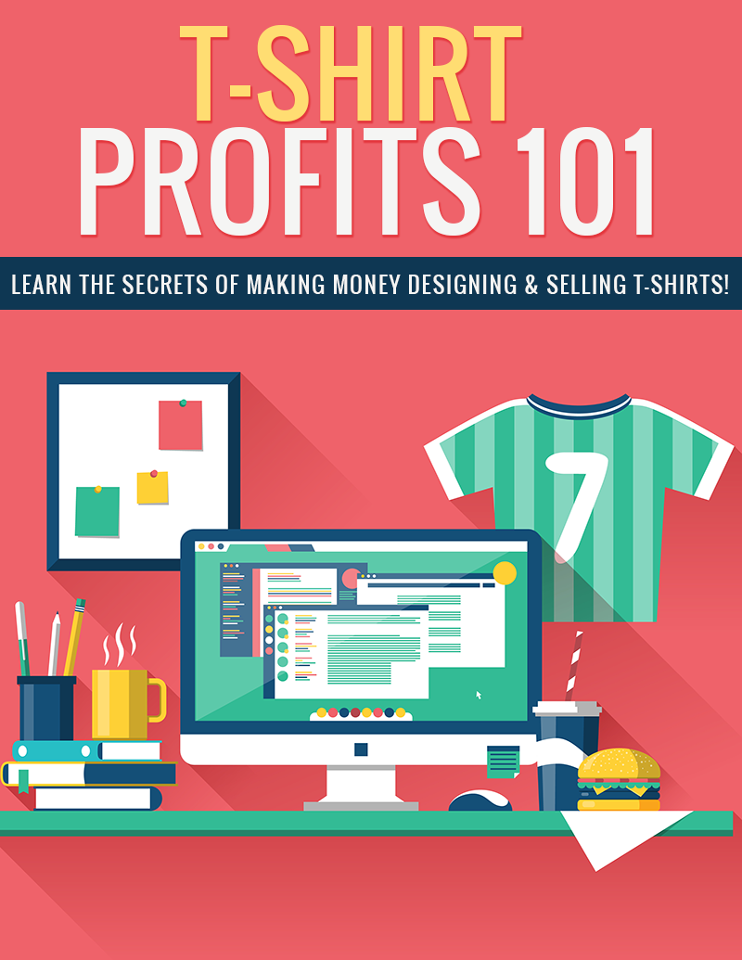

Legal

No part of this publication may be, including but not limited to, reproduced, in any form or medium, stored in a data retrieval system or transmitted by or through any means, without prior written permission from the publisher. The information contained herein has been obtained from sources believed to be reliable at the time of publication. The opinions expressed herein are subject to change without notice.
The publisher disclaims all warranties as to the accuracy, completeness, or adequacy of such information. The publisher assumes no liability for errors, omissions, or inadequacies in the information contained herein or from the interpretations thereof. The publisher specifically disclaims any liability from the use or application of the information contained herein or from the interpretations thereof.

Table of Contents

Legal 2
Table of Contents 3
Introduction 5
Identify Your Niche 6
Copyright & Trademark Information 9
Designing Shirts 10
T-Shirt Companies 11
TeeSpring 11
Skreened 12
Society6 12
Other Alternatives 12
Marketing Your Shirts 14
Pinterest 14
Facebook 14
Wanelo 15
Conclusion 16
Resources 18

Introduction

T-shirts have been incredibly popular for decades. They’re comfortable, durable, and come in a dizzying array of colors and styles. You can find a t-shirt for just about any kind of interest you can imagine.

People love to purchase t-shirts that speak of the things they are passionate about. Whether it’s their family, their hobby, their profession, their pet, or something else, people enjoy wearing t-shirts that let the world know what they’re into.

For this reason, creating t-shirts can be incredibly lucrative. If you can find a topic that speaks to a large group of people, create an attractive design that really works for that group, and then put that design in front of the right people, it is almost certain to make money.

Of course, finding the right topics and designing well to fit that niche is the tricky part. It takes a significant amount of time and research to find topics and designs that will succeed.

In this guide, you’re going to learn about some of the tricks the pros use to make big money in the t-shirt market. You’ll learn how to find hot topics, how to get great designs, and how to market those designs to the right people.

Let’s get started.

Identify Your Niche

The first thing you need to do is choose a passionate niche, but keep in mind that not every passionate niche would have fans who would be willing to buy t-shirts. For example, there are certain groups of people who don’t buy graphic t-shirts as often as others. College kids tend to buy a lot of graphic t-shirts, while the older generation does not. So you must not only keep the niche itself in mind, but also the market (people) that are interested in that niche.

There are certain niches that are virtually evergreen niches. These niches will tend to have a much greater potential for profit, because people have proven over many years they will buy shirts in these niches.

Such niches include:

- Pets
- Family & Romance (especially children, grandchildren and couples)
- Emergency & Medical Careers (nurse, paramedic, EMT, firefighter)
- Artistic Careers (writer, artist, designer, chef)
- Nerdy Stuff (science fiction, fantasy)
- Sports (football, baseball, basketball, soccer, golf, racing)
- Hobbies (crafts, cooking, camping, fishing, hunting, reading)
- Gaming (console games, tablet games, PC games)
- Retro (especially stuff from the 80s)

These are a few good ideas to get you started, but these markets are also pretty competitive. There are thousands of new shirts put on sale every day in these exact niches. So if you want to find topics that are a little less competitive, it will take a bit more research.

One thing you can do is check pins on Pinterest. Try searching for “t-shirt” and look at the most popular designs. See what colors and styles are being pinned, and what those niches are. Look for the pins that have the most repins and likes.

Here is an example:

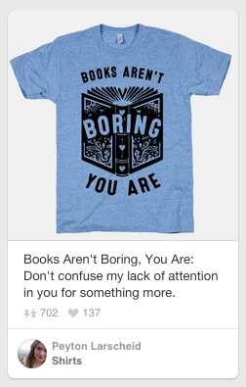

In the above example, you can see this shirt has had 702 repins and 137 likes. This is clearly the type of shirt people are interested in, so making something in this particular niche would probably be profitable.

Keep in mind you can’t just use someone’s slogan without checking to see if it’s been trademarked. You don’t want to make a shirt with a slogan you saw online and later find out it’s trademarked because you’re being sued.

You can also check the bestselling shirts at a wide variety of online t-shirt sellers to see what’s doing well.

Copyright & Trademark Information

One thing you absolutely must keep in mind is that you can’t just create any kind of shirt you want, even if it’s your own unique spin on it. For example, you can’t just do your own illustration of Harry Potter and put that on a shirt, because Harry Potter is protected by Copyright and Trademark laws. You can’t use a major sports team, because those team names, logos, and colors are trademarked.

You can still use sports teams, but you’d have to do it in a way that does not infringe. For example, I once saw a shirt being marketed to fans of the Georgia Bulldogs that said, “Black & Red ‘til I’m Cold & Dead”. That same slogan could have applied to any team, in any sport, that used those colors for their uniforms, such as the Atlanta Falcons.

You could also look into licensing if you’re really interested in using something that is copyrighted or trademarked. Let’s say you wanted to create a line of t-shirts for fans of Game of Thrones or Big Bang Theory. You’d have to contact the legal department of the production companies to inquire about licensing. You’re not likely to get permission at a price you can live with, but it doesn’t hurt to try.

Remember that even common phrases can be trademarked. Just because you’ve seen it on other t-shirts and even on memes online, doesn’t mean it’s legal to use it.

Designing Shirts

If you already know a little bit about graphic design, it shouldn’t be too difficult to create images for your t-shirts. Pretty much any design program (Photoshop, Illustrator, GIMP, etc.) is fine for creating t-shirt designs. Most systems accept image formats such as JPG and PNG, allowing you to use whichever program you prefer. Most systems also provide templates you can download to ensure you’re creating the right size image for your shirt.

You can look at existing successful t-shirts for ideas for designs. Obviously you don’t want to copy their designs. Just use them for inspiration as far as colors, layout, and the type of graphics you might want to use.

You could also hire someone to design your shirts for you. It’s nor difficult to find freelance designers that are hungry enough for work that they’ll create basic t-shirt designs for you for just a few dollars. Let’s say you pay a designer $25 to do a simple design. Even if you only sell a handful of shirts, you’ll still make a profit off that design.

Craigslist is a good place to start. You could always post an ad looking for a designer for t-shirt graphics. Mention how much you’re willing to pay, and ask for samples.

Many of the most successful t-shirts are nothing more than interesting text arranged in an eye-catching, pleasing way. Even a beginner can learn to create simple designs without much trouble.

T-Shirt Companies

A few years ago, only a handful of print-on-demand shirt websites existed. Sites like CafePress (cafepress.com) and Zazzle (zazzle.com) pioneered the field, but they failed to really make the kind of impact the newest generation of sites has made.

TeeSpring

http://www.teespring.com

Teespring really exploded the market by creating a system that would allow time sensitive promotions, making people more apt to order immediately rather than waiting. Their system uses a combination of time (a countdown during which time the item must be purchased before it becomes unavailable) and scarcity (calling items “Limited Edition” and insinuating they may never be offered again) to inspire people to purchase right away.

Teespring requires you to sell a certain number of shirts before any shirts will be printed, so if you don’t meet that minimum, your efforts will all be in vain. This makes it tricky for beginners, because you never know for sure if a design will meet the minimum to be printed.

Skreened

http://www.skreened.com

Skreened (skreened.com) is one of a growing number of socially conscious companies. They ensure their shirts are not made in sweatshops, and they give money to various charities. They are a very popular choice.

Society6

http://www.society6.com

Society6 is a company that has set itself apart from other companies by allowing all over printing. Most t-shirt companies only allow printing in certain areas of the front and back of a shirt. Society6 allows you to print your design over the entire surface of the shirt. They also have other items like leggings, and you can sell art prints, too.

Other Alternatives

There are dozens of other popular sites that will allow you to sell your t-shirt designs. They vary in features and pricing.

Here are a few you can check out:

http://www.cafepress.com

http://www.zazzle.com

http://www.redbubble.com

http://www.theprintful.com

http://www.spreadshirt.com

This is just a small selection of the many sites that offer print-on-demand t-shirts. It’s a good idea to take a look at several of the most popular sites and see which one looks like the best fit for your purposes.

Marketing Your Shirts

You can’t just create t-shirts and expect them to sell. It would be great if it worked that way, of course, but it doesn’t. It’s important to actually promote your shirts if you want to make any money.

There are a number of ways you can promote your shirts, and we’re going to take a look at a few of the best.

Pinterest

https://ads.pinterest.com/

There are two ways to promote your shirts on Pinterest. The first, of course, is simply pinning your images on your own Pinterest account. This isn’t against their rules as long as you’re not using an affiliate link.

There are also paid Pinterest ads that allow you to get more views than you could by simply pinning ads on your own account.

Facebook

https://www.facebook.com/business/products/ads

While it’s certainly possible to promote t-shirts on Facebook without spending money, it’s very difficult and will probably only lead to you getting blocked from the pages and groups you try to advertise to. (Unless, of course, you already have your own group or page with a lot of members.)

Facebook ads can be targeted by interest, so ads can be remarkably effective. But it’s a good idea to test a design with a small budget first to be sure it converts. If you spend $20 on ads and don’t sell a single shirt, it might be time to try a different niche or a different design.

Wanelo

https://wanelo.com/

Wanelo stands for “Want, Need, Love”, and it is a Pinterest-style website that allows users to submit their favorite products. It’s free, and it doesn’t take much time. Only certain shops like Skreened are available, but if you set up a shop with Shopify.com to sell your shirts, you can use Wanelo’s Shopify app.

Conclusion

Selling t-shirts can be an incredibly powerful way to make money online, and it requires very little to no upfront investment, making it a great option for people who don’t have much money to start a business.

You’ll need to have a little bit of design experience if you don’t want to pay someone else to design your shirts for you, but as long as you can use a program like Photoshop or use something like TeeSpring’s online designer, you can do this yourself.

Remember, you will need to do some marketing, but basic promotion can be done for free. Pinterest is one of the best places to promote your t-shirts for free, but they also have a paid ad platform that can be profitable. Facebook is another ideal place to advertise, but you probably won’t get very far without putting some money into paid ads.

Take the time to thoroughly research what kinds of shirts are currently selling. Don’t just waste time making designs that may or may not sell. If you take the time to do some research first, you will increase your chances of selling a lot of shirts and making a profit.

I wish you the best of luck with your new t-shirt business!

Resources

Here are quick links to the resources mentioned in the guide:

TeeSpring:

http://www.teespring.com

Skreened:

http://www.skreened.com

Society6:

http://www.society6.com
CafePress:

http://www.cafepress.com

Zazzle:

http://www.zazzle.com

Red Bubble:

http://www.redbubble.com

Printful:

http://www.theprintful.com

SpreadShirt:

http://www.spreadshirt.com

Pinterest Ads:

https://ads.pinterest.com/

Facebook Ads:

https://www.facebook.com/business/products/ads

Wanelo:

http://www.wanelo.com

