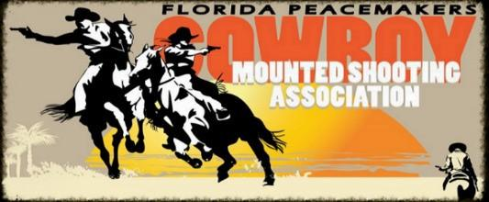

We have 24 mounted shooting events throughout the season (October 2023 through September 2024). Florida Peacemakers CMSA is a non-profit organization.

$300.00 Banner Sponsorship Includes:

- Recognition and thanking our sponsors several times during each event from the announcer’s booth.
- Sponsors will be listed on our website sponsor page at www.flpeacemakers.com
- Sponsors will be announced throughout all the FPCMSA events including the New Years/FL State championship. This is going to be another big year for cowboy mounted shooting in the state of Florida! All of the major events would be an excellent opportunity for your company to set up a booth and promote your business, free of charge.
- We will hang YOUR SUPPLIED banner in the arena at all 24 events!

Thank You so much for your support,

Florida Peacemakers Cowboy Mounted Shooting Association

X (Sponsor)

Date: ___/___/______ Check number: _________

Please make check payable to: FPCMSA

FPCMSA mailing address:
Nelson Riollano
2550 SE 80th St
Ocala, FL 34480

