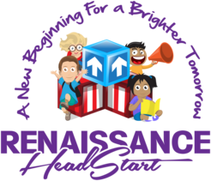

COVID19 Updates

Dear RHS Families,
While this is a time we have never seen before, we are making preparation to make the transitions as comfortable as possible for all those involved. The “New Norm” for Head Start will definitely be a drastic change but a necessary one. Please know that we are taking every precaution to make our centers a healthy environment where your children will be safe at all times. All of our staff will be equipped and trained regarding the new COVID19 Mandates outlined by the CDC (Center for Disease Control) and the State of MI. With everyone working together we will make the necessary changes an easier pill to swallow. Please make a note to view our website often for updates and we will be reaching out to our currently enrolled parents personally. For our new parents, please allow RHS a chance to make your child’s Head Start Experience a great one. RHS look forward to seeing our families soon.

Sincerely,
Tina L. Edwards
Executive Director

